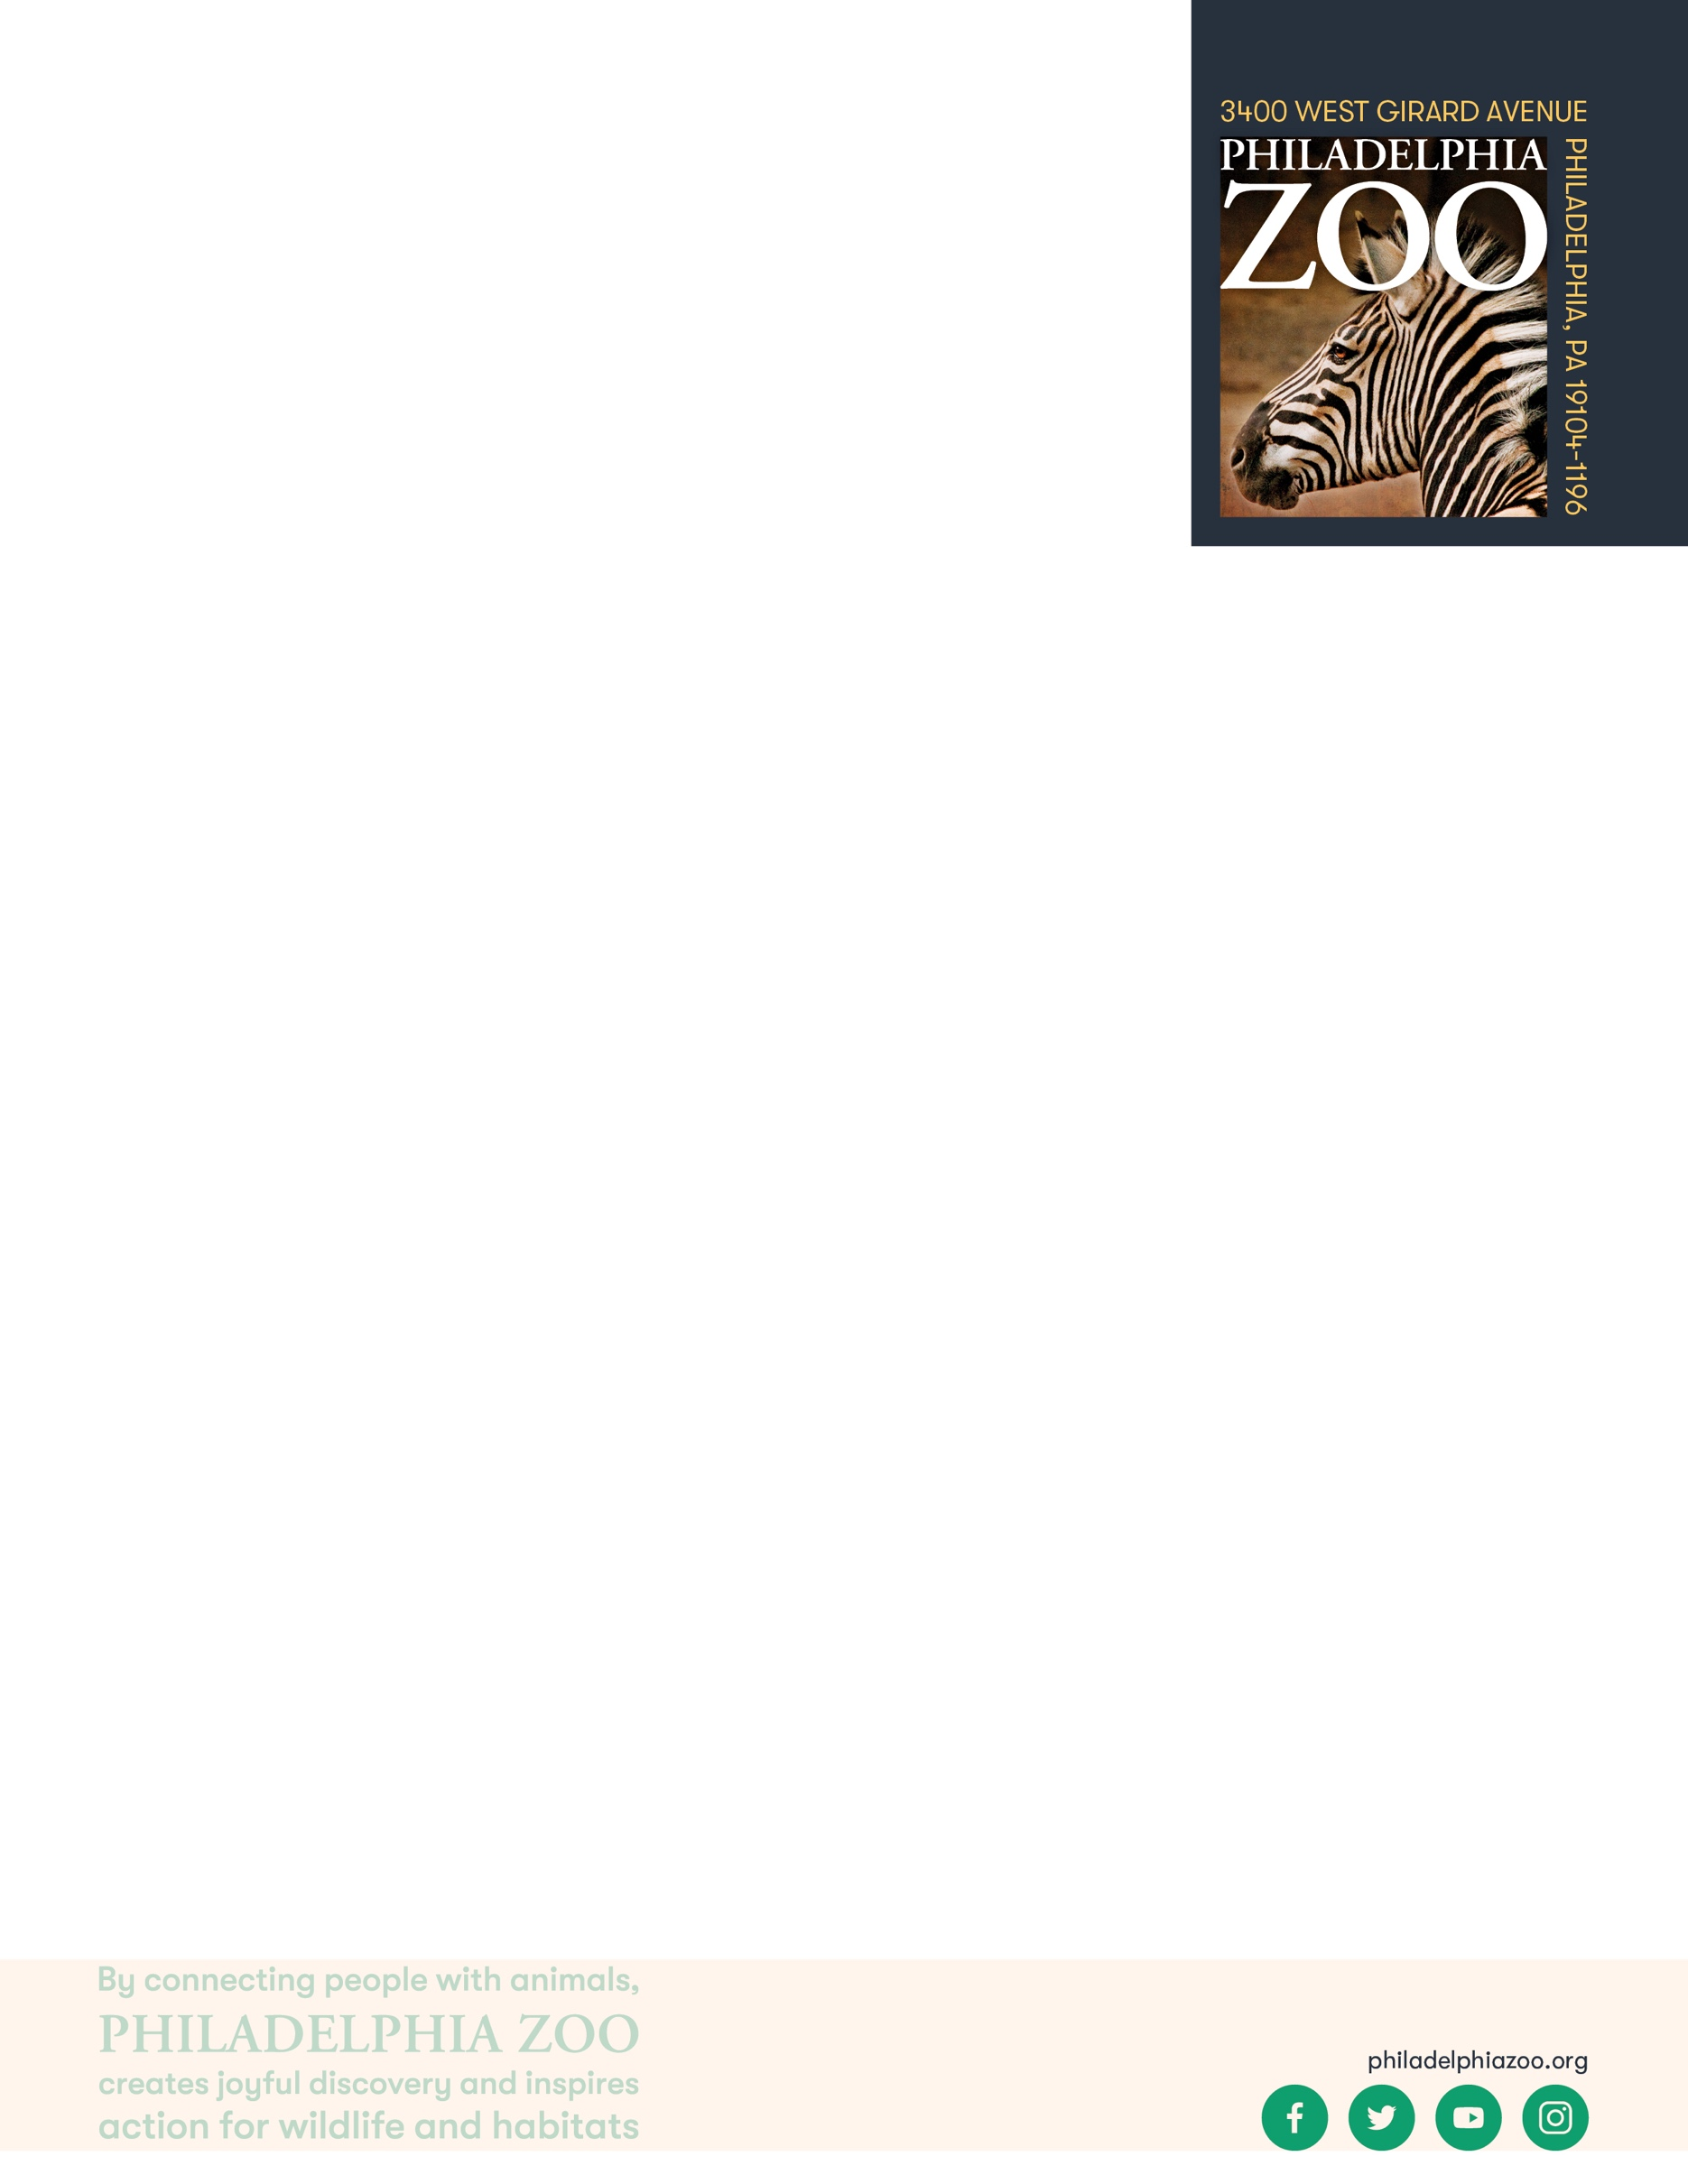**Animal Care**

**K-2 Onsite Activity**

**Lesson Summary**

Students will be able to determine resources they can use to learn more about animal care.

**Objectives**

Students will be able to research and gather information on animal care

**Essential Question**

How can we figure out what animals need to be properly taken care of?

**Materials**

* Paper (or worksheet such as provided at the end of the lesson)
* Writing utensils

**Prep**

1. 1 Week before: Look at the [Zoo map](https://www.philadelphiazoo.org/zoo-map/) to determine the best place for students to inquire with Zoo staff. The best options would be the Contact Yard, the McNeil Avian Center, Wings of the World, or at the Giraffe Feeding Experience.
2. 1 Day before: Print out worksheets as needed (1 for each student)
3. 15 minutes before: Prep students for expectations

**Key Terms**

* **Zookeeper:** The person/people responsible for the daily care animals that live at the zoo for conservation purposes
* **Veterinarian:** A doctor for animals.
* **Basic Needs:** All living things including animals need food, water, and shelter to survive and these are called their basic needs. Different animals have different types of specific needs.
* **Hygiene:** The practice of keeping clean, for example a habitat to ensure health and prevent sickness for one’s self or another being.
* **Diet:** The specific types and amounts of food and drink eaten and drunk by an animal.
* **Enrichment:** Practices or items that improve the quality care for animals, by encouraging natural behaviors and simultaneously exercising the bodies and minds of the animals.
* **Training:** The practice of teaching an animal a specific behavior or skills for enrichment and for the benefit or their care.
* **Choice:** The act of animals being able to decide if they want to participate in training or not.
* **Husbandry:** The care of animals including observing to monitor health, cleaning to ensure hygiene, preparing and providing diets, training for care and enrichment.

**Background**

Animal Care is a full team effort. Many people are involved in making sure every animal is taken care of in a safe and healthy environment, is given all of the necessary basic needs, and is provided enrichment as well. Although

many people think of zookeepers and veterinarians as the main animal caretakers at a Zoo, many different people and careers are important. This also includes nutritionists, curators, scientific researchers, maintenance, and many more!

Those that work in animal care are animal advocates and protectors, striving to give these animals the best life possible in the name of conservation. They work together and collaborate to make sure that their animals basic needs are met every day, but also their mental wellbeing. They take observations to make decisions on how to maintain safety for the animals, proper type and amount of food, hygiene, and enrichment.



**Implementation**

1. Excite: Welcome the students to the Zoo and ask them to imagine themselves as a zookeeper for the day. What are some animals you would be excited to take care of if you were a zookeeper?
2. Explore: As you walk around the Zoo, verbally discuss some of the animals, and the things that might be important factors and features to consider if you were to take care of them. For example, lemurs are animals that move around in the trees. Perhaps giving them perches to climb on, or providing them food in high places could help support their specific needs.
3. Explain: Remind students that all living things need food, water, shelter, and space, but they may need care in different ways – whether it’s a different type of animal or a different individual of the same animal. Whether it’s the foods they need or prefer to eat, whether it’s the amount of sleep they need, whether is the amount of space they might prefer to have from one another, whether it’s the types of things they might enjoy doing, etc.
4. Elaborate: Ask students to consider what some important questions we would need answers to in order to take the best care possible of an animal. These can be questions we could get answers to either by getting information from a source, or by making observations of the animal to learn more about them.
5. Locate a staff member at the Contact Yard, the McNeil Avian Center, Wings of the World, or at the Giraffe Feeding Experience that might be able to answer some of your students’ questions regarding specific animals. Ask students to record their responses. Choose up to 5 questions to ask the animal expert present. Out of respect of the staff member’s time, it may not be possible to answer every students’ question. Consider other ways students might be able to get answers to their questions, such as signage, website materials, or other informational resources.
6. Evaluate: Ask students to share what additional things they may have learned about animal care through their deeper understanding.

Additional Resources

[Ask a Keeper](https://www.youtube.com/watch?v=Y8dQHRZEco4)

Behind-the-scenes with a Veterinarian

[Behind-the-scenes with a Nutritionist](https://www.youtube.com/watch?v=TrS8V6a0L9Q)

**PA STEEL Curriculum Standards**

3.1.K.A, 3.4.K-2.A

Name: __________________________________________________________

Teacher: ________________________________________________________

School: _________________________________________________________

Date: ___________________________________________________________

Consider important questions we would need answers to in order to take the best care possible of an animal. Then, find answers to these questions by making observations, asking an animal expert, reading signs at the Zoo, or other researching other informational resources. Record your answers.

|  |  |
| --- | --- |
| **Question** | **Answer** |
|  |  |
|  |  |
|  |  |
|  |  |
|  |  |

What skills do you think are important to have in order to take good care of animals? ____________________________________________________________________________________________________________________________________________________________________________________

__________________________________________________________________________________________

__________________________________________________________________________________________

__________________________________________________________________________________________