**Animal Care**

**K-2 Post-Activity** 

**Lesson Summary**

Students will participate in a relay race performing animal care tasks to practice skillsets zookeepers utilize.

**Objectives**

Students will be able to collaborate to complete a series of tasks

Students will be able to consider important skillset that were needed to complete the tasks

**Essential Question**

What skills are required to take care of animals?

**Materials**

* Large pieces of paper to represent animal habitats (one for each group)
* Stuffed animal or animal figurine (one for each group)
* Pick-up tools such as gloves, plastic bags, dustpans, and/or hand trowels
* Fake poop (3D model or pictures, attached at the end of lesson)
* Waste bin
* Food cards (one set for whole class, attached at the end of lesson)
* Different small toys to represent enrichment options
* Tasks Checklist (one for each group, attached at the end of lesson)
* Writing utensils

**Prep**

1. Week before: Gather supplies. Select the best location for this activity.
2. 1 day before: Print materials (Task Checklist, Feces Examples, Food Options) for relay and additional materials (such as the worksheet included at the end of the lesson.
3. 1 hour before: Set up the relay race (see image on right)
   1. Set up as many pieces of paper mimicking enclosures as there will be groups (4 students per group)
   2. Place one stuffed animal or one animal figurine in each enclosure, as well as one fake poop in each
   3. Off to the side, set up three stations. One containing all of the pick-up tools, one containing all of the food options, and one containing the enrichment items

**Key Terms**

* **Zookeeper:** The person/people responsible for the daily care animals that live at the zoo for conservation purposes
* **Veterinarian:** A doctor for animals.
* **Basic Needs:** All living things including animals need food, water, and shelter to survive and these are called their basic needs. Different animals have different types of specific needs.
* **Hygiene:** The practice of keeping clean, for example a habitat to ensure health and prevent sickness for one’s self or another being.
* **Diet:** The specific types and amounts of food and drink eaten and drunk by an animal.
* **Enrichment:** Practices or items that improve the quality care for animals, by encouraging natural behaviors and simultaneously exercising the bodies and minds of the animals.
* **Training:** The practice of teaching an animal a specific behavior or skills for enrichment and for the benefit or their care.
* **Choice:** The act of animals being able to decide if they want to participate in training or not.
* **Husbandry:** The care of animals including observing to monitor health, cleaning to ensure hygiene, preparing and providing diets, training for care and enrichment.



**Background**

Animal Care is a full team effort. Many people are involved in making sure every animal is taken care of in a safe and healthy environment, is given all of the necessary basic needs, and is provided enrichment as well. Although many people think of zookeepers and veterinarians as the main animal caretakers at a Zoo, many different people and careers are important. This also includes nutritionists, curators, scientific researchers, maintenance, and many more!

Those that work in animal care are animal advocates and protectors, striving to give these animals the best life possible in the name of conservation. They work together and collaborate to make sure that their animals basic needs are met every day, but also their mental wellbeing. They take observations to make decisions on how to maintain safety for the animals, proper type and amount of food, hygiene, and enrichment.

**Implementation**

* + - 1. Excite: Ask students “What do you imagine a typical Zookeeper’s day looks like? What do you think they are doing?” Make a list of their responses.
      2. Agree with the students that although a Zookeeper’s job may include many of these things, they are particularly focused on meeting the needs of the animals, categorized into the four F’s: Fence, Food, Feces, and Fun. Have these four words written out for the students to see. Fence refers to the safety and security of the animal within its habitat, food refers to preparing and providing appropriate meals for the animals, feces refers to poop and the cleaning that needs to be done to ensure the animal’s hygiene, and fun refers to the relationships built with the animals that allow keepers to take good care of them and provide their animals with things to keep the animals interested.
      3. Explore: Emphasize that zookeeping isn’t a one-person job, so they will be working together and practicing their collaboration skills to make the habitat of various different animals as comfortable as possible. Remind students that they will want to be efficient but very thorough with taking care of the animals. Share the details of the race:
         1. The first student will check on fence. They will travel to their animal habitat, make some observations to ensure their animal is safely in their enclosure and in good health. Check off and initial to alert other zookeepers that task has been completed.
         2. The next student will check on feces. They will need to look at the animal poop left in the habitat and determine the best tool to use to clean it up. They will go to the table where supplies are being kept, pick a tool, clean up and dispose of poop in the designated waste bin, and return the tool to the table. Check off and initial.
         3. The next student will prepare the food. They will travel to the food table and solve a puzzle and figure out which diet would be the most appropriate for the animal in their care. (If the animal they are caring for is not included in the cards, they should determine which animal most closely resembles their animal to figure out which food they might eat). Then, the correct food should be placed in the animal’s enclosure. Check off and initial.
         4. The next and final student will take care of fun. They will need to check the table for enrichment items and carefully select on they think would work best for their animal, and place it in the enclosure. Check off and initial.
      4. Split the students into teams (up to 4 students per team, or 8 if put in pairs). Once students are ready to begin the race, let the relay race begin. Give support to students if needed.
      5. Explain: Point out to the students that while they completed their duties as zookeepers, they had to use a lot of different skillsets.
      6. Elaborate: Ask students to share which parts of the activity they thought were realistic or unrealistic to the true job of what a zookeeper does in order to take care of animals.
      7. Evaluate: Ask the students to share which skillsets they felt they used or practiced while performing their tasks in this activity. Skills might include team work and collaboration, time management, observation skills, problem solving, patience, passion, etc.

**Expansion**



If you visited the Zoo, ask students to consider what they learned to inform their responses in today’s activity. Review some of the things that is important to consider when taking care of animals, as well as what skillsets are important in order to take the best care of animals.

Invite students to practice organization and sequence of events, by completing an activity determining a series of events in animal care. Example worksheet provided at the end of this lesson.

Additional Resources

[Ask a Keeper](https://www.youtube.com/watch?v=Y8dQHRZEco4)

Behind-the-scenes with a Veterinarian

[Behind-the-scenes with a Nutritionist](https://www.youtube.com/watch?v=TrS8V6a0L9Q)

**PA STEELS Curriculum Standards**

3.1.K.A, 3.4.K-2.A

**Additional Resources**

Tasks Checklist (1 for each group)

|  |  |  |  |  |
| --- | --- | --- | --- | --- |
| Tasks Checklist | |  | Tasks Checklist | |
| * Fence | Initial: _________ |  | * **Fence** | Initial: _________ |
| * Feces | Initial: _________ |  | * **Feces** | Initial: _________ |
| * Food | Initial: _________ |  | * **Food** | Initial: _________ |
| * Fun | Initial: _________ |  | * **Fun** | Initial: _________ |

|  |  |  |  |  |
| --- | --- | --- | --- | --- |
| Tasks Checklist | |  | Tasks Checklist | |
| * Fence | Initial: _________ |  | * **Fence** | Initial: _________ |
| * Feces | Initial: _________ |  | * **Feces** | Initial: _________ |
| * Food | Initial: _________ |  | * **Food** | Initial: _________ |
| * Fun | Initial: _________ |  | * **Fun** | Initial: _________ |

Feces Examples (1 set for whole class)

|  |  |
| --- | --- |
|  |  |
| Otter spraint | Piegon droppings |
|  |  |
| Snake urate | Tiger feces |

Food Options (1 set for whole class)

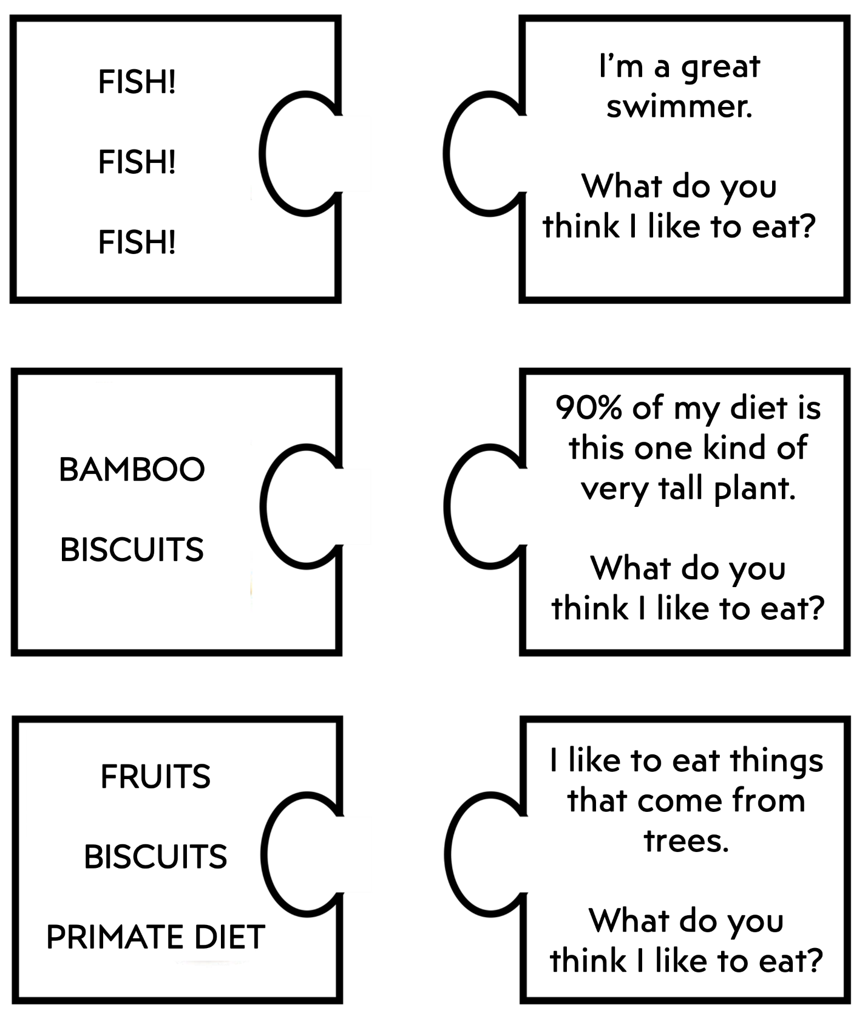

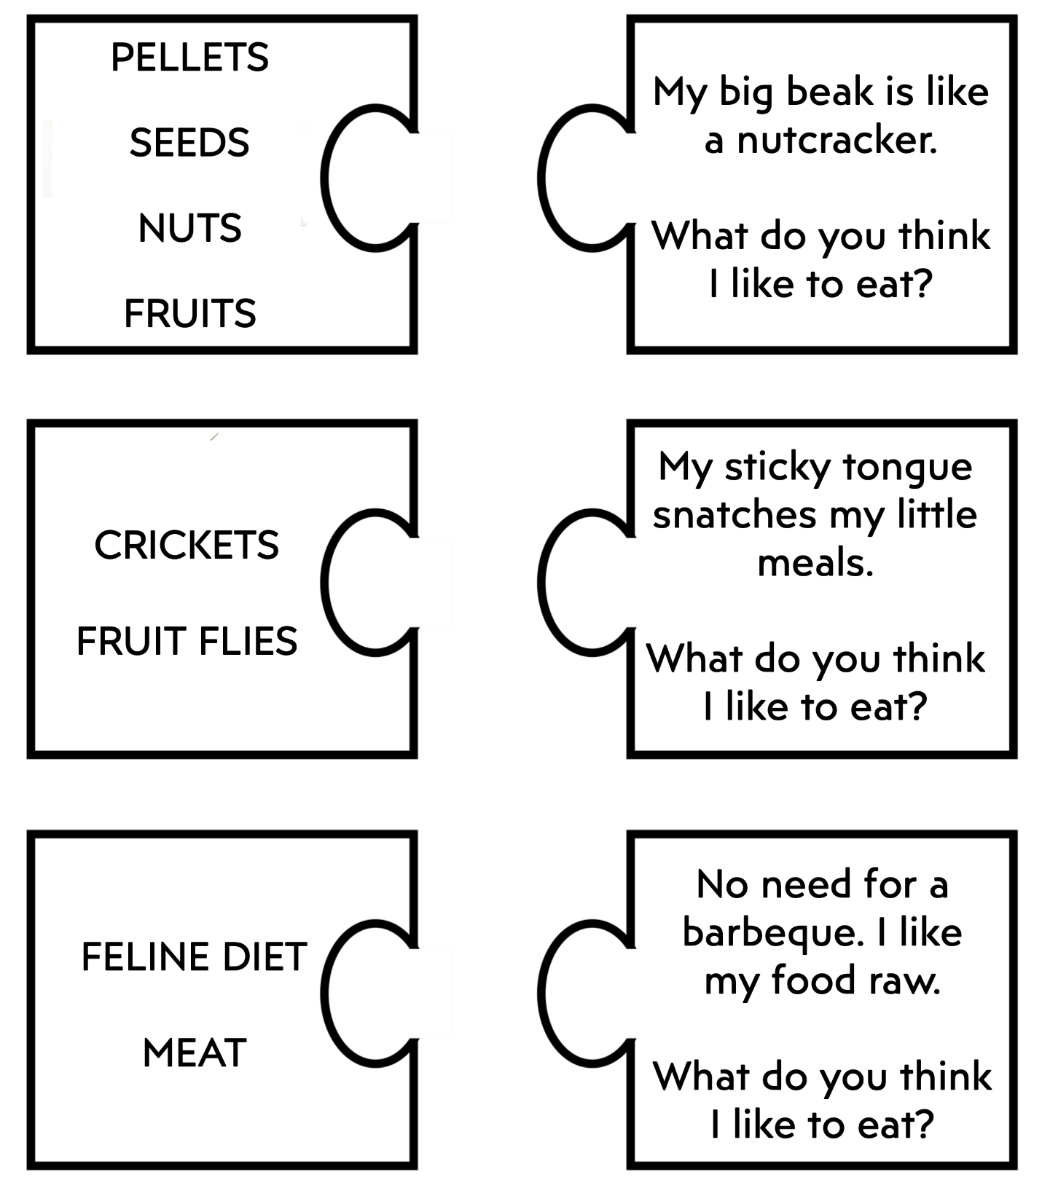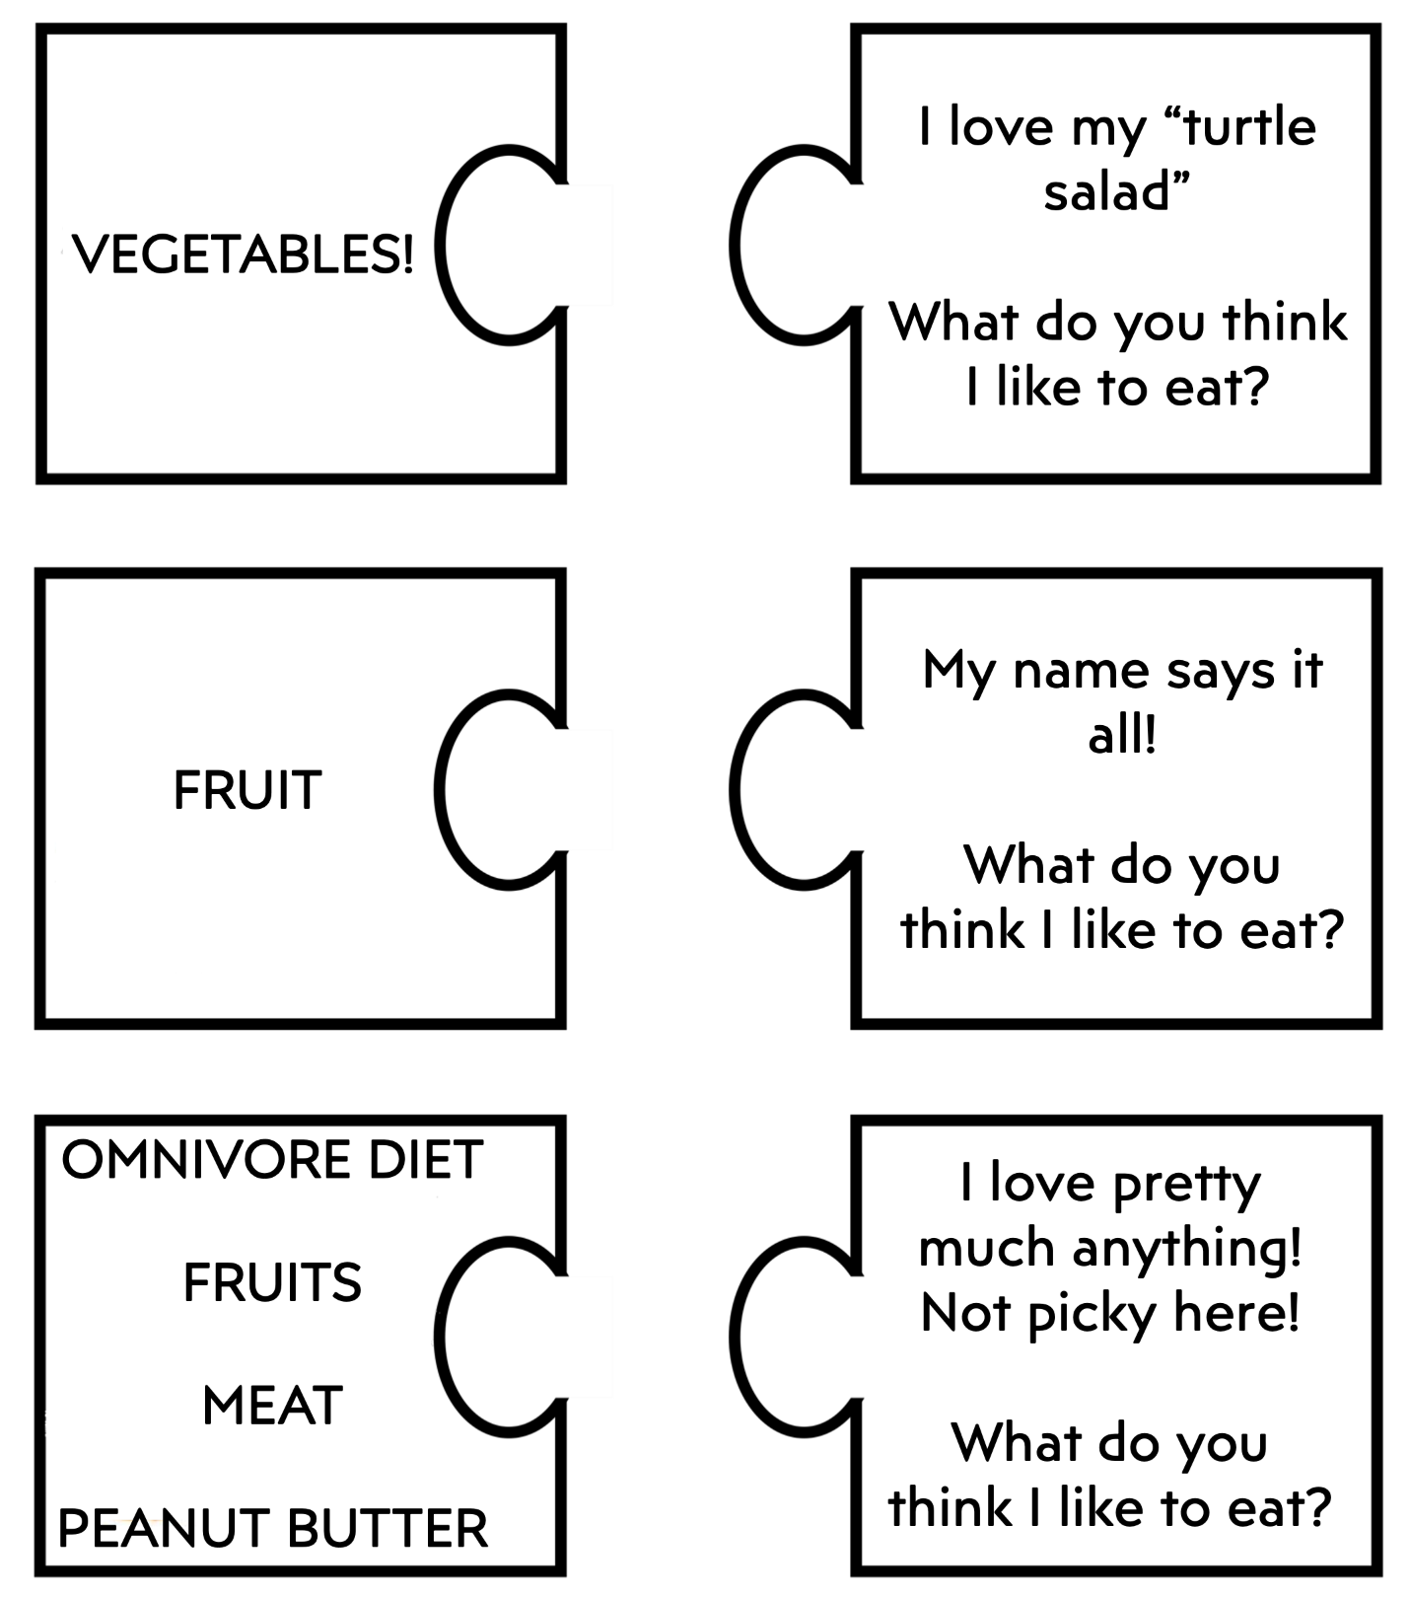

Name: __________________________________________________________

Teacher: ________________________________________________________

School: _________________________________________________________

Date: ___________________________________________________________

Every day, keepers have a list of tasks to complete to ensure the wellbeing of every animal. Read the tasks below and determine which order you think would be the best to complete these tasks and take care of the animal. Write a number 1 to 6 next to each task to put them in the order you think makes the most sense.

___ Training: The animals get trained to make sure they are used to being around people like veterinarians and guests.

___ Enrichment: The animals are provided extra activities in order to practice their natural behaviors, and also exercise their minds and bodies.

___ Cleaning: Each animal’s space should be cleaned to ensure the health of the animal and keepers.

___ Diet Prep: Each animal should have the appropriate type and proper amount of food prepared for them to eat for the day.

___ PM Check: Staff check on the animals in the afternoon to ensure they are safely in their habitats, are in good health, and ate all of their food.

___ Reporting Notes: Staff make notes about the animals to keep a record of everything that happened that day.

___ Feeding: Animals are fed the food that was prepared for them.

___ AM Check: Staff check on the animals in the morning to ensure they are safely in their habitats, are in good health, and ate all of their food.



Why do you think it would be best to complete the tasks in that particular order?

______________________________________________________________________________________________________________________________________________________________________________________________________________________________________________________________________________