**Animal Care**

**3-5 Onsite Activity** 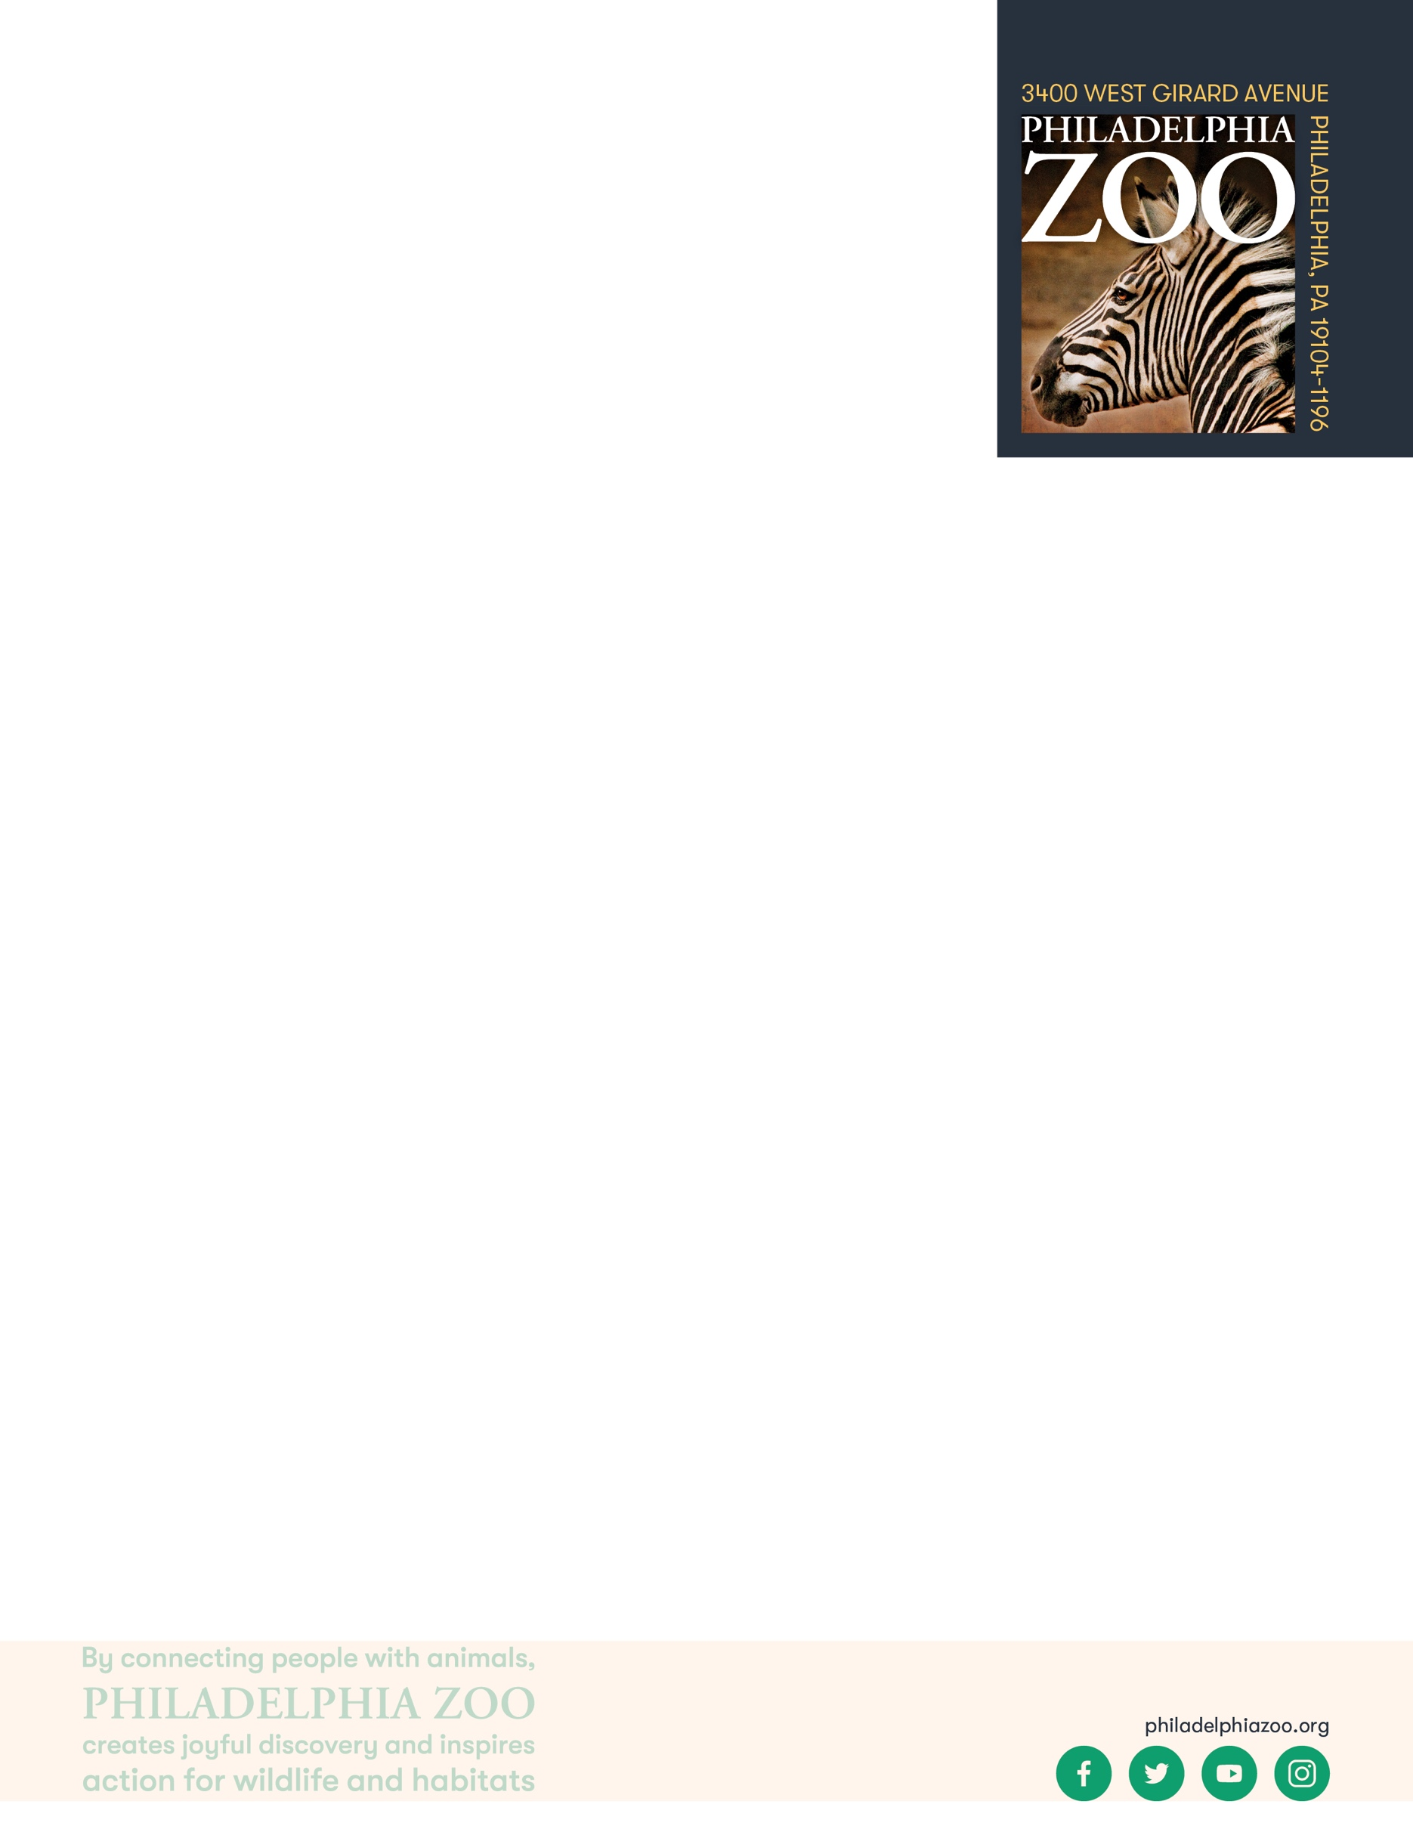

**Lesson Summary**

Students observe animal features and infer and determine unique considerations are accounted for in a Zoo setting.

**Objectives**

Students will be able to observe animal features and infer implications

**Essential Question**

What does an animal need to survive and how does a zoo provide that?

**Materials**

* Paper (or worksheet such as provided at the end of the lesson)
* Writing utensils

**Prep**

1. 1 Week before: Look at the [Zoo map](https://www.philadelphiazoo.org/zoo-map/) to determine locations for observations
2. 1 Day before: Print out worksheets as needed (1 for each student)
3. 15 minutes before: Prep students for expectations

**Key Terms**

* **Zookeeper:** The person/people responsible for the daily care animals that live at the zoo for conservation purposes
* **Veterinarian:** A doctor for animals.
* **Basic Needs:** All living things including animals need food, water, and shelter to survive and these are called their basic needs. Different animals have different types of specific needs.
* **Hygiene:** The practice of keeping clean, for example a habitat to ensure health and prevent sickness for one’s self or another being.
* **Diet:** The specific types and amounts of food and drink eaten and drunk by an animal.
* **Enrichment:** Practices or items that improve the quality care for animals, by encouraging natural behaviors and simultaneously exercising the bodies and minds of the animals.
* **Training:** The practice of teaching an animal a specific behavior or skills for enrichment and for the benefit or their care.
* **Choice:** The act of animals being able to decide if they want to participate in training or not.
* **Husbandry:** The care of animals including observing to monitor health, cleaning to ensure hygiene, preparing and providing diets, training for care and enrichment.

**Background**

Animal Care is a full team effort. Many people are involved in making sure every animal is taken care of in a safe and healthy environment, is given all of the necessary basic needs, and is provided enrichment as well. Although

many people think of zookeepers and veterinarians as the main animal caretakers at a Zoo, many different people and careers are important. This also includes nutritionists, curators, scientific researchers, maintenance, and many more!

Those that work in animal care are animal advocates and protectors, striving to give these animals the best life possible in the name of conservation. They work together and collaborate to make sure that their animals basic needs are met every day, but also their mental wellbeing. They take observations to make decisions on how to maintain safety for the animals, proper type and amount of food, hygiene, and enrichment.

**Implementation**

1. Excite: Welcome students to the Philadelphia Zoo and ask them to imagine themselves as a zookeeper for the day. What are some animals you would be excited to take care of if you were a zookeeper?
2. Explore: As you walk around the zoo, ask students to consider unique features the animal have, and how those are considered in the habitat and materials provided to the animals by the keepers.
3. Explain: Remind students that there are many factors considered when it comes to caring for animals. Animal exhibits are designed to make sure the animal has everything it needs, just as they would get from their natural habitat. This includes what the animal eats, how it gets water, how much space it needs, how to make sure the animal is secure, who that animal will live with, if anyone the type of shelter it will need, if the animal should live inside or outside, what temperature or humidity an animal needs, what natural behaviors are important to the animal etc.
4. Elaborate: Invite students to spend some extra time observing particularly features (either physical or behavioral) that they notice that different animals have. Then, ask students to observe and infer how those features are considered and cared for by the exhibit design and zookeeper support.
5. Evaluate: Ask students to share what additional things they may have learned about animal care through their deeper observations.

**Expansion**

If students previously designed an exhibit for the Zoo animals, invite them to compare and contrast their designs to the exhibits at the Zoo. Then, have create another habitat for the same animal that combines elements of both their original design and the actual habitat at the zoo. Have students consider and reflect on some of the following questions:

* 1. Were there things that may have been overlooked or forgotten when designing the original habitats?
  2. Are there elements from the designed habitat that Zoo’s habitat to improve it?
  3. Is the designed habitat you designed possible to build and meet all of the needs of the animal?

Additional Resources

[Ask a Keeper](https://www.youtube.com/watch?v=Y8dQHRZEco4)

Behind-the-scenes with a Veterinarian

[Behind-the-scenes with a Nutritionist](https://www.youtube.com/watch?v=TrS8V6a0L9Q)

**PA STEELS Curriculum Standards**

3.1.3.F, 3.1.3.G

Name: __________________________________________________________

Teacher: ________________________________________________________

School: _________________________________________________________

Date: ___________________________________________________________

Observe particular features (either physical or behavioral) of some animals at the Zoo. Describe what these features are. Then, observe and infer how those features are considered and cared for by the exhibit design and zookeeper support.

|  |  |
| --- | --- |
| **What unique features does this animal have?** | **How are these features considered in its care?** |
|  |  |
|  |  |
|  |  |
|  |  |
|  |  |

What steps do you think Zookeepers take in order to learn more about the needs of the animals in their care? ____________________________________________________________________________________________________________________________________________________________________________________

__________________________________________________________________________________________

__________________________________________________________________________________________

__________________________________________________________________________________________