**Animal Care**

**3-5 Post-Activity**

**Lesson Summary**

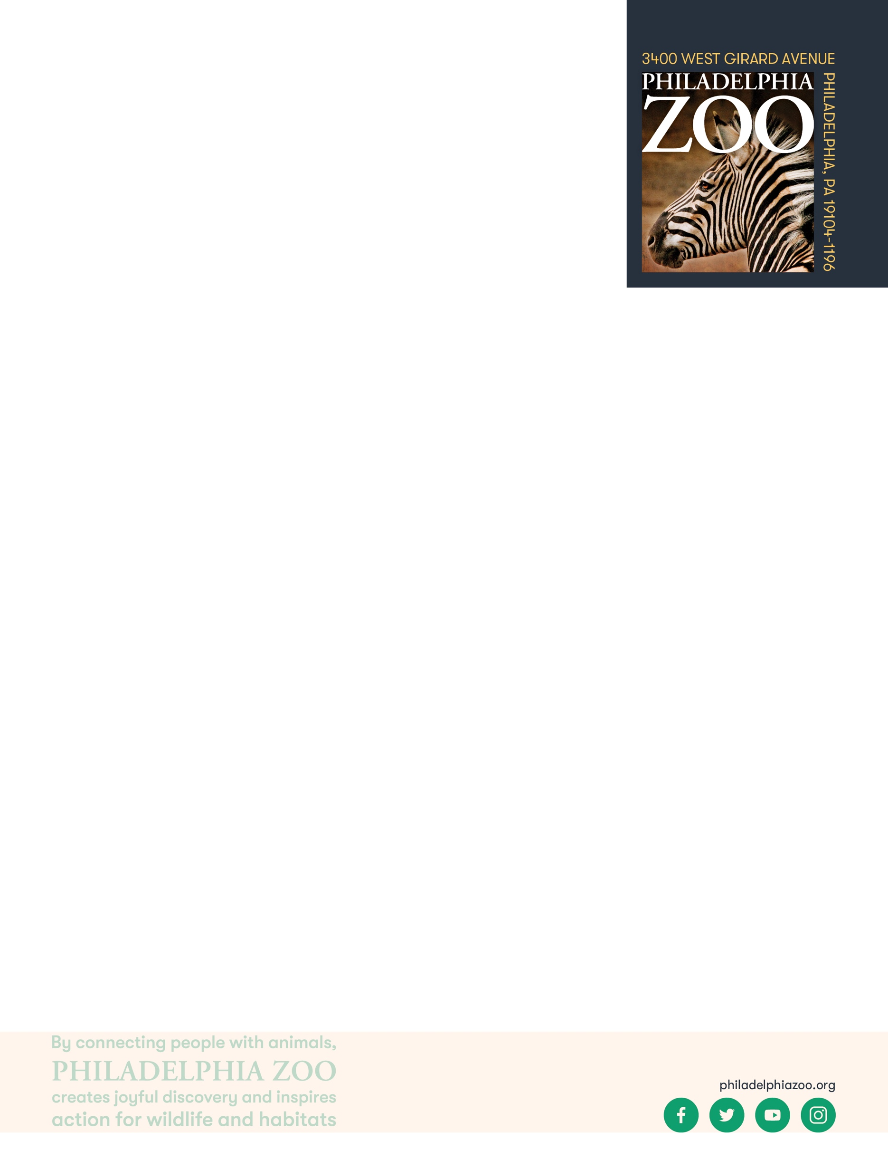Students use a reference sheet to determine and select a possible diet to feed a bear based on specific nutritional parameters.

**Objectives**

Students will be able to determine various solutions based on parameters

Students will be able to use calculate appropriate values

Students will be able to compare and contrast multiple possible solutions

**Essential Question**

What does an animal need to survive and how does a zoo provide that?

**Materials**

* Food pieces (optional, supplied at end of lesson)
* Scrap paper (or worksheet such as provided at the end of the lesson)
* Writing utensils

**Prep**

1. 1 day before: Print out food pieces (1 per set of students) and worksheets as needed (1 for each student)

**Key Terms**

* **Zookeeper:** The person/people responsible for the daily care animals that live at the zoo for conservation purposes
* **Veterinarian:** A doctor for animals.
* **Basic Needs:** All living things including animals need food, water, and shelter to survive and these are called their basic needs. Different animals have different types of specific needs.
* **Hygiene:** The practice of keeping clean, for example a habitat to ensure health and prevent sickness for one’s self or another being.
* **Diet:** The specific types and amounts of food and drink eaten and drunk by an animal.
* **Enrichment:** Practices or items that improve the quality care for animals, by encouraging natural behaviors and simultaneously exercising the bodies and minds of the animals.
* **Training:** The practice of teaching an animal a specific behavior or skills for enrichment and for the benefit or their care.
* **Choice:** The act of animals being able to decide if they want to participate in training or not.
* **Husbandry:** The care of animals including observing to monitor health, cleaning to ensure hygiene, preparing and providing diets, training for care and enrichment.

**Background**

Animal Care is a full team effort. Many people are involved in making sure every animal is taken care of in a safe and healthy environment, is given all of the necessary basic needs, and is provided enrichment as well. Although

many people think of zookeepers and veterinarians as the main animal caretakers at a Zoo, many different people and careers are important. This also includes nutritionists, curators, scientific researchers, maintenance, and many more!

For example, The Philadelphia Zoo has a nutritionist on staff that helps ensure that every single animal at the zoo is getting the proper diet, with all of the vitamins and nutrients needed to help keep them healthy.

Those that work in animal care are animal advocates and protectors, striving to give these animals the best life possible in the name of conservation. They work together and collaborate to make sure that their animals basic needs are met every day, but also their mental wellbeing. They take observations to make decisions on how to maintain safety for the animals, proper type and amount of food, hygiene, and enrichment.

**Implementation**

1. Excite: Ask students if they know what a bear, specifically a sloth bear, would like to eat. How would they find out? How would they know if the sloth bear enjoyed those foods or if they were healthy for the sloth bear? How would they know if they were correct?
2. Explore: Share with students that they will first collectively gather some information about sloth bears. Ask students to share what information they might already know about bears, or specifically sloth bears.
   1. More information: Sloth bears are a type of bear from Southeast Asia, found in India, Nepal, and Sri Lanka. They get their name due to their slight resemblance to sloths with long, curved claws and ability to climb trees - they are in fact bears though! Sloth bears are omnivores that eat both plants and meat, in particular invertebrates and different types of fruit. They have great adaptations to help them get these foods too. Their long snout helps them to sniff around and reach into insect mounds, and their lungs are so powerful they can dislodge termites 8-10 feet from under the ground.
3. Explain: Share with students that an important part of taking care of animals at the Zoo is research! Animal nutritionists, such as the one at the Philly Zoo, does a lot of research to create an appropriate diet for each animal and to ensure that they are getting all of the proper vitamins and nutrients they need to survive. After determining the proper diet of the animal, they work with staff in the commissary (where food is stored and processed) to ensure those foods are available, and keepers to ensure those foods are provided to the animals.

1. Elaborate: Share with students that they will be practicing the role of the zookeeper. They will be reading a recommendation provided by the nutritionist to determine what foods and what amounts they should feed the sloth bear in their care. The sloth bear is a male bear named Bhalu (born January 20, 2013).
2. Provide students with any materials that might be helpful for them to calculate (scrap paper, the provided food pieces to manipulate, the provided worksheet to keep track of solution). Ensure students have access to the reference information either by reading it, printing it, or displaying it on board for all to see.
   1. Sloth bears are omnivores that eat both plants and meat. However, there are particular types of fruits and meats that are healthiest for them. Based off of research, the nutritionist at the Philadelphia Zoo recommends that Bhalu should have 500 grams of fruit and veggies each day, but only blueberries, papaya, squash and tomatoes are appropriate for him to eat. He should also eat a total of 600 grams of meat each day, but only meat in the form of bear chow, as well as 45 grams of invertebrates each day, including ants and mealworms. Of the foods that are okay for him to eat, he should get as much of a variety as possible to get all of the nutrients he needs!
3. Once students have had time to determine potential meal options to provide to the sloth bear, have students compare and contrast their solutions. As you do this, students will likely discover that each student could have different numbers for each food item but that they are still the proper diets. Keepers try to keep the animals engaged and will try to switch up the food items they are given daily or the amount, to make it more interesting for the animals.
4. Evaluate: Ask the class to review some ways that animals are cared for at the zoo.

**Expansion**

Ask students to consider *how* they would provide this food to the animals. Explain to students that the diet described is an example the base diet for sloth bears. This diet has all of the nutrients and vitamins they need to survive, but does not share specifically how they should be fed to the animals. Keepers spend a lot of time measuring out the food items and then giving the animals these foods in different ways, including through enrichment or training. Ask students to brainstorm and then discuss some ways zookeepers might train or enrich a sloth bear at the zoo and how they might do it.



Work with students to research the diet of a sloth bear in the wild. Ask students to compare and contrast to see how the diet in the wild might be similar or different from their diet in the zoo. Then, discuss why that might be.

Additional Resources

[Ask a Keeper](https://www.youtube.com/watch?v=Y8dQHRZEco4)

Behind-the-scenes with a Veterinarian

[Behind-the-scenes with a Nutritionist](https://www.youtube.com/watch?v=TrS8V6a0L9Q)

**PA STEELS Curriculum Standards**

3.1.3.F, 3.1.3.G

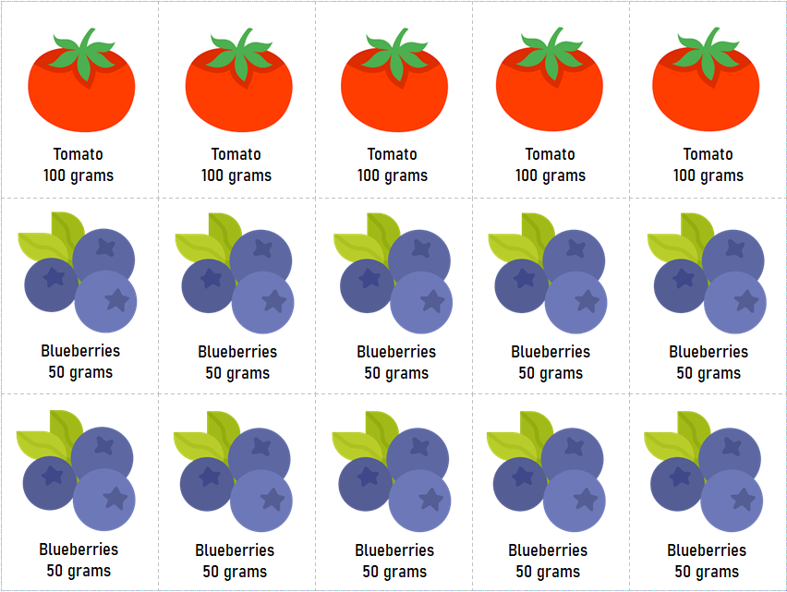

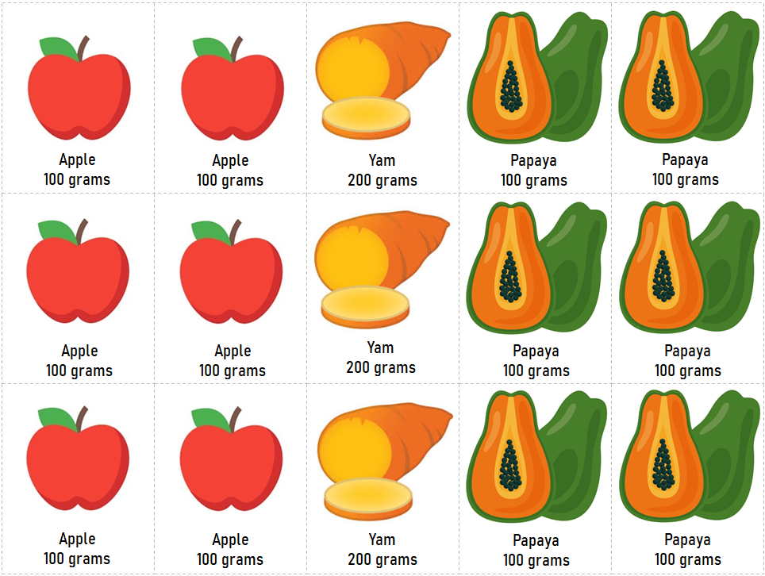

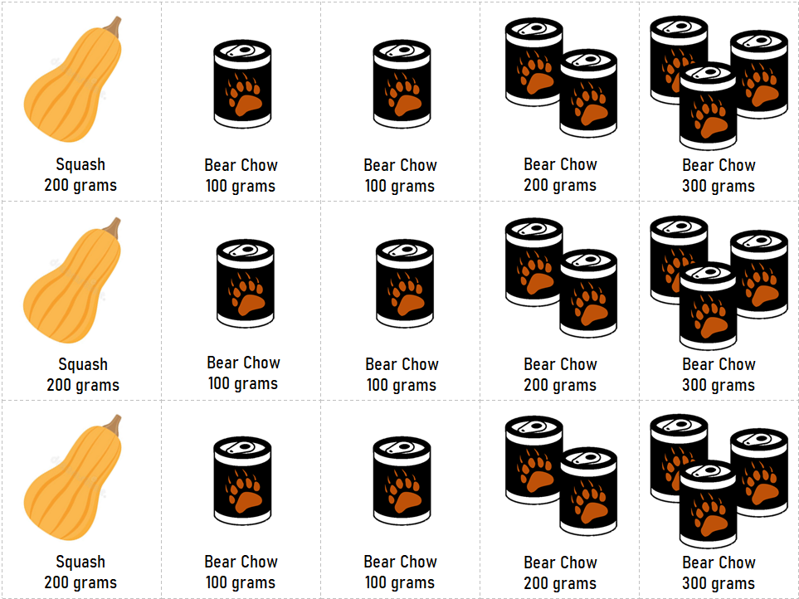

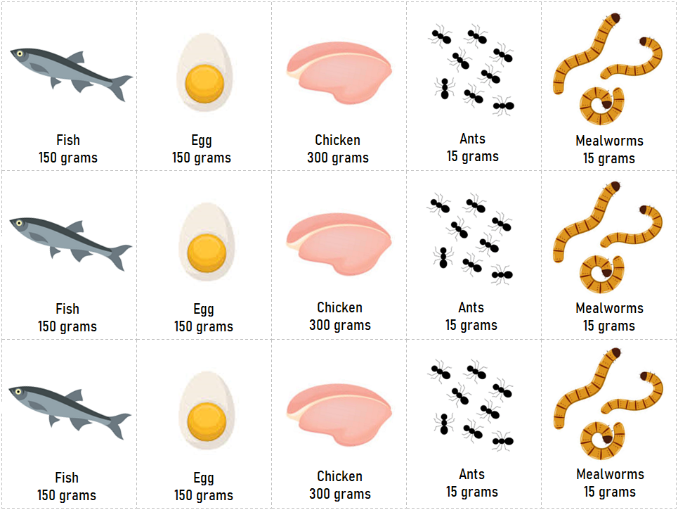

Name: __________________________________________________________

Date: ___________________________________________________________

Animal caretakers need to make sure that every animal they care for not only gets the right types of food, but also the right amounts. Sloth bears are omnivores that eat both plants and meat. However, there are particular types of plants and meats that are healthiest for them. Use the information in the passage below and math to calculate and decide how much of each food Bhalu could be given. Then, compare notes with a classmate.

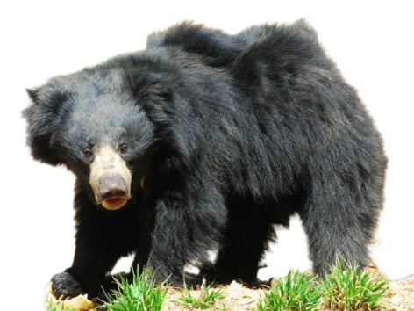

Based off of research, the nutritionist at the Philadelphia Zoo recommends a particular diet for Bahlu the sloth bear. They say that Bhalu should eat 500 grams of fruit and veggies each day, but only blueberries, papaya, squash and tomatoes are appropriate for him to eat. He should also eat a total of 600 grams of meat each day, but only meat in the form of bear chow, as well as 45 grams of invertebrates each day, including ants and mealworms. Of the foods that are okay for him to eat, he should get as much of a variety as possible to get all of the nutrients he needs!

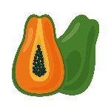

__________ grams of Yam

__________ grams of Tomato

__________ grams of Apple

__________ grams of Blueberries

__________ grams of Squash

__________ grams of Papaya

Fruits & Veggies

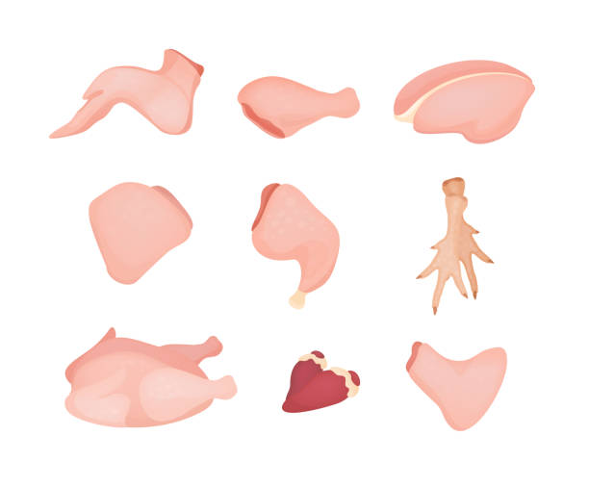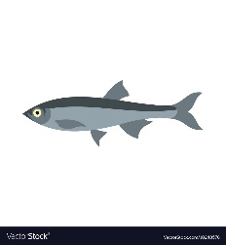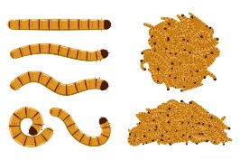

__________ grams of Fish

__________ grams of Chicken

__________ grams of Bear Chow

__________ grams of Ants

__________ grams of Egg

__________ grams of Mealworms

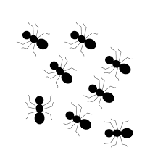

Meat