**Animal Care**

**6-8 Pre-Activity**

**Lesson Summary**

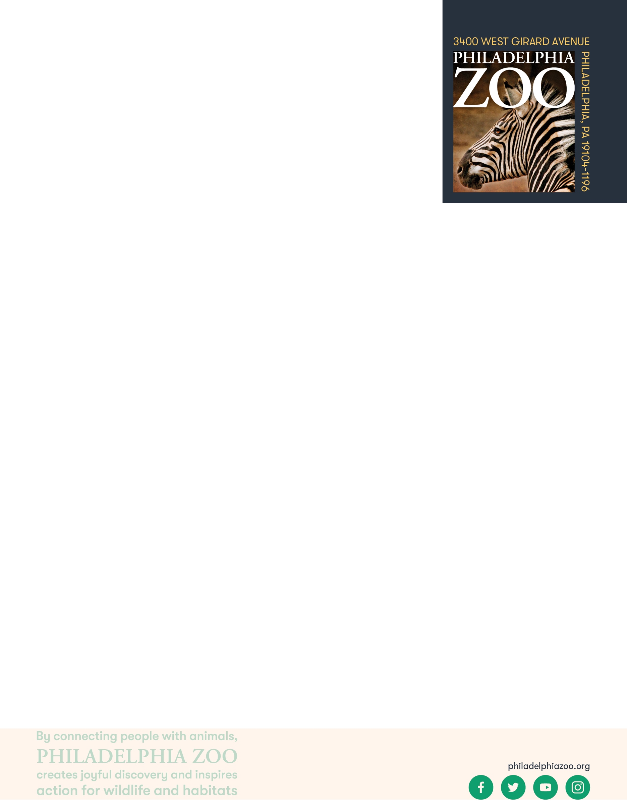Students will review animal information to consider challenges for taking care of animals in a zoo habitat.

**Objectives**

Students will be able to utilize their prior knowledge to create a design

Students will be able iterate their design with additional knowledge provided

Students will be able to consider important parameters as limitations to their design

**Essential Question**

What does an animal need to survive and how does a zoo provide that?

**Materials**

* Caribbean & Greater Flamingo Information Sheets (provided at the end of the lesson)
* Access to the [Philly Zoo website](https://www.philadelphiazoo.org/animals/) (or other research resources)
* Scrap paper or worksheet (such as provided at the end of the lesson)
* Writing utensils
* Coloring utensils

**Prep**

1 Hour before: Print out informational text (1 for each student) and worksheets as needed (1 for each student)

**Key Terms**

* **Zookeeper:** The person/people responsible for the daily care animals that live at the zoo for conservation purposes
* **Veterinarian:** A doctor for animals.
* **Basic Needs:** All living things including animals need food, water, and shelter to survive and these are called their basic needs. Different animals have different types of specific needs.
* **Hygiene:** The practice of keeping clean, for example a habitat to ensure health and prevent sickness for one’s self or another being.
* **Diet:** The specific types and amounts of food and drink eaten and drunk by an animal.
* **Enrichment:** Practices or items that improve the quality care for animals, by encouraging natural behaviors and simultaneously exercising the bodies and minds of the animals.
* **Training:** The practice of teaching an animal a specific behavior or skills for enrichment and for the benefit or their care.
* **Choice:** The act of animals being able to decide if they want to participate in training or not.
* **Husbandry:** The care of animals including observing to monitor health, cleaning to ensure hygiene, preparing and providing diets, training for care and enrichment.

**Background**

Animal Care is a full team effort. Many people are involved in making sure every animal is taken care of in a safe and healthy environment, is given all of the necessary basic needs, and is provided enrichment as well. Although

many people think of zookeepers and veterinarians as the main animal caretakers at a Zoo, many different people and careers are important. This also includes nutritionists, curators, scientific researchers, maintenance, and many more! For example, The Philadelphia Zoo has a nutritionist on staff that helps ensure that every single animal at the zoo is getting the proper diet, with all of the vitamins and nutrients needed to help keep them healthy.

Those that work in animal care are animal advocates and protectors, striving to give these animals the best life possible in the name of conservation. They work together and collaborate to make sure that their animals basic needs are met every day, but also their mental wellbeing. They take observations to make decisions on how to maintain safety for the animals, proper type and amount of food, hygiene, and enrichment.

**Implementation**

1. Excite: Ask students if they could fashion their house however they wanted, what would they want to include? How would these items add to their comfort, health, or happiness?
2. Explore: Provide writing and drawing materials to students and invite them to design a Zoo habitat for a Flamingo, either individually or in groups. Give students designated amount of time to provide drawings and explanations.
3. Bring the students together and ask them to share some important features students considered when designing these Zoo habitats. What features did they include and why? What information did they use about the penguin in consideration of what to include in the habitat?
4. Explain: When taking care of animals, although there is often a lot of information available, scientists learn new information is learned all the time. In fact, the Zoo is overseen by a larger organization called the Association of Zoos and Aquariums (AZA), that uses the most up to date scientific research to create regulations for animal care. It’s important for animal caretakers to keep this in mind in order to replicate the characteristics of the environment from where these animals adapted as best as possible.
5. Share with the students that they will now be reviewing some details specifically about Flamingos. As they review this information, invite the students to highlight, annotate, or take notes of the information. Provide the students the Flamingo Information Sheets and/or online resources to review.
6. In a class discussion, consider some of the physical and behavioral adaptations that flamingos have. For example, these animals might not be born pink as expected, but do rely on different food to be pink. What can be done to meet the needs of these animal at the Zoo? What would be some challenges of providing the right kind of habitat for animals like this? Are there alternative ways consider meeting these needs?
7. Elaborate: Ask students to return to their designed Zoo habitat for Greater or Caribbean Flamingos. Provide them a designated amount of time to make changes that might be better suited to these flamingos and their basic needs and habitat needs.
8. Invite students to review as a class some of the changes they might have made. How are their updated habitats similar or different to their original designs?
9. Evaluate: Ask the class to review some important skills animal care takers should utilize when creating inhabitable environments for animals in a Zoo setting.

Additional Resources

[Ask a Keeper](https://www.youtube.com/watch?v=Y8dQHRZEco4)

Behind-the-scenes with a Veterinarian

[Behind-the-scenes with a Nutritionist](https://www.youtube.com/watch?v=TrS8V6a0L9Q)

**Curriculum References**

3.1.6-8.U

Greater Flamingo

**What is their average weight?** The average weight is around 7lbs

**Where are they found in the wild?** Mudflats and shallow coastal lagoons in northern, sub-Saharan Africa, southern Asia, the Middle East and southern Europe.

**What do they eat?** In the Wild: small invertebrates, microalgae and plant seeds; In the Zoo formulated flamingo food which includes the carotenoids that give them their pink color. During the breeding season, they get a different formulated diet. They are fed 4 times a day and allotted a certain amount of food but given extra to account for wild animals eating some. They are typically fed inside their indoor space but can be seen filter feeding in their pond.

**What is their average life span?** In the wild: 30-40 years In zoos: 60+ years

**What is their social structure?** They are highly social and live in large groups, some groups have over 1,000 flamingos.

**What is their IUCN Conservation Status?**  **IUCN: Least Concern:** While they are considered Least Concern, they still face threats in the wild.  Greater Flamingo are very sensitive to disturbances by predators or people and may abandon their breeding colonies if they are threatened, which can cause reproductive failures and a declining population. They are also facing habitat loss as wetlands are being destroyed and lead poisoning.

With their pink and crimson plumage, long legs and necks, and strongly hooked bills, flamingos cannot be mistaken for any other type of bird. The flamingo’s pink or reddish color comes from the rich sources of carotenoid pigments (like the pigments of carrots) in the algae and small crustaceans the birds eat. We eat carotenoids, too, whenever we munch on carrots, beets, and certain other veggies, but not enough to turn us orange!

In order to fly, flamingos need to run a few paces to gather speed. This speed is not related to the ground but rather to the air, so they usually take off facing into the wind. In flight, flamingos are quite distinctive, with their long necks stretched out in front and the equally long legs trailing behind. Their outstretched wings showcase the pretty black and red (or pink) coloration that, with slight variations, is shared by all flamingo species.

Flamingos are social birds that live in groups of varying sizes, from a few pairs to sometimes thousands or tens of thousands.

Flamingos live in lagoons or large, shallow lakes. These bodies of water may be quite salty or caustic, too much so for most other animals. In some lakes, their only animal “neighbors” are algae, diatoms, and small crustaceans. That works in the flamingo’s favor, as the birds dine on these small creatures!

Flamingos lay one large, chalky white egg in a mud nest build like a sand castle by the parents. A parent sits on the mound, reaches over, picks up mud and dribbles it onto the nest, which can reach 2 feet (0.6 meters) in height and is usually surrounded by a trench as further protection from rising water. At hatching, a flamingo chick has gray down feathers and is the size of a tennis ball. It also has a straight, pink bill and swollen pink legs, both of which turn black within a week.

After hatching, the chick stays on the nest mound for 5 to 12 days. During this time, the chick is fed a type of “milk” called crop milk that comes from the parents’ upper digestive tract. Both males and females can feed the chick this way, and even flamingos that are not the parents can act as foster-feeders. The begging calls the hungry chick makes are believed to stimulate the secretion of the milk. As the parents feed their chicks the crop milk, they are drained of their color—so much so that their plumage turns a pale pink or white! The parents gain this color back eventually as the chicks become independent and eat on their own.

Chicks and their parents recognize one another through their distinctive calls! Adult flamingos have few natural predators, as they tend to live in inhospitable places where the lagoons are pretty bare of vegetation, so few other birds or animals come there. But flamingo chicks are sometimes preyed upon by eagle species.

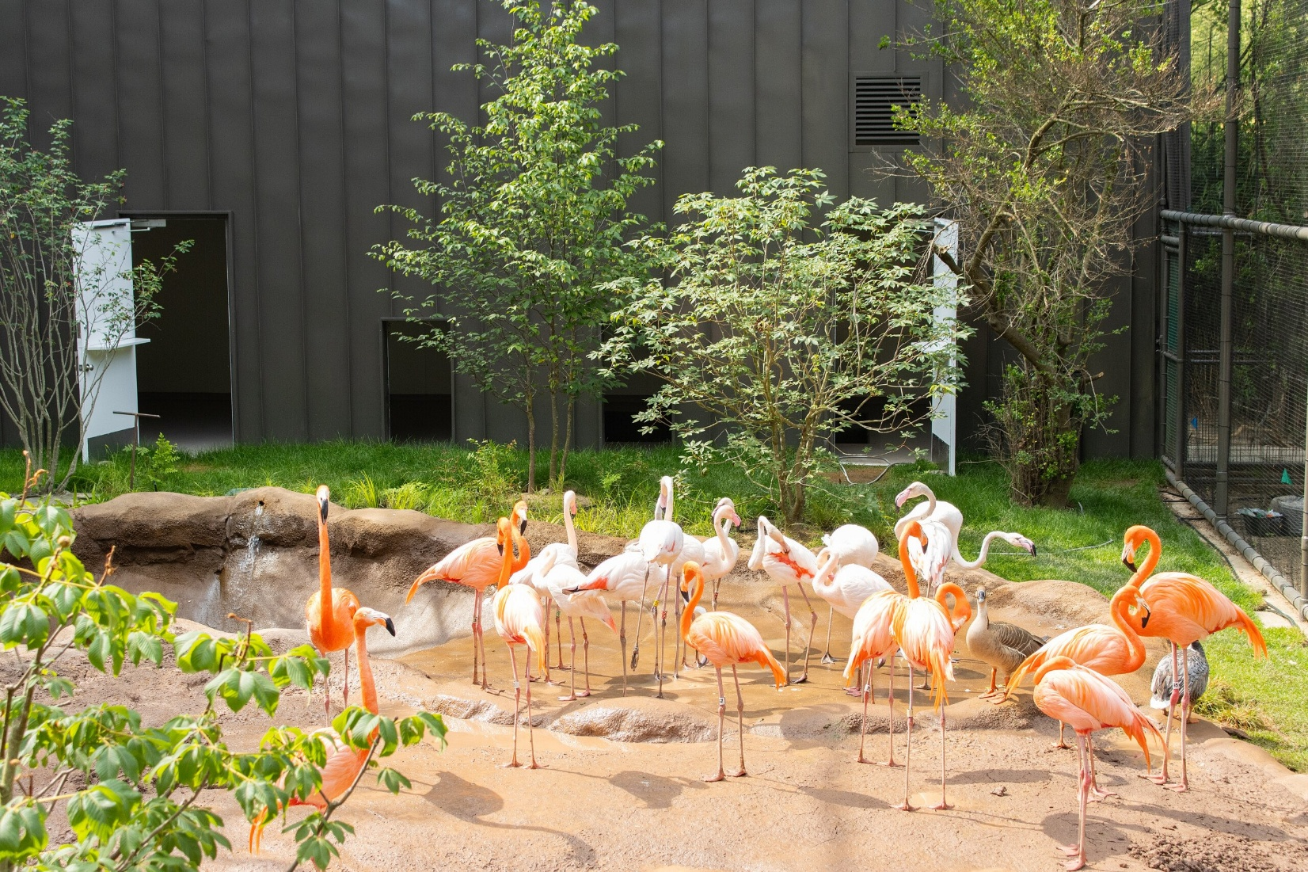

Name: __________________________________________________________

Date: ___________________________________________________________

Use your knowledge and understanding of Flamingos to create a habitat for them in the first box below.

Then, review information regarding flamingos. Create a new habitat design with the provided details considered.

Compare and contrast the updated habitat to the original.