**Animal Care**

**6-8 Onsite Activity** 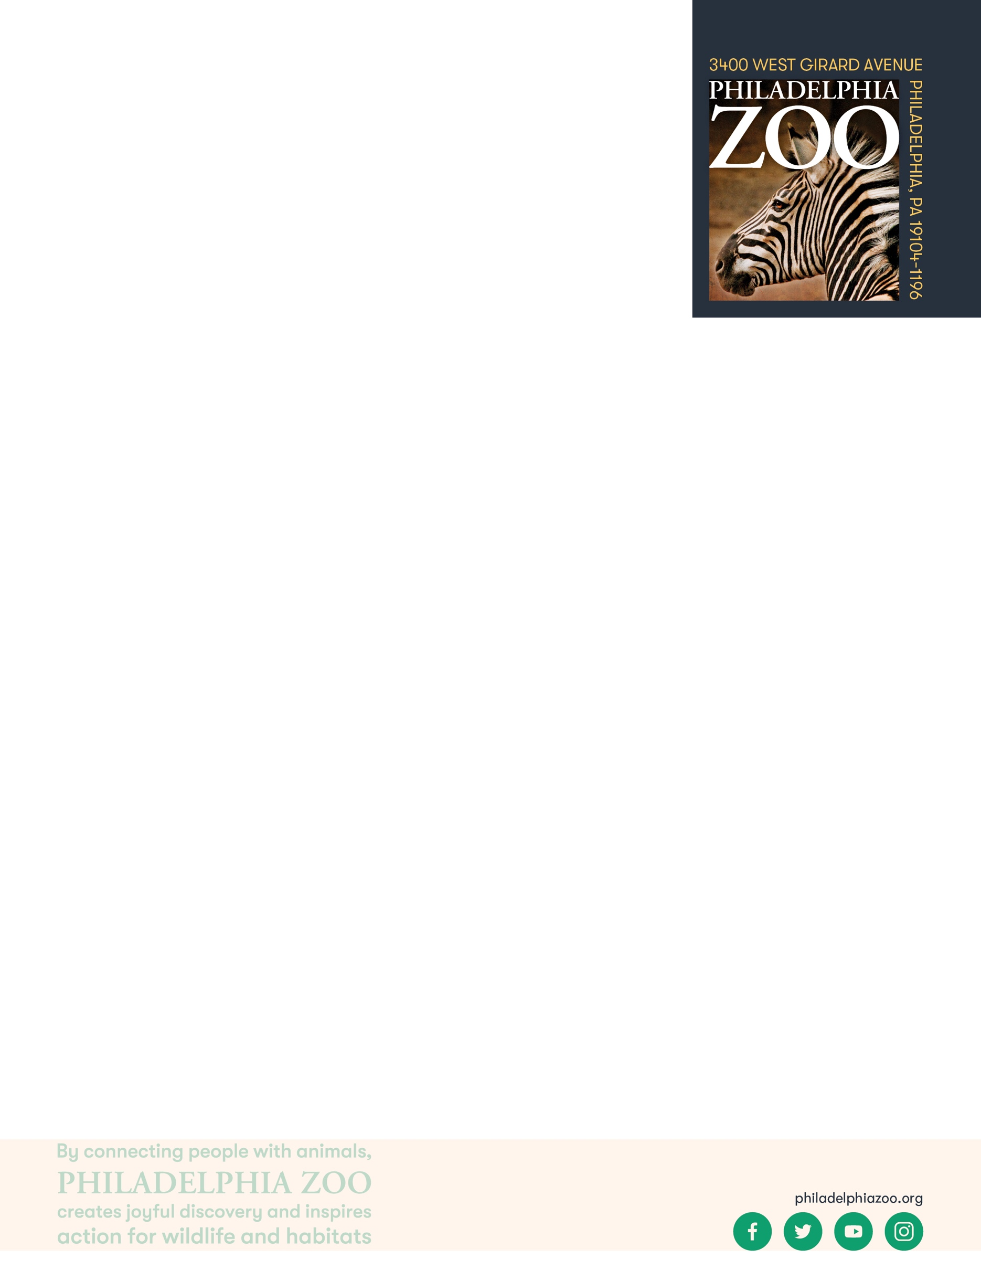

**Lesson Summary**

Students observe animal exhibit and determine reasoning behind choice made for animal care.

**Objectives**

Students will be able to observe exhibit features and infer implications

**Essential Question**

What does an animal need to survive and how does a zoo provide that?

**Materials**

* Paper (or worksheet such as provided at the end of the lesson)
* Writing utensils

**Prep**

1. 1 Week before: Look at the [Zoo map](https://www.philadelphiazoo.org/zoo-map/) to determine locations for observations
2. 1 Day before: Print out worksheets as needed (1 for each student)
3. 15 minutes before: Prep students for expectations

**Key Terms**

* **Zookeeper:** The person/people responsible for the daily care animals that live at the zoo for conservation purposes
* **Veterinarian:** A doctor for animals.
* **Basic Needs:** All living things including animals need food, water, and shelter to survive and these are called their basic needs. Different animals have different types of specific needs.
* **Hygiene:** The practice of keeping clean, for example a habitat to ensure health and prevent sickness for one’s self or another being.
* **Diet:** The specific types and amounts of food and drink eaten and drunk by an animal.
* **Enrichment:** Practices or items that improve the quality care for animals, by encouraging natural behaviors and simultaneously exercising the bodies and minds of the animals.
* **Training:** The practice of teaching an animal a specific behavior or skills for enrichment and for the benefit or their care.
* **Choice:** The act of animals being able to decide if they want to participate in training or not.
* **Husbandry:** The care of animals including observing to monitor health, cleaning to ensure hygiene, preparing and providing diets, training for care and enrichment.

**Background**

Animal Care is a full team effort. Many people are involved in making sure every animal is taken care of in a safe and healthy environment, is given all of the necessary basic needs, and is provided enrichment as well. Although

many people think of zookeepers and veterinarians as the main animal caretakers at a Zoo, many different people and careers are important. This also includes nutritionists, curators, scientific researchers, maintenance, and many more!

Those that work in animal care are animal advocates and protectors, striving to give these animals the best life possible in the name of conservation. They work together and collaborate to make sure that their animals basic needs are met every day, but also their mental wellbeing. They take observations to make decisions on how to maintain safety for the animals, proper type and amount of food, hygiene, and enrichment.

**Implementation**

1. Excite: Welcome students to the Philadelphia Zoo and challenge them to find the strangest item in the exhibits as they walk around.

Note: The items in the exhibit, although may sometimes lookout of place, are provided by the keepers and there with a purpose.

1. Explore: As you walk around the zoo, ask students to consider what the purposes of these items might be. Why would such items be in these places?
2. Explain: Remind students that there are many factors considered when it comes to caring for animals. Animal exhibits are designed to make sure the animal has everything it needs, just as they would get from their natural habitat. This includes the specific basic needs of the animal, but considers the natural behaviors of the species, as well as the preferences of the individual. Keepers also provide enrichment to the animals, which comes in the form of objects or activities, that encourages their natural behaviors and encourages the animals to exercise their bodies and minds.
3. Elaborate: Invite students to spend some extra time observing one exhibit or a series of exhibits, particularly looking at the items in the exhibit and how they are being used. This might include perching, lighting, random toys, puzzle feeders, feed poles, water, etc. Then, ask students to infer what the purpose of these features are and what they might provide to that specific animal.
4. Evaluate: Ask students to share what additional things they may have learned about animal care through their deeper observations.

Additional Resources

[Ask a Keeper](https://www.youtube.com/watch?v=Y8dQHRZEco4)

Behind-the-scenes with a Veterinarian

[Behind-the-scenes with a Nutritionist](https://www.youtube.com/watch?v=TrS8V6a0L9Q)

**PA STEELS Curriculum Standards**

3.1.6-8.U

Name: __________________________________________________________

Teacher: ________________________________________________________

School: _________________________________________________________

Date: ___________________________________________________________

As you walk around the Zoo, take notice of the things present in the animal exhibit. What are they? Why are they there? What could they be for? Record your observations and your inferences in the chart below.

|  |  |
| --- | --- |
| **What items or things are the animals using** | **Why might they be there and what are they for?** |
|  |  |
|  |  |
|  |  |
|  |  |
|  |  |

What important decisions should be made when a keeper choose what items to provide to the animals?

____________________________________________________________________________________________________________________________________________________________________________________

__________________________________________________________________________________________

__________________________________________________________________________________________

__________________________________________________________________________________________