**Animal Care**

**9-12 Pre-Activity**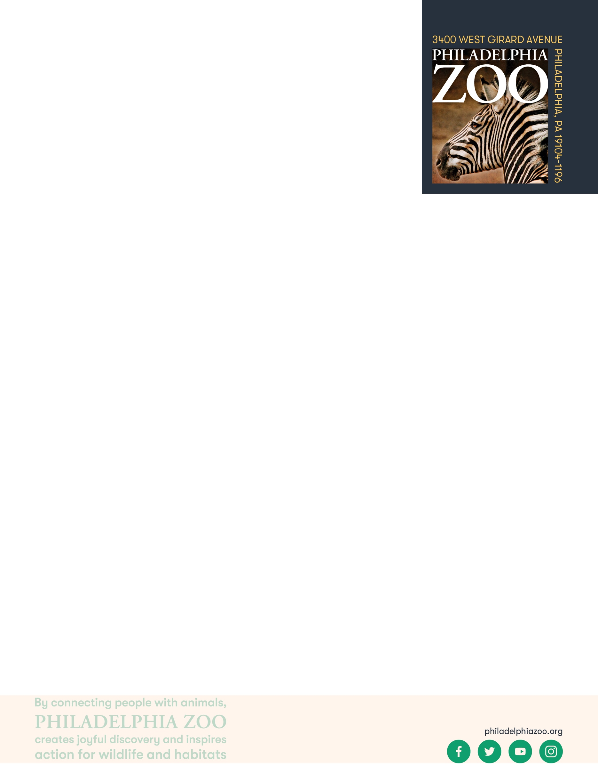

**Lesson Summary**

Students examine celery absorbing colored water and compare and contrast to absorption processes of animals, as an example of dynamic animal care.

**Essential Question**

What does an animal need to survive and how does a zoo provide that?

**Objectives**

Students will be able to observe and record changes

Students will be able to compare and contrast observation to learned information

Students will be able to consider how information can be applied and inform animal care practices

**Materials**

* Scrap paper (or worksheet such as provided at the end of lesson)
* Flamingo Photos (provided at the end of the lesson)
* Access to the [Philly Zoo website](https://www.philadelphiazoo.org/animals/) (or other research resources)
* Cup
* Water
* Celery stalks
* Food coloring
* Writing utensils
* Coloring utensils

**Prep**

1. 1 Week before: Gather or purchase materials. Ensure enough is present to provide as many kits as there might be groups.
2. 1 Hour before: Prepare informational text, print out Flamingo photos as needed, and print out worksheets as needed (1 for each student).

**Key Terms**

* **Zookeeper:** The person/people responsible for the daily care animals that live at the zoo for conservation purposes
* **Veterinarian:** A doctor for animals.
* **Habitat**: the natural environment of an animal or plant, where that living thing can find their food, water, shelter, and space
* **Basic Needs:** All living things including animals need food, water, and shelter to survive and these are called their basic needs. Different animals have different types of specific needs.
* **Diet:** The specific types and amounts of food and drink eaten and drunk by an animal.
* **Enrichment:** Practices or items that improve the quality care for animals, by encouraging natural behaviors and simultaneously exercising the bodies and minds of the animals.

**Background**

Animal Care is a full team effort. Many people are involved in making sure every animal is taken care of in a safe and healthy environment, is given all of the necessary basic needs, and is provided enrichment as well. Although many people think of zookeepers and veterinarians as the main animal caretakers at a Zoo, many different people and careers are important. This also includes nutritionists, curators, scientific researchers, maintenance, and many more!

Those that work in animal care are animal advocates and protectors, striving to give these animals the best life possible in the name of conservation. They work together and collaborate to make sure that their animals basic needs are met every day, but also their mental wellbeing. They take observations to make decisions on how to maintain safety for the animals, proper type and amount of food, hygiene, and enrichment.

**Implementation**

1. Excite: Invite students to share some of their favorite foods to eat. Ask students to consider what these different foods provide for them. Answers might include energy, vitamins, nutrients, hydration, etc.
2. Share with students that they will be exploring these processes by doing an experiment to observe changes over time in a piece of celery.
3. Invite students (either in groups, pairs or individually depending on how many materials you have) to fill a cup halfway with water and add a small amount of food coloring of their choice. Place a stalk or two of celery into the cup of colored water.
4. Invite students to make initial observations of the celery including a drawing and description.
5. Then, allow the celery some time to sit (i.e. wait until the end of class or until the next class period for observations). Invite students to make periodic observations and recordings of what changes they notice. Expected results may look like this, with the food coloring being absorbed by the celery:

|  |  |  |
| --- | --- | --- |
|  |  |  |
| 0 hours | 12 hours | 24 hours |

1. Explore: After the students have observed the celery overtime, invite them to a full class discussion. Ask the students to consider what was demonstrated in this experiment. Welcome any answers that students provide.
2. Share with the students the series of photos of a Caribbean Flamingo, Rowan, from the Philadelphia. The photos depict Rowan’s first year and his development since hatching on July 2, 2021. First ask the students to share what they are observing happening to the flamingo.
3. Then, ask the students to compare and contrast their experiment to the photos they are seeing. What is happening? How are is the experiment similar to what is happening to the Flamingo? Why might that be?
4. Explain: Share with students the following information regarding flamingos and the history of their care in institutions like Zoos (either by reading it aloud, printing out this information and distributing it, or presenting it on a board).
   1. Flamingos are known for their beautiful pink coloration. When flamingos first hatch, they are born with white feathers, which are replaced with pink feathers usually by the first year.

However, many flamingos in captivity at institutions like Zoos often faded back to a nearly white plumage. In the 1940’s, the Philadelphia Zoo developed a new diet for the flamingos that included ground carrots for the first time. Overtime, a change in feather color and skin pigmentation occurred. It was realized that flamingos get their gorgeous pink plumage the coloring from these foods gets absorbed into their skin and feathers! Specifically, from the carotenoids (yellow, orange, and red organic pigments that are produced by plants and algae) in their diet. By the mid-1950’s, the Philadelphia Zoo’s flamingo diet breakthrough was shared with zoos around the world, which continues to inform important additions to flamingo diet.

Philadelphia Zoo, being the first Zoo in America, has always been a leader in animal care. They have had to be innovative in the way they learned and cared for their animals, and thoughtful in sharing this information wildly to care for animals globally.

1. Elaborate: As a group, ask the students to consider how their experiment might relate to animal care. Welcome any ideas that the students share, which likely revolve around the demonstration of products (such as coloration, vitamins, minerals, or even toxins) being absorbed through digestion.
2. Evaluate: Ask students to consider why the natural history of a species, such as that their coloration is due to absorption of carotenoids, would be important information for the Zoo to learn? How would this information inform animal care practices?



Additional Resources

[Ask a Keeper](https://www.youtube.com/watch?v=Y8dQHRZEco4)

Behind-the-scenes with a Veterinarian

[Behind-the-scenes with a Nutritionist](https://www.youtube.com/watch?v=TrS8V6a0L9Q)

**PA STEELS Curriculum Standards**

3.4.9-12.H

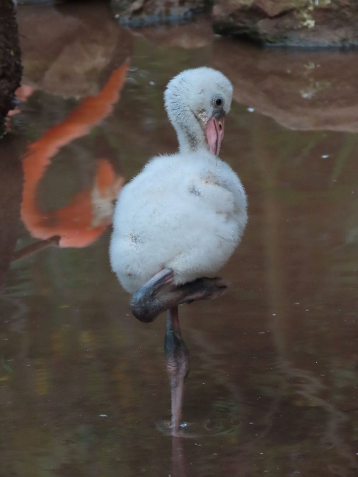

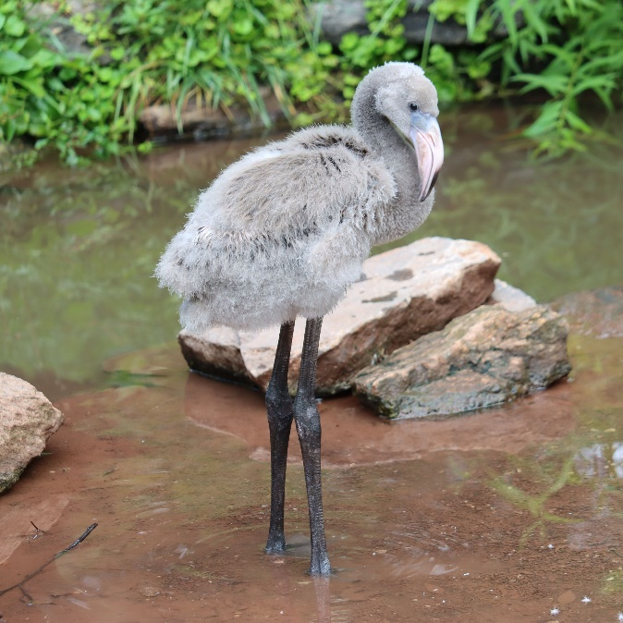

Rowan the Caribbean Flamingo’s first year. Hatched at Philadelphia Zoo on July 1, 2021

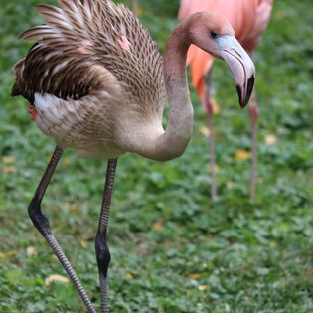

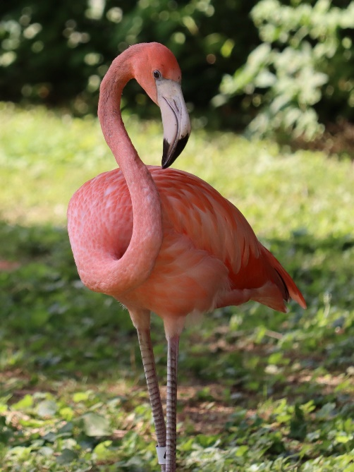

Name: __________________________________________________________

Date: ___________________________________________________________

Place a few stalks of celery into a glass of water with some food coloring. Check on the celery occasionally overtime and record your observations below.

What do the celery stalks represent?

What does the food coloring represent?

|  |  |  |
| --- | --- | --- |
| Observation 1 | Observation 2 | Observation 3 |
| Time elapsed: | Time elapsed: | Time elapsed: |
|  |  |  |
| Description: | **Description:** | **Description:** |

What is happening to the celery overtime? _________________________________________________________

__________________________________________________________________________________________

How is this similar to what you observed happening to the flamingo? _____________________________________

__________________________________________________________________________________________

__________________________________________________________________________________________

How would this information help to inform animal care practices? _______________________________________

__________________________________________________________________________________________

__________________________________________________________________________________________