**Animal Care**

**9-12 Post-Activity**

**Lesson Summary**

Students use a reference sheet of various individual animals at different Zoo, compare their information, and consider which might make good mating pairs.

**Objectives**

Students will be able to

**Essential Question**

What does an animal need to survive and how does a zoo provide that?

**Materials**

* Gibbon SSP Information (provided at the end of the lesson)
* Access to additional resources [AZA Website](https://www.aza.org/species-survival-plan-program/)
* Scrap paper (or worksheet such as provided at the end of the lesson)
* Writing utensils

**Prep**

1. 1 day before: Print out SSP Information (1 per set of students) and worksheets as needed (1 for each student)

**Key Terms**

* **Zookeeper:** The person/people responsible for the daily care animals that live at the zoo for conservation purposes
* **Veterinarian:** A doctor for animals.
* **Basic Needs:** All living things including animals need food, water, and shelter to survive and these are called their basic needs. Different animals have different types of specific needs.
* **Hygiene:** The practice of keeping clean, for example a habitat to ensure health and prevent sickness for one’s self or another being.
* **Diet:** The specific types and amounts of food and drink eaten and drunk by an animal.
* **Enrichment:** Practices or items that improve the quality care for animals, by encouraging natural behaviors and simultaneously exercising the bodies and minds of the animals.
* **Training:** The practice of teaching an animal a specific behavior or skills for enrichment and for the benefit or their care.
* **Choice:** The act of animals being able to decide if they want to participate in training or not.
* **Husbandry:** The care of animals including observing to monitor health, cleaning to ensure hygiene, preparing and providing diets, training for care and enrichment.

**Background**

Animal Care is a full team effort. Many people are involved in making sure every animal is taken care of in a safe and healthy environment, is given all of the necessary basic needs, and is provided enrichment as well. Although

many people think of zookeepers and veterinarians as the main animal caretakers at a Zoo, many different people and careers are important. This also includes nutritionists, curators, scientific researchers, maintenance, and many more!

For example, The Philadelphia Zoo has a nutritionist on staff that helps ensure that every single animal at the zoo is getting the proper diet, with all of the vitamins and nutrients needed to help keep them healthy.

Those that work in animal care are animal advocates and protectors, striving to give these animals the best life possible in the name of conservation. They work together and collaborate to make sure that their animals basic needs are met every day, but also their mental wellbeing. They take observations to make decisions on how to maintain safety for the animals, proper type and amount of food, hygiene, and enrichment.

**Implementation**

1. Excite: Ask students to share what important factors people may consider when choosing a partner. Some people might consider looks, personality, medical history, stability, etc.
2. Invite students to consider if those same factors would be as important for animals in choosing a partner. For animals, although personality and physical features can definitely play a role in selection, animals are primarily focused on survival and passing on genes that would allow their offspring the greatest chances of survival.
3. Explore: Finally, ask students to share some ideas on how this would be mimicked or made possible in a Zoo setting. Any creative responses students have would be interested to document or record.
4. Explain: In addition to providing an animal a safe habitat that provides them the appropriate food, water, shelter, and space, Zoos also are focused on growing the population in ethical ways. Species that need specific support in growing their populations are a part of what’s called the Species Survival Plan (SSP).
   1. The SSP is a program for selected species in zoos and aquariums that manages the breeding of a species in order to maintain a healthy and self-sustaining population that is both genetically diverse and demographically stable. The SSP includes a database of all individuals of a specific species and important information that can help inform which animals would be appropriate matches to one another.
5. Ask students to consider what data could or should be included in the SSP database that could ensure an ethical and successful program in growing of a population of a species. Answers may include family history (such as ensuring that the pair do not share genetics), the number of previous offspring (the less that they have previously reproduced, the more likely the pair will increase genetic diversity to the population), age, location, etc.
6. Elaborate: Share with the students that they will be exploring an example of a subset of animals from an SSP database for individual White-handed Gibbons. The Philadelphia Zoo has had great success in breeding White-handed Gibbons, and recently had a birth of a female name Ophelia on May 27, 2021. Although White-handed gibbons don’t typically get old enough to breed until they are 6 to 9, considerations for potential pairings could begin early for future planning.
7. Provide each group of students with the SSP information sheet. Invite students to review the information regarding a number of White-handed gibbons individuals, and discuss which male individual(s) might be a good future match for Ophelia. Encourage students to be prepared to shar their reasoning.
8. After students have had time to review and select their pairing, invite the class back together to discuss. Allow students to share the different selection they made for Ophelia, and their reasoning behind selecting that individual.
9. Evaluate: Ask students to consider and share why breeding programs would be important in a Zoo setting and for the species as a whole.

Extension

Ask students to consider additional complications that may arise upon pairing two individual animals, and what solutions might be made. For example, there have been many instances in which two animals are paired up, and either don’t like each other or never successfully mate. What else might Zoos be able to do to support conservation of a species?

Additional Resources

[Ask a Keeper](https://www.youtube.com/watch?v=Y8dQHRZEco4)

Behind-the-scenes with a Veterinarian

[Behind-the-scenes with a Nutritionist](https://www.youtube.com/watch?v=TrS8V6a0L9Q)

**PA STEELS Curriculum Standards**

3.1.9-12.P, 3.1.9-12.Q,3.1.9-12.R

White-handed Gibbons (*Hylobates lar*) SSP Information Sheet

|  |  |  |  |  |
| --- | --- | --- | --- | --- |
|  | Birth Year | Current Location | Parent IDs  (abbreviated) | # Offspring |
| Ophelia | 2021 | Philadelphia, PA | Sire: 21  Dam: 44 | 0 |
| Tembeling  (#967) | 1996 | Moorpark, CA | Sire: 35  Dam: 49 | 0 |
| Bapu  (#1459) | 2002 | Singapore | Sire: unk  Dam: unk | 2 |
| Gibbi  (#1229) | 2007 | Bulgaria | Sire: 20  Dam: 22 | 0 |
| Leo  (#1036) | 2011 | Columbus, OH | Sire: 21  Dam: 44 | 2 |
| Cusa  (#1075) | 2020 | Santa Fe, CA | Sire: 01  Dam: 02 | 0 |

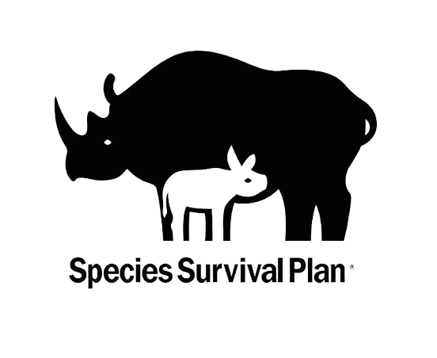

Name: __________________________________________________________

Date: ___________________________________________________________

The Philadelphia Zoo has had great success in breeding White-handed Gibbons, and recently had a birth of a female name Ophelia on May 27, 2021. Although White-handed gibbons don’t typically get old enough to breed until they are 6 to 9, considerations for potential pairings could begin early for future planning.

Review the SSP information sheet, list of the pros and cons of the individual, potential matches for Ophelia, and select who you think would be the best pairing. Provide your reasoning.

|  |  |  |
| --- | --- | --- |
| **Individual** | **Pros** | **Cons** |
| House Name:  Birthdate:  Location:  Sire: Dam:  Number of existing offspring: |  |  |
| House Name:  Birthdate:  Location:  Sire: Dam:  Number of existing offspring: |  |  |
| House Name:  Birthdate:  Location:  Sire: Dam:  Number of existing offspring: |  |  |
| House Name:  Birthdate:  Location:  Sire: Dam:  Number of existing offspring: |  |  |
| House Name:  Birthdate:  Location:  Sire: Dam:  Number of existing offspring: |  |  |

Which male do you think could be the best potential match for Ophelia? __________________________________

Why? _____________________________________________________________________________________

__________________________________________________________________________________________