**Characteristics of Life**

**K-2 Pre-Activity**

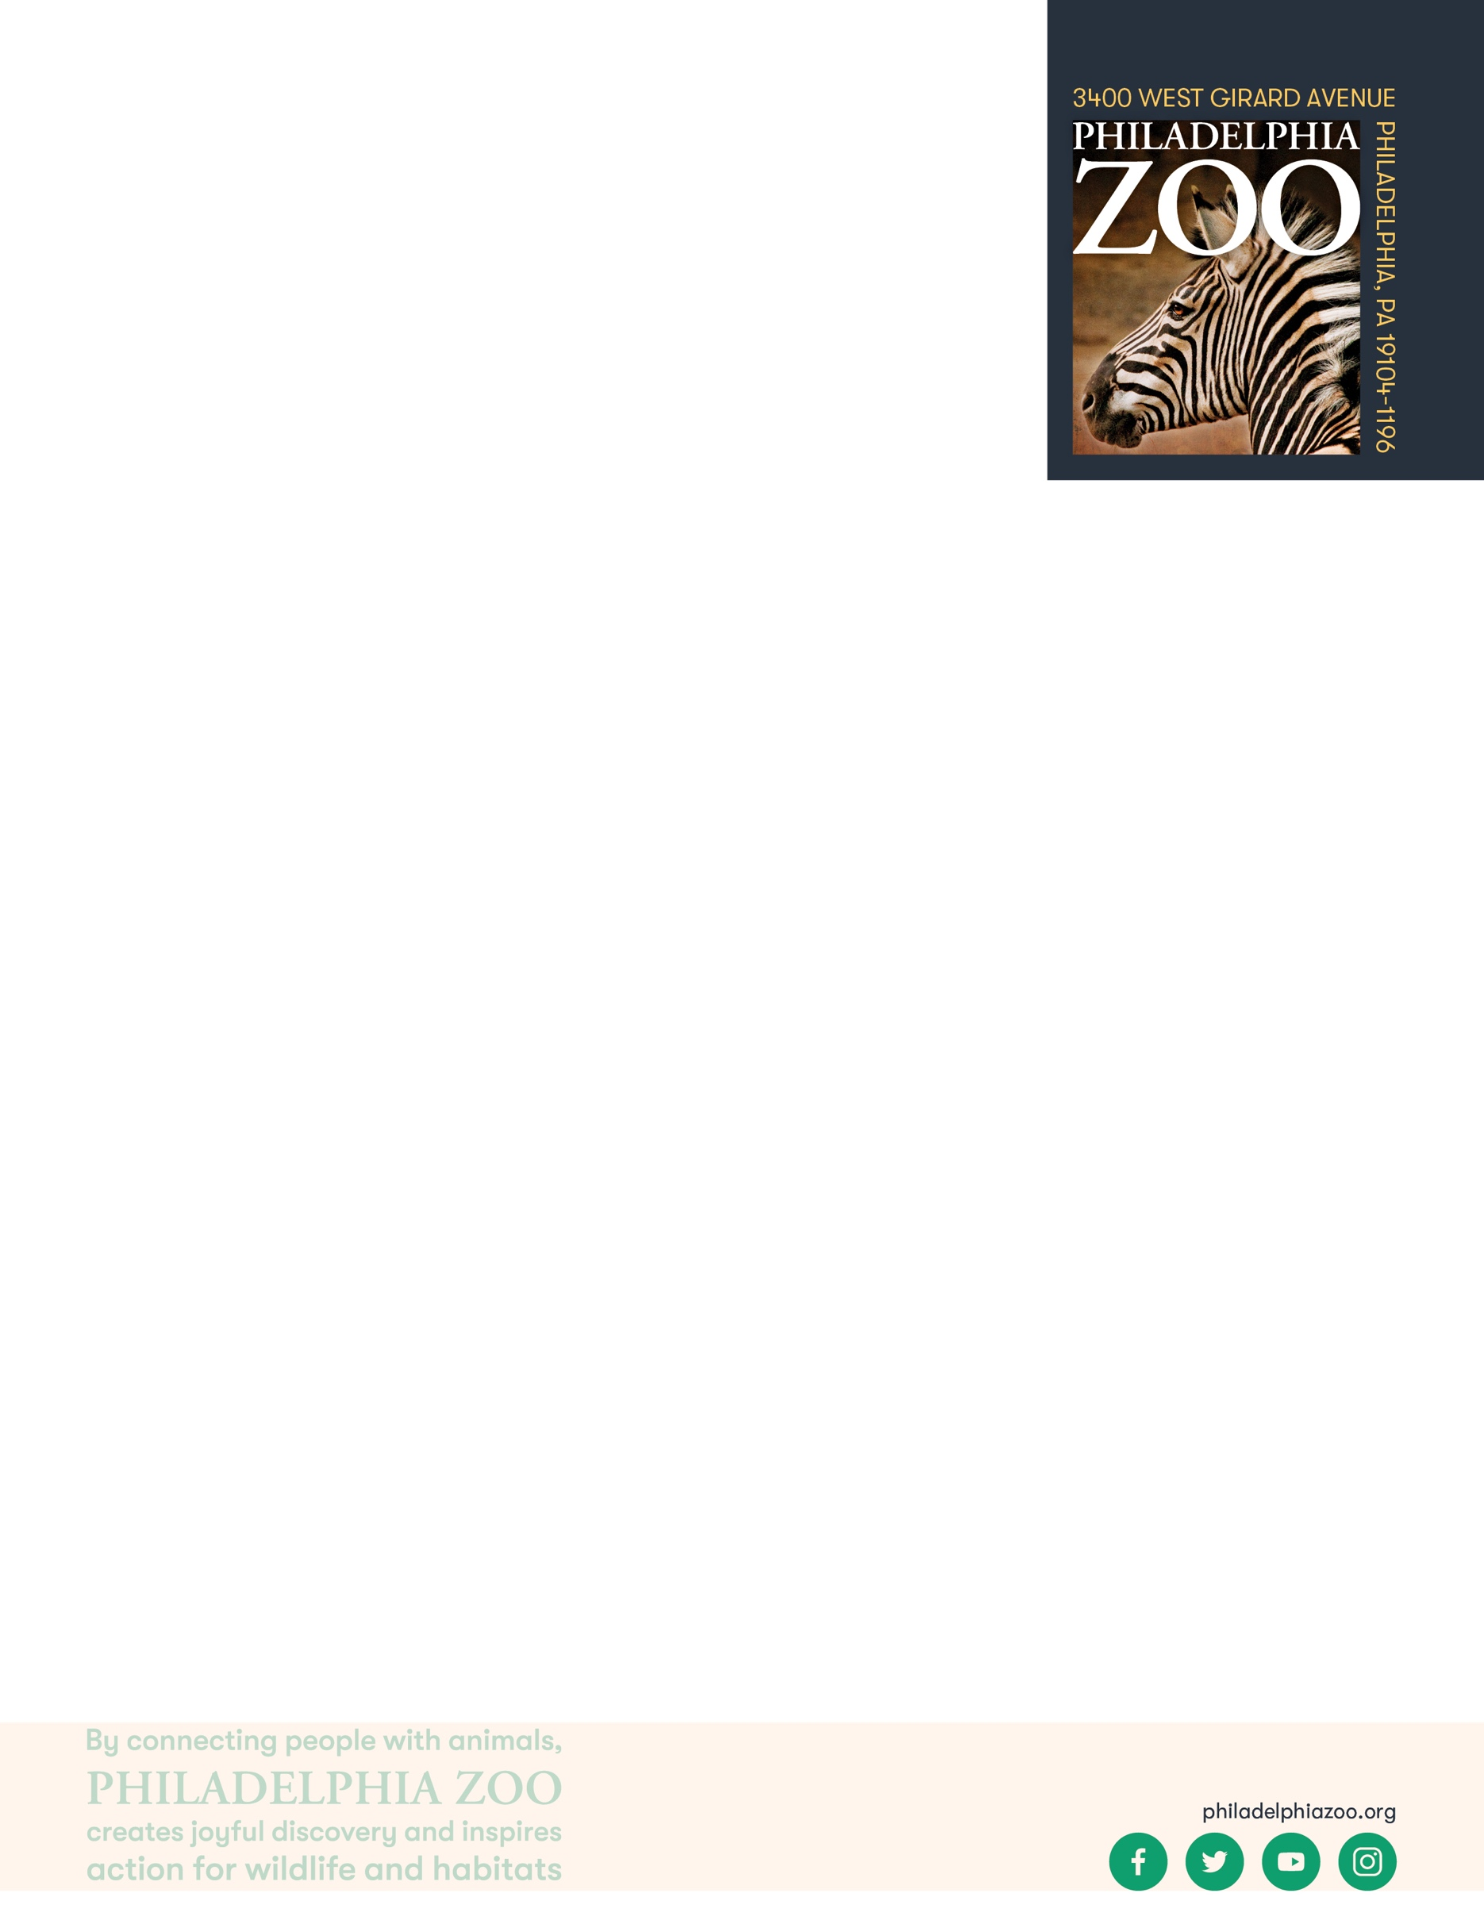

**Lesson Summary**

In this lesson, students will observe different items to determine the characteristics of living things, and classify items as living things or non-living things.

**Objectives**

Students will be able to identify the characteristics of living things

Students will be able to organize things as living or non-living

**Essential Question**

How do you know if something is living or non-living?

**Materials**

* Various items for students to observe such as scissors, a pen, a plant, a toy, and yourself.
* Paper (or worksheet such as provided at the end of the lesson)
* Writing utensils

**Prep**

1. 1 Day before: Select and/or gather items to present to class. Print out worksheets as needed (1 for each student)

**Key Terms**

* **Classification:** the assignment of organisms to groups that share characteristics
* **Living:** anything that is or has been alive, having life. Able to breathe, eat, drink, move, grow and reproduce.
* **Non-living thing**: anything that is not or has never been alive, not having life

**Background**

Living things have shared characteristics that indicate they are living. These are breathing, moving, needing food and water, growing and reproducing. To sustain life, all living things require food, water, shelter and space. However, not all living things meet those needs in the same way.

There are many ways in which organisms(living things) can be classified and grouped together. This process involves grouping organisms together based on shared characteristics. Some of these characteristics might include habitat, presence of a backbone, food source, diet, how they move, etc. By sorting through similarities and differences of organisms, we gain a better understanding of them and their needs, and are therefore able to better work toward protecting a preserving all living things!

**Implementation**

1. Excite: Start by presenting a toy to the students. Ask the students to share how they would take care of this toy.
2. Then, ask to see a show of hands of how many students have a pet at home. Ask students to share some of the pets that they have. Then, ask students to share how they would take care of their pet, whether they have one or not.
3. Explore: Point out that there were some similarities and differences between the ways in which they would care for those different things. Compare and contrast as a class. Students may realize that one is living and non-living on their own. However, if they don’t, probing questions may help them arrive to that conclusion.
4. Ask students to consider how specifically they knew the toy was non-living and that the pet was living. What characteristics did each have? It may help to show them more items and determining if those are living or non-living, and further discussing their similarities or differences.
5. Explain: Inform the class that living things include plants, animals, and people and that they all share the same characteristics of being able to move, breathe grow, eat, drink and reproduce.
6. Point out that although all living things share these characteristics, some of these may be easier to see and observe than others. However, that doesn’t always mean that thing does not have that feature. Instead, further examination or research may be necessary to determine if its living or not.
7. Elaborate: Segue into the lesson by telling students that today they will observe items around the room and must decide if each item is a living or non-living thing. Students can work individually, in groups, or as a whole class. Invite them to use a checklist to determine if the items are living or not.
8. Evaluate: Ask the class how they knew which items were living and which ones weren’t.

**Extensions**

Invite students outside to find living and non-living things outdoors!

**PA STEELS Curriculum Standards**

3.1.K.A

Name(s): ________________________________________________________

Date: ___________________________________________________________

Write the name of the item you are classifying. Make some close observations of this items. Then answer each question about that marking a ✓ if yes, a X if f no, or a ? if you don’t know. Then use your answers to help you decide if these things are living or non-living.



|  |  |  |  |  |  |  |
| --- | --- | --- | --- | --- | --- | --- |
| Item | Does it move? | Does it breathe? | Does it eat? | Does it grow? | Does it reproduce? | Is it a living thing? |
|  |  |  |  |  |  |  |
|  |  |  |  |  |  |  |
|  |  |  |  |  |  |  |
|  |  |  |  |  |  |  |
|  |  |  |  |  |  |  |
|  |  |  |  |  |  |  |
|  |  |  |  |  |  |  |