**Characteristics of Life**

**K-2 Onsite Activity**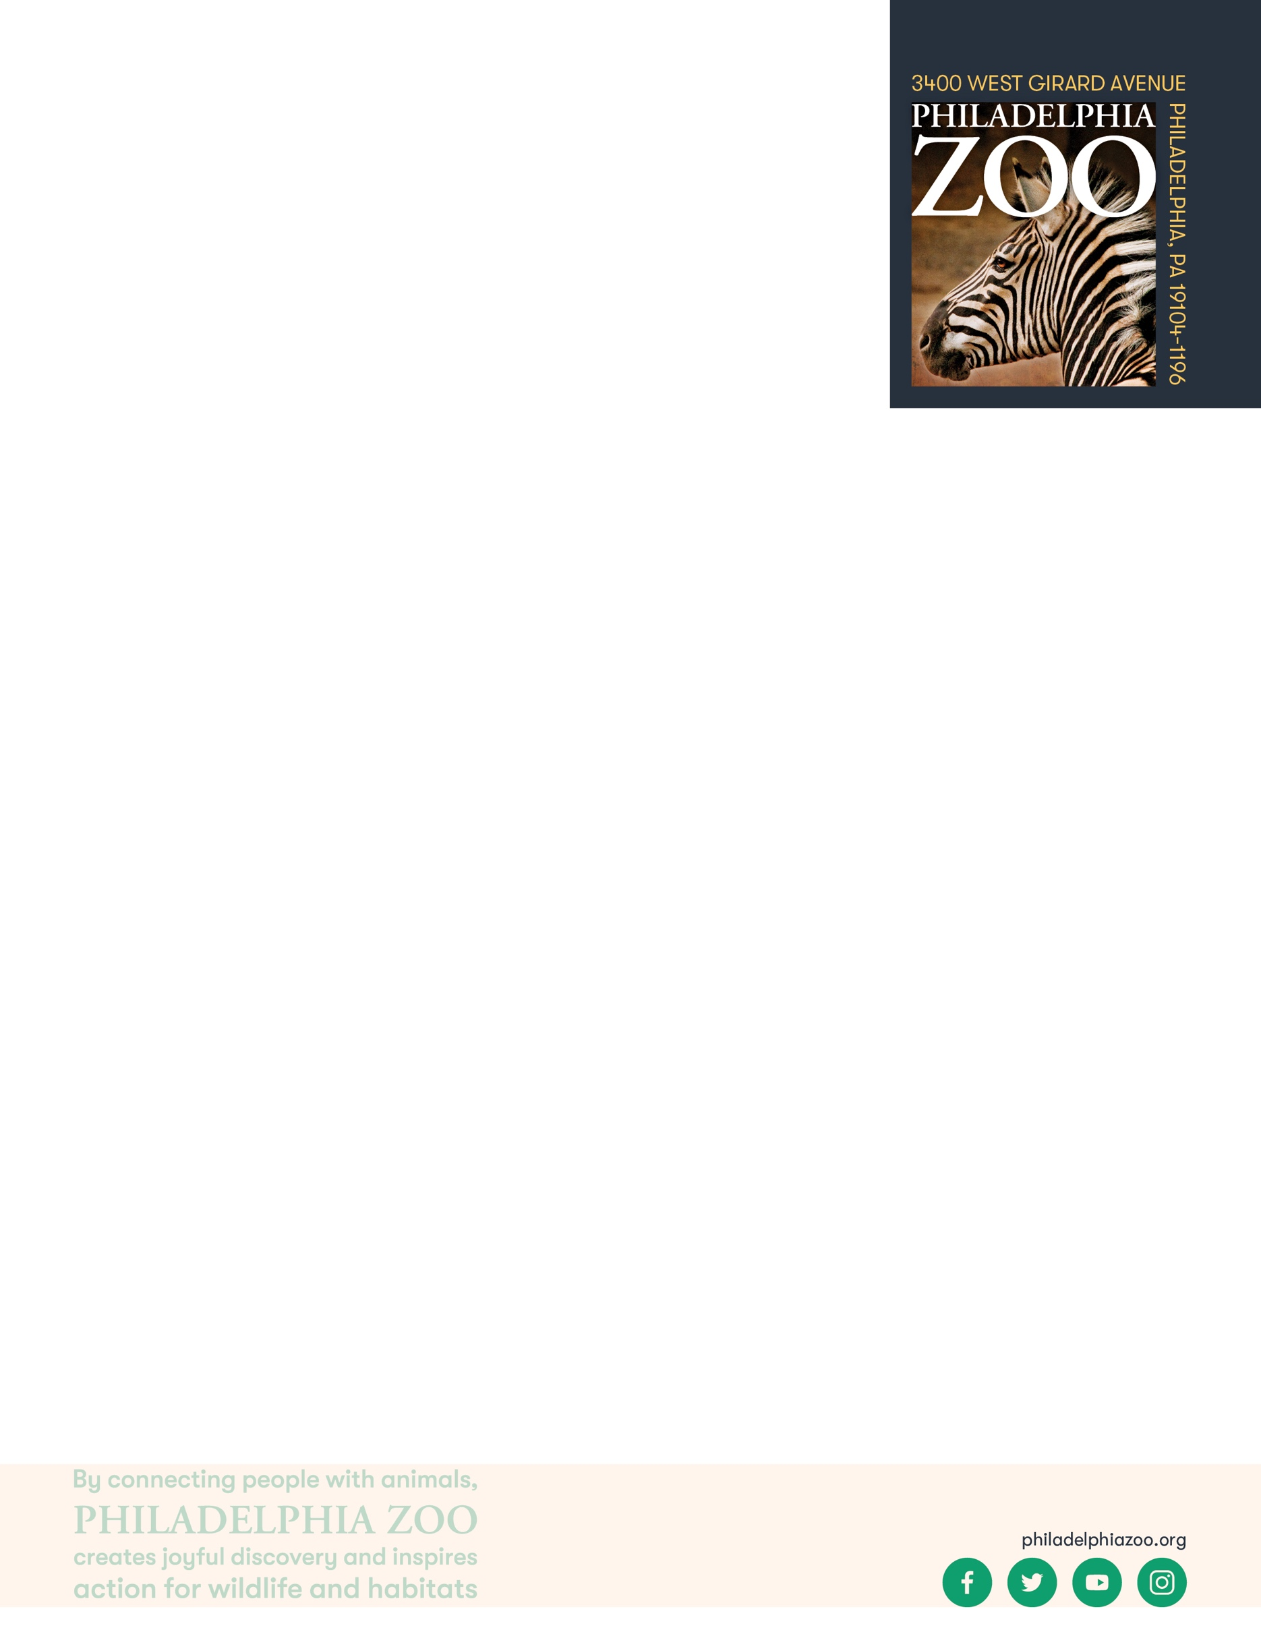

**Lesson Summary**

In this lesson, students will observe and identify living and non-living things while exploring the Zoo

**Objectives**

Students will be able to observe living and non-living things

Students will be able to classify living and non-living things based on shared characteristics including moving, breathing, needing an energy source, growing, and reproducing

**Essential Question**

How do you know if something is living or non-living?

**Materials**

* Paper (or worksheet such as provided at the end of the lesson)
* Writing utensils
* Coloring utensils

**Prep**

1. 1 Week before: Look at the [Zoo map](https://www.philadelphiazoo.org/zoo-map/) to determine locations for observations
2. 1 Day before: Print out worksheets as needed (1 for each student)
3. 15 minutes before: Prep students for expectations

**Key Terms**

* **Classification:** the assignment of organisms to groups that share characteristics
* **Living:** anything that is or has been alive, having life. Able to breathe, eat, drink, move, grow and reproduce.
* **Non-living thing:** anything that is not or has never been alive, not having life

**Background**

Living things have shared characteristics that indicate they are living. These are breathing, moving, needing food and water, growing and reproducing. To sustain life, all living things require food, water, shelter and space. However, not all living things meet those needs in the same way.

There are many ways in which organisms(living things) can be classified and grouped together. This process involves grouping organisms together based on shared characteristics. Some of these characteristics might include habitat, presence of a backbone, food source, diet, how they move, etc. By sorting through similarities and differences of organisms, we gain a better understanding of them and their needs, and are therefore able to better work toward protecting a preserving all living things!

**Implementation**

1. Excite: Welcome the students to the zoo and ask students to share what they are most excited to see!
2. Explore: As you walk around the zoo, have students practice identifying the things they see as living or non-living by pointing and sharing/
3. Explain: Remind students that all living things can move, breathe, need food and water, grow and reproduce and scientists know this through observation and research.
4. Elaborate: Ask students to pick 6 total things to spend more time observing. 3 of these things should be living, 3 of these should be non-living. Invite students to draw the thing as they observe. Then, ask them to share some of the ways they were able to determine if what they were observing was living or not.
5. Evaluate: Have students discuss the living and non-living things they observed at the zoo and explain how they were able to and classify if it was living or non-living.

**Expansion**

Have students choose one of the living things they saw at the zoo and also start to consider and draw the things that it would need to survive.

**PA STEELS Curriculum Standards**

3.1.K.A

Name: __________________________________________________________

Teacher: ________________________________________________________

School: _________________________________________________________

Date: ___________________________________________________________

Welcome to the zoo! As you explore around, please find 3 living and 3 non-living things. Draw what you observed. Then provide reasoning on how you knew they were classified as living or non-living.

**Living Things**

**Identifiers: __________________ Identifiers: __________________ Identifiers: __________________**

**___________________________ ___________________________ ___________________________**

**___________________________ ___________________________ ___________________________**

**Non-Living Things**

**Identifiers: __________________ Identifiers: __________________ Identifiers: __________________**

**___________________________ ___________________________ ___________________________**

**___________________________ ___________________________ ___________________________**