**Characteristics of Life**

**K-2 Post Activity**

**Lesson Summary**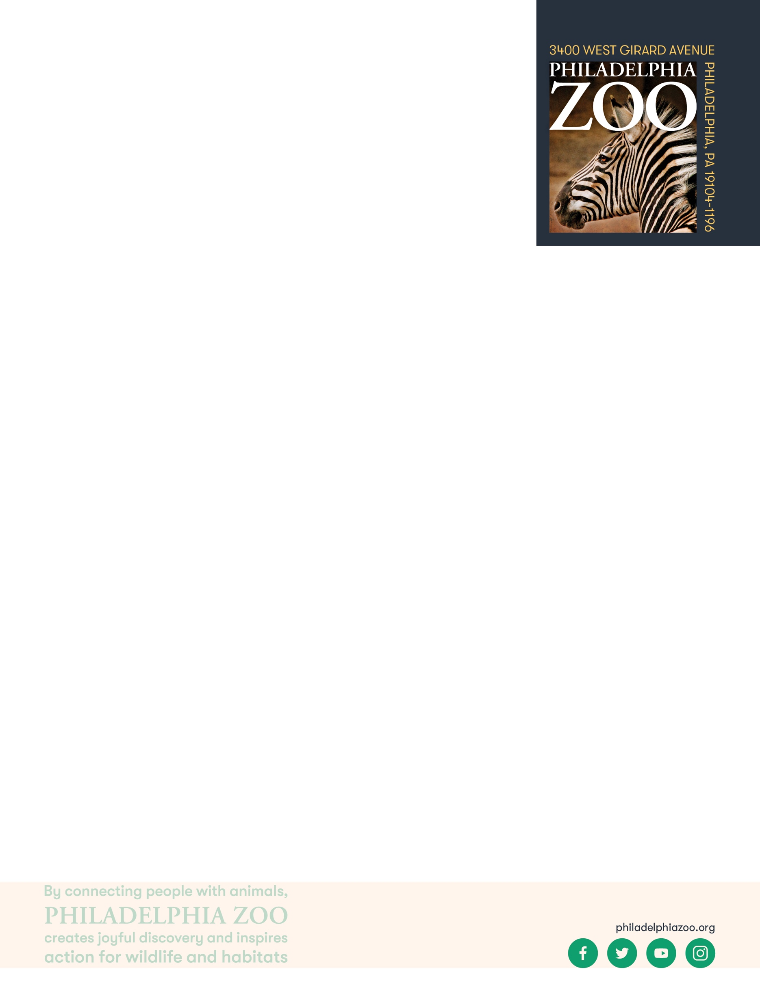

Students consider, reflect, and describe what they think life would be like if they were a different animal.

**Objectives**

Students will be able to recognize that both humans and animals are both living Students will be able compare and contrast the differences between humans and other animals.

**Essential Question**

What would life be like if you were an animal?

**Materials**

* Resources such as a book, movie, or [Philly Zoo website](https://www.philadelphiazoo.org/animals/)
* Paper (or worksheet such as provided at the end of the lesson)
* Writing utensils

**Prep**

1. 1 hour before: Print the worksheets as needed (1 for each student)

**Key Terms**

* **Classification:** the assignment of organisms to groups that share characteristics
* **Living:** anything that is or has been alive, having life. Able to breathe, eat, drink, move, grow and reproduce.
* **Non-living thing**: anything that is not or has never been alive, not having life
* **Human**: being or relating to a person or to people

**Background**

Living things have shared characteristics that indicate they are living. These are breathing, moving, needing food and water, growing and reproducing. To sustain life, all living things require food, water, shelter and space. However, not all living things meet those needs in the same way.

There are many ways in which organisms(living things) can be classified and grouped together. This process involves grouping organisms together based on shared characteristics. Some of these characteristics might include habitat, presence of a backbone, food source, diet, how they move, etc. By sorting through similarities and differences of organisms, we gain a better understanding of them and their needs, and are therefore able to better work toward protecting a preserving all living things!

**Implementation**

1. Excite: Ask students to consider if we are a living thing and what characteristics help us to determine this.
2. Remind students that all living things breath, move, eat, grow, and reproduce. To sustain life, all living things require food, water, shelter and space. However, not all living things meet those needs in the same way.
3. Explore: Ask students to share how each of the basic needs are met by a human.
4. Invite students to share what types of food they eat, what and how they drink, what they’re shelter might look like, and what kinds of things they like to do that might require different amounts of space. Demonstrate to the students the differences and similarities and differences that can be seen in the basic needs even between humans.
5. Explain: Point out that all living things have the same basic needs of shelter, space, water and food. However, the types of food, where they get their water, how much space and the type of shelter they live in, is different for many different living things.
6. Elaborate: Invite students to consider what their life would be like if they were a different animal (this can be a chosen animal or designated animal). Ask students to consider what their daily life would be like, what new challenges they might experience, how they would get their basic needs, and what they would want to tell their real selves.
7. Evaluate: Have students break up into groups and share what they thought their life would be like as this different animal. At the end, have a few students share with the whole class if they feel comfortable.

**Extensions**

Read a story to students to expand their understanding of the animal that they’re exploring to understand better.

**PA STEELS Curriculum Standards**

3.1.K.A, 3.4.k-2.A

Name(s): ________________________________________________________

Date: ___________________________________________________________

You are a human and therefore a mammal. What do you think life would be like if you were an animal instead? Pick one animal and think about what your life would be like if you were that animal.

What animal would you be? __________________________________________

What would your daily life be like as that animal?

______________________________________________________________________________________________________________________________________________________________________________________________________________________________________________________________________________

What new challenges do you think you would face as that animal?

______________________________________________________________________________________________________________________________________________________________________________________________________________________________________________________________________________

How would you get food, water, shelter, and space as this animal?

______________________________________________________________________________________________________________________________________________________________________________________________________________________________________________________________________________

What would you say to humans if you had the chance?

______________________________________________________________________________________________________________________________________________________________________________________________________________________________________________________________________________