**Characteristics of Life**

**3-5 Onsite Activity**

**Lesson Summary**

Students explore similarities and differences between animals by making observations of Zoo animals and comparing and contrasting features.

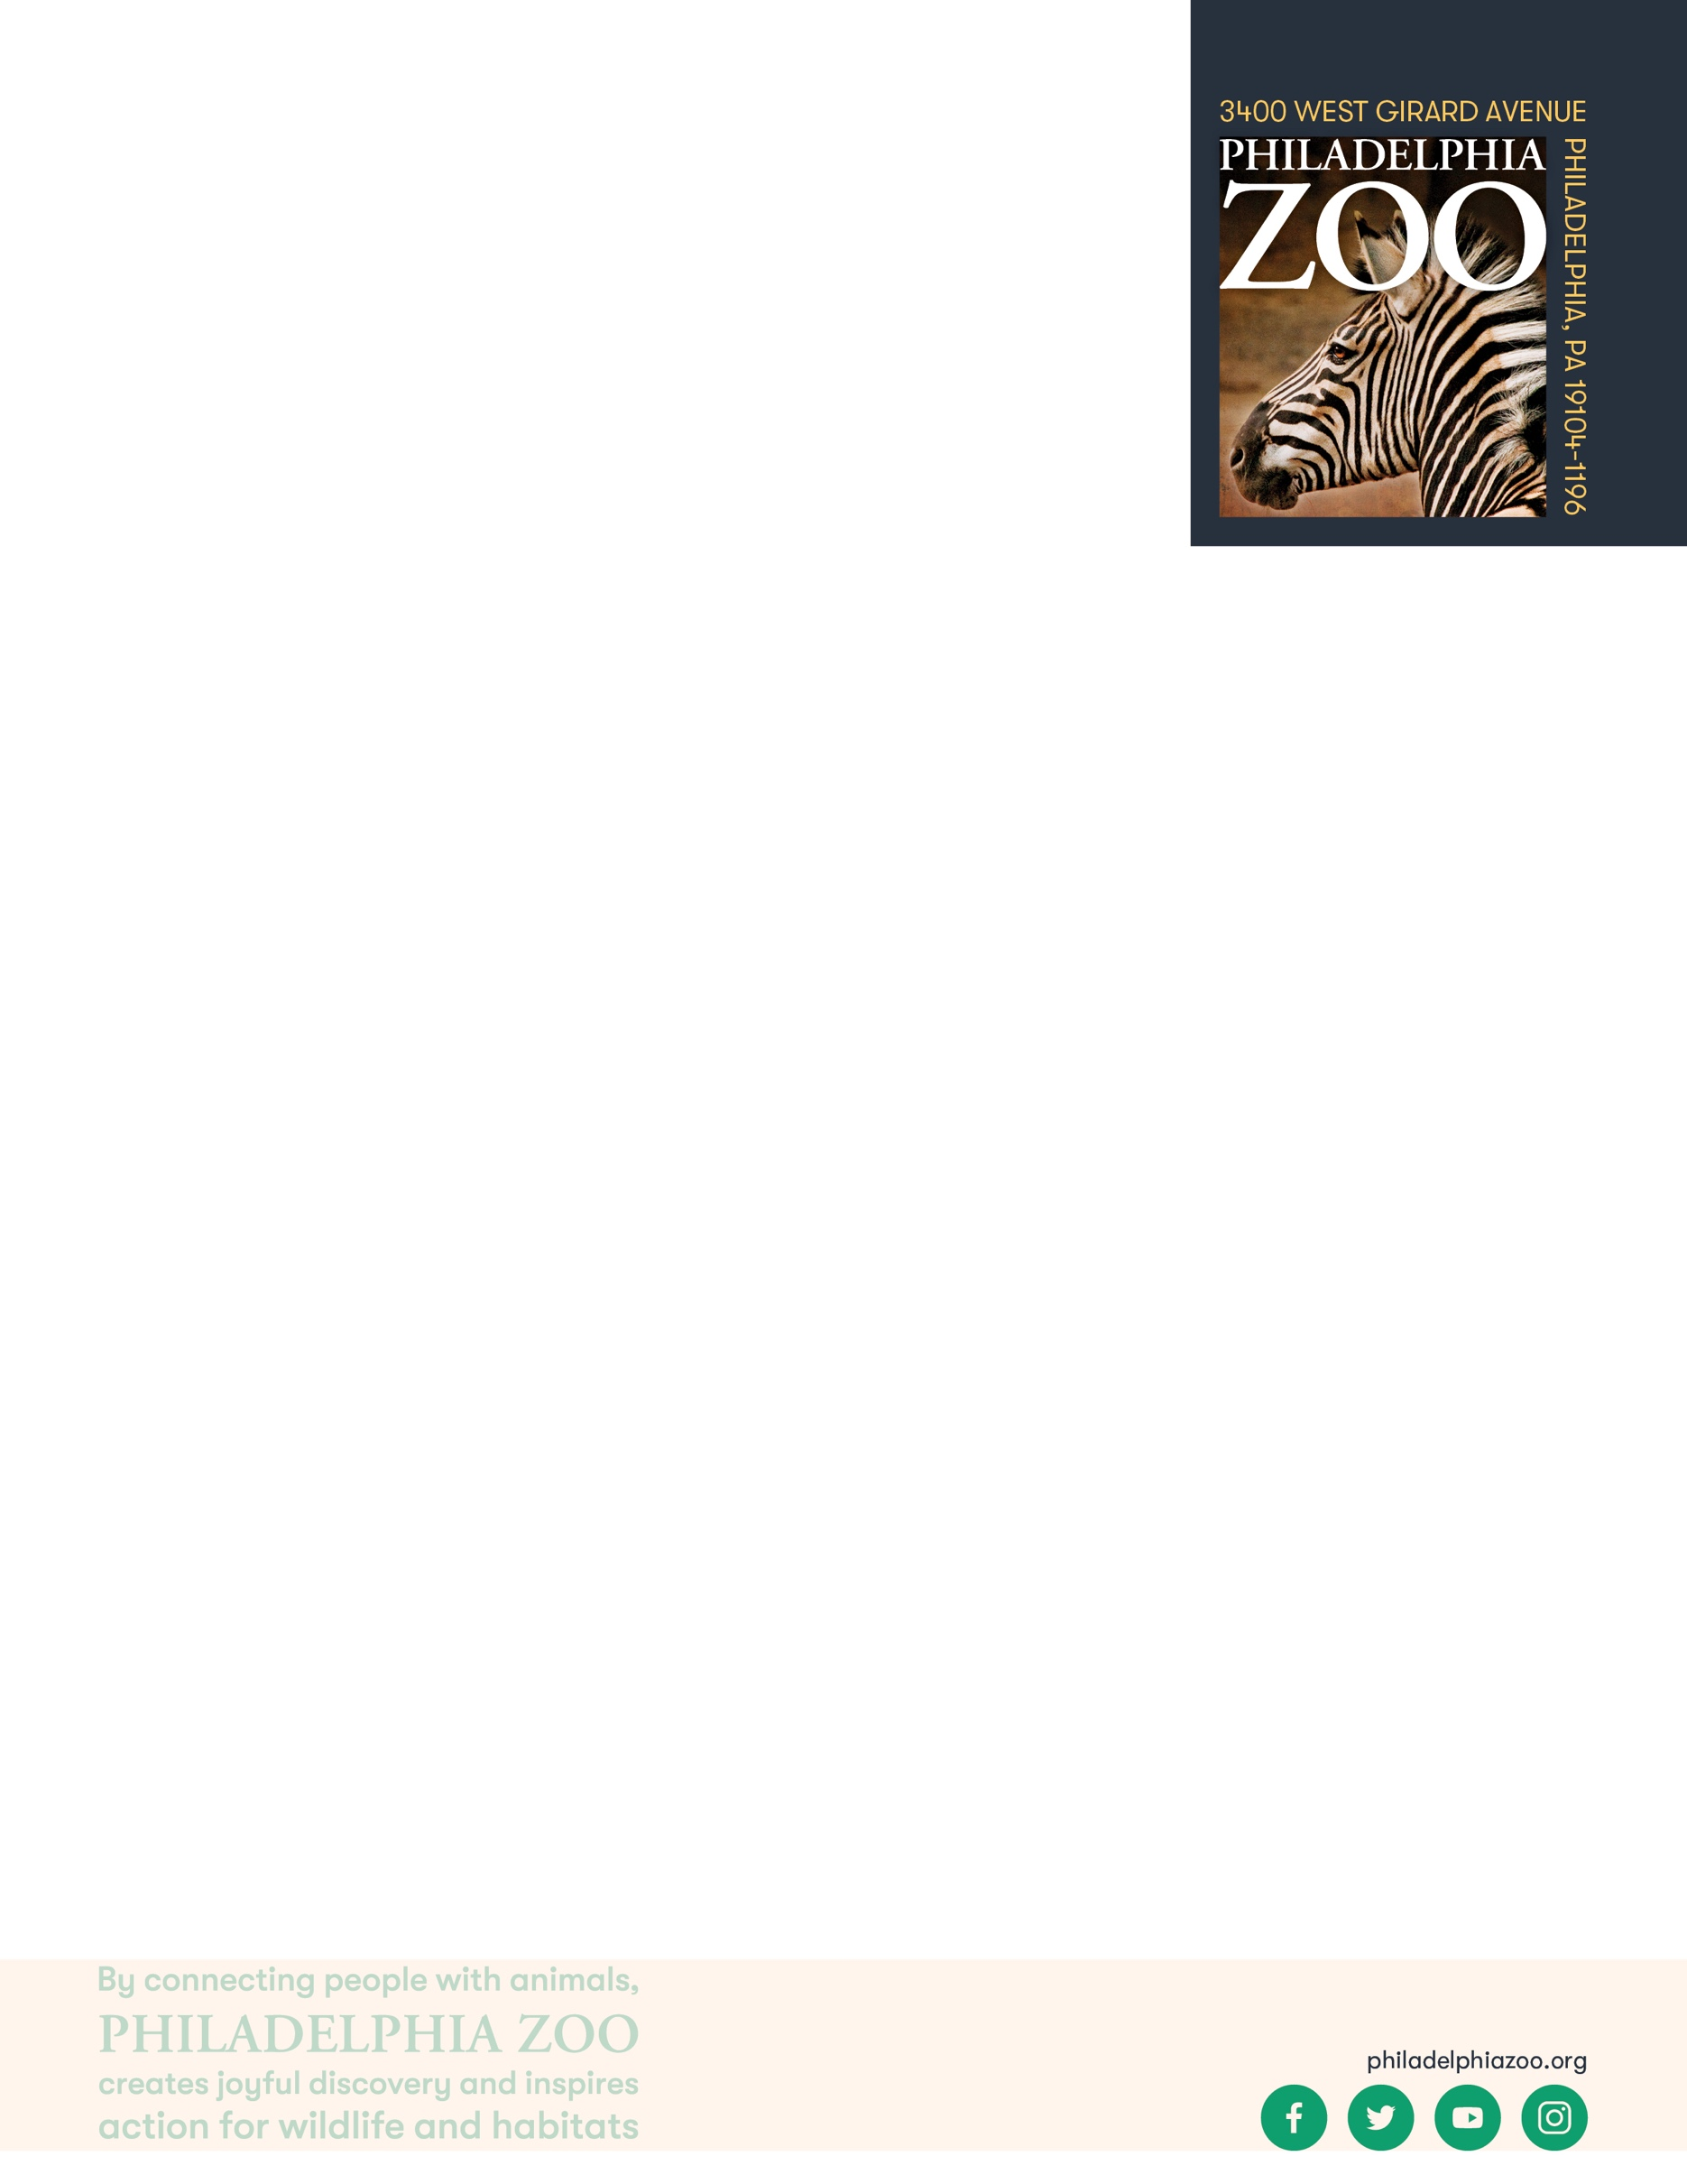

**Objectives**

Students will be able to describe animal features based on observations.

**Essential Question**

How are living things similar or different from one another?

**Materials**

* Paper (or worksheet such as provided at the end of the lesson)
* Writing utensils

**Prep**

1. 1 Week before: Look at the [Zoo map](https://www.philadelphiazoo.org/zoo-map/) to determine locations for observations
2. 1 Day before: Print out worksheets as needed (1 for each student)
3. 15 minutes before: Prep students for expectations

**Key Terms**

* **Classification:** the assignment of organisms to groups that share characteristics
* **Nonliving:** not having life
* **Living:** having life, able to breathe, eat, drink, move, grow, and reproduce

**Background**

There are many ways in which organisms(living things) can be classified. This process involves grouping organisms together based on shared characteristics. Some of these characteristics might include habitat, presence of a backbone, food source, diet, how they move, etc. By observing these organisms and sorting through their similarities and differences, we gain a better understanding of them and their needs, and are therefore able to better work toward protecting and preserving all living things!

**Implementation**

1. Excite: Welcome the students to the Zoo and ask them to share which animals they are most excited to see!
2. Explore: As you walk around the Zoo, verbally discuss some similarities and differences you notice between the animals you see.
3. Explain: Remind students that scientists make observations of animals to sort them into groups. They are able to do this through observations and research, and it allows them to learn more about the animals to be able to better protect and conserve them!
4. Elaborate: Locate 3 different animals (either in the same place or in different buildings thorough the Zoo) for the students to observe and describe in detail the animals that they see.
   1. We recommend visiting Reptile and Amphibian House, Big Cat Falls, and the McNeil Avian Center and observing one animal in each area for the biggest variety between animals.
5. Follow up student observations, with discussion comparing and contrasting these animals.
6. Evaluate: Ask students to share what additional things they may have learned about these animals through their deeper observations.

**Expansion**

Invite students to explore similarities and differences they’ve found between the animals they observed and themselves.

Invite students to fill out a three-way Venn diagram exploring the similarities and differences of the animals that they observed.

**PA STEELS Curriculum Standards**

3.1.4.A, 3.1.3.D



Name: __________________________________________________________

Teacher: ________________________________________________________

School: _________________________________________________________

Date: ___________________________________________________________

Welcome to the zoo! As you explore around please pick 3 animals in different areas to spend some extra time observing. Use the chart below to describe the animals you observed. After you’ve made your observations, compare and contrast these animals.

|  |  |  |
| --- | --- | --- |
| **Animal** | **Descriptive Words** | **Does this Animal Have…** |
|  |  | ☐ Eyes ☐ Ears ☐ Nose  ☐ Legs ☐ Wings ☐ Tail  ☐ Teeth ☐ Claws ☐ Shell  ☐ Fur ☐ Scales ☐ Feathers |
|  |  | ☐ Eyes ☐ Ears ☐ Nose  ☐ Legs ☐ Wings ☐ Tail  ☐ Teeth ☐ Claws ☐ Shell  ☐ Fur ☐ Scales ☐ Feathers |
|  |  | ☐ Eyes ☐ Ears ☐ Nose  ☐ Legs ☐ Wings ☐ Tail  ☐ Teeth ☐ Claws ☐ Shell  ☐ Fur ☐ Scales ☐ Feathers |

What are some things that the animals above have in common?

__________________________________________________________________________________________

__________________________________________________________________________________________

__________________________________________________________________________________________

What are some things that are different between these animals?

__________________________________________________________________________________________

__________________________________________________________________________________________

__________________________________________________________________________________________