**6-8 Pre-Activity**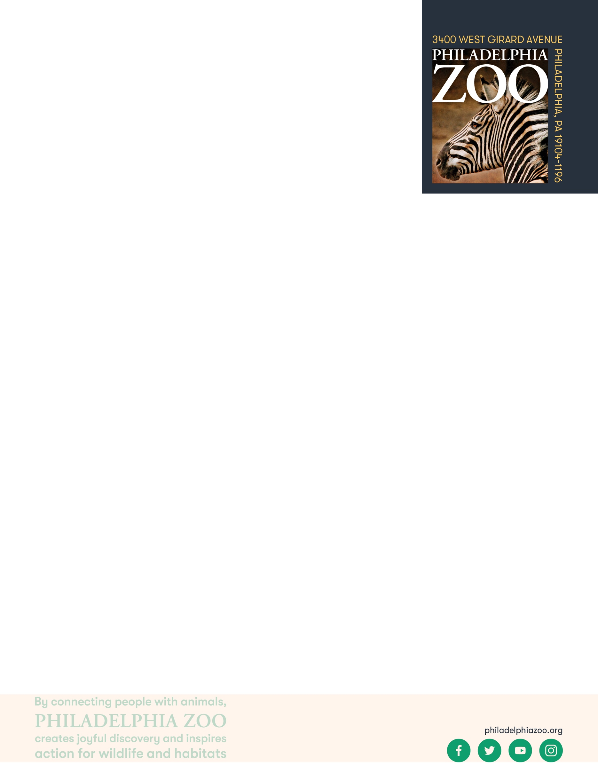

**Lesson Summary**

Students examine the life cycle and ecological role of red eared sliders in their native habitat. By learning about the adaptability of the species, students can hypothesize the effects of red eared siders, in a space not built for their ecological role, have on resources for other organisms.

**Objectives**

Students will be able to describe the impact an introduced species has on an ecosystem

Students will be able to refer to text to make inferences

Students will be able to use accessible information to explain the patterns that can occur when and introduced species is left to populate or removed from an ecosystem

**Essential Question**

How does the introduction of a species effect the availability of resources for other species?

**Materials**

* Red Eared Slider information sheet (provided at the end of the lesson)
* Environmental pressures information sheet (provided at the end of the lesson)
* Scrap paper
* Writing utensils

**Prep**

1. 1 Day before: Print out information sheets as needed (1 for each student)

**Key Terms**

* **Introduced Species:** a species living outside its native distributional range
* **Biodiversity:** the variety of life in the world or in a particular habitat or ecosystem
* **Generalist:** an organism that can thrive in a wide range of environmental conditions and utilize a variety of food sources
* **Ecological Displacement:** situations where species are forced to move from their typical habitats due to various disturbances, often leading to increased competition and potential population declines

**Background**

There are many ways in which organismscan adapt to their surroundings and some are better than others. This process involves grouping organisms together based on shared characteristics. Some of these characteristics might include habitat, presence of a backbone, food source, diet, how they move, etc. By observing these organisms and sorting through their similarities and differences, we gain a better understanding of them and their needs, and are therefore able to better work toward protecting and preserving all living things!

**Implementation**

1. Excite: Ask students to share an animal and/or plant they see often outside in their daily life. Then have students write down what role in the environment they think these animals have.
2. Invite the students to get into groups to determine how those animals and their relationships with the plants and one another allow the environment to stay intact.
3. Bring the class back as a whole and ask groups to share some ecological cycles they came up with using the animal/plants relationship. Ask them what they think would happen, if one part of that ecosystem was thriving or declining more than another.
4. Share with students that they just worked through an example of things that happen all around us. The biodiversity of an area can be impacted by the addition or subtraction of different organisms. All organisms are independent, yet in order to survive must be interdependent on other organisms in a delicate balance.
5. Explore: Ask students now to read up on the Red Eared Slider, an animal a lot are familiar with as a common pet turtle that one can find in a pet shop.
6. Ask students first to take some time learning about the turtle’s habitat, adaptations, growth rate and demeanor towards other organisms. What are some reasons that the animals might adapt well? What are some features that tell us the animal could be a potential risk to a new environment? Ask the students to record some of their findings.
7. After students have had time to make observations, discuss as a class if they think these animals could be harmful to an ecosystem or environment? Why or why not?
8. Explain: Share with the students that there are so many adaptations that help animals survive in their native ecosystems. This is the same reason some animals have been around for thousands of years and others have gone extinct. Provide thought provoking words like “generalist” and “specialist” to help students further think about what makes an animal adapt well to an environment.
9. Discuss with the students as a class if they think the information they’ve been provided is sufficient enough to determine if Red Eared Sliders are invasive in Philadelphia, Camden, New York City or any other place that is not their native environment? Would we be able to identify if these animals could cause an ecological displacement of native animals? Why or why not?
10. Elaborate: Share with students that the information provided might be able to start to determine if the red eared slider in an invasive species, but we have to understand why and how the animal came to be in a place that wasn’t there natural environment. Share that introduced species are a huge part of what make up the world as we know it today, examples of other introduced species are cockroaches, rats, horses, cows, cats and more.
11. Discuss with the students as a class again if they think the information they’ve been provided is sufficient enough to determine how to deal with invasive species such as the red eared slider in a way that supports efforts to keep the ecosystem intact.
12. Ask the students to use their observations and the information from the readings to create a food web/ecological map of the role a red eared slider would play in an ecosystem such as Philadelphia.
    1. Based off student observations and the readings, students may have been able to create something like the following pro con list:

Red Eared Slider:

+ -

Generalist that thrives in disturbed environments Threatens native turtles

Provides services like seed distribution and bioturbation Impacts species beyond turtles

Raise Awareness about turtles Transmits diseases or parasites

1. Evaluate: Discuss with the students as a class one last time if they think the information they’ve been provided is sufficient enough to determine the role a species such as the red eared slider can play on the interdependent relationships in a specific environment.
2. Ask students if they think the introduction of non-native species is a topic to be further discussed. If so, why or why not? To end, ask students to come up with one thing they can do to help others understand the importance of knowing why certain animals are called invasive

.

**PA STEELS Standards**

3.1.6-8.I

**Red Eared Slider Facts**

Red-eared slider turtles thrive in diverse environments, ranging from their native habitats to new regions where they’ve become an introduced species. Exploring the natural setting of red-eared sliders sheds light on their adaptability and the challenges they face as introduced species.

Native to the southeastern United States, red-eared slider turtles are naturally found in slow-moving freshwater environments such as ponds, lakes, swamps, and rivers. These bodies of water provide an ideal setting for their growth and reproduction, offering ample food, basking sites, and soft substrates for nesting. As sliders, they exhibit an adaptable nature that allows them to thrive in varying conditions. These environments support diverse turtle populations, contributing to balanced ecosystems where red-eared sliders play essential roles. Their presence is integral to maintaining healthy aquatic systems, with their diet often comprising aquatic vegetation, small fish, and invertebrates.

Their remarkable resilience enables them to establish populations quickly, potentially altering the ecological balance such as, these turtles can outcompete other turtles due to their aggressive foraging habits and high reproductive rates.

This pattern of invasion showcases their influence as an introduced species, requiring ongoing monitoring and management to ensure the wellbeing of native ecosystems.

These adaptable sliders can easily adjust to new environments, often displacing native species due to competition for resources. As animal habitats become increasingly disrupted by human activity, the impact of introduced species like the slider turtle is magnified. Their presence in new areas is not passive; these turtles actively compete with native species for food, basking areas, and breeding sites. Invasive by nature, red-eared sliders often thrive at the expense of native turtle species, which might be less equipped to deal with the added competition.

