**Characteristics of Life**

**6-8 Onsite Activity**

**Lesson Summary**

Students observe and describe features of Zoo animals, compare and contrast these features, and determine how similar or different these animals may be classified based on these findings.

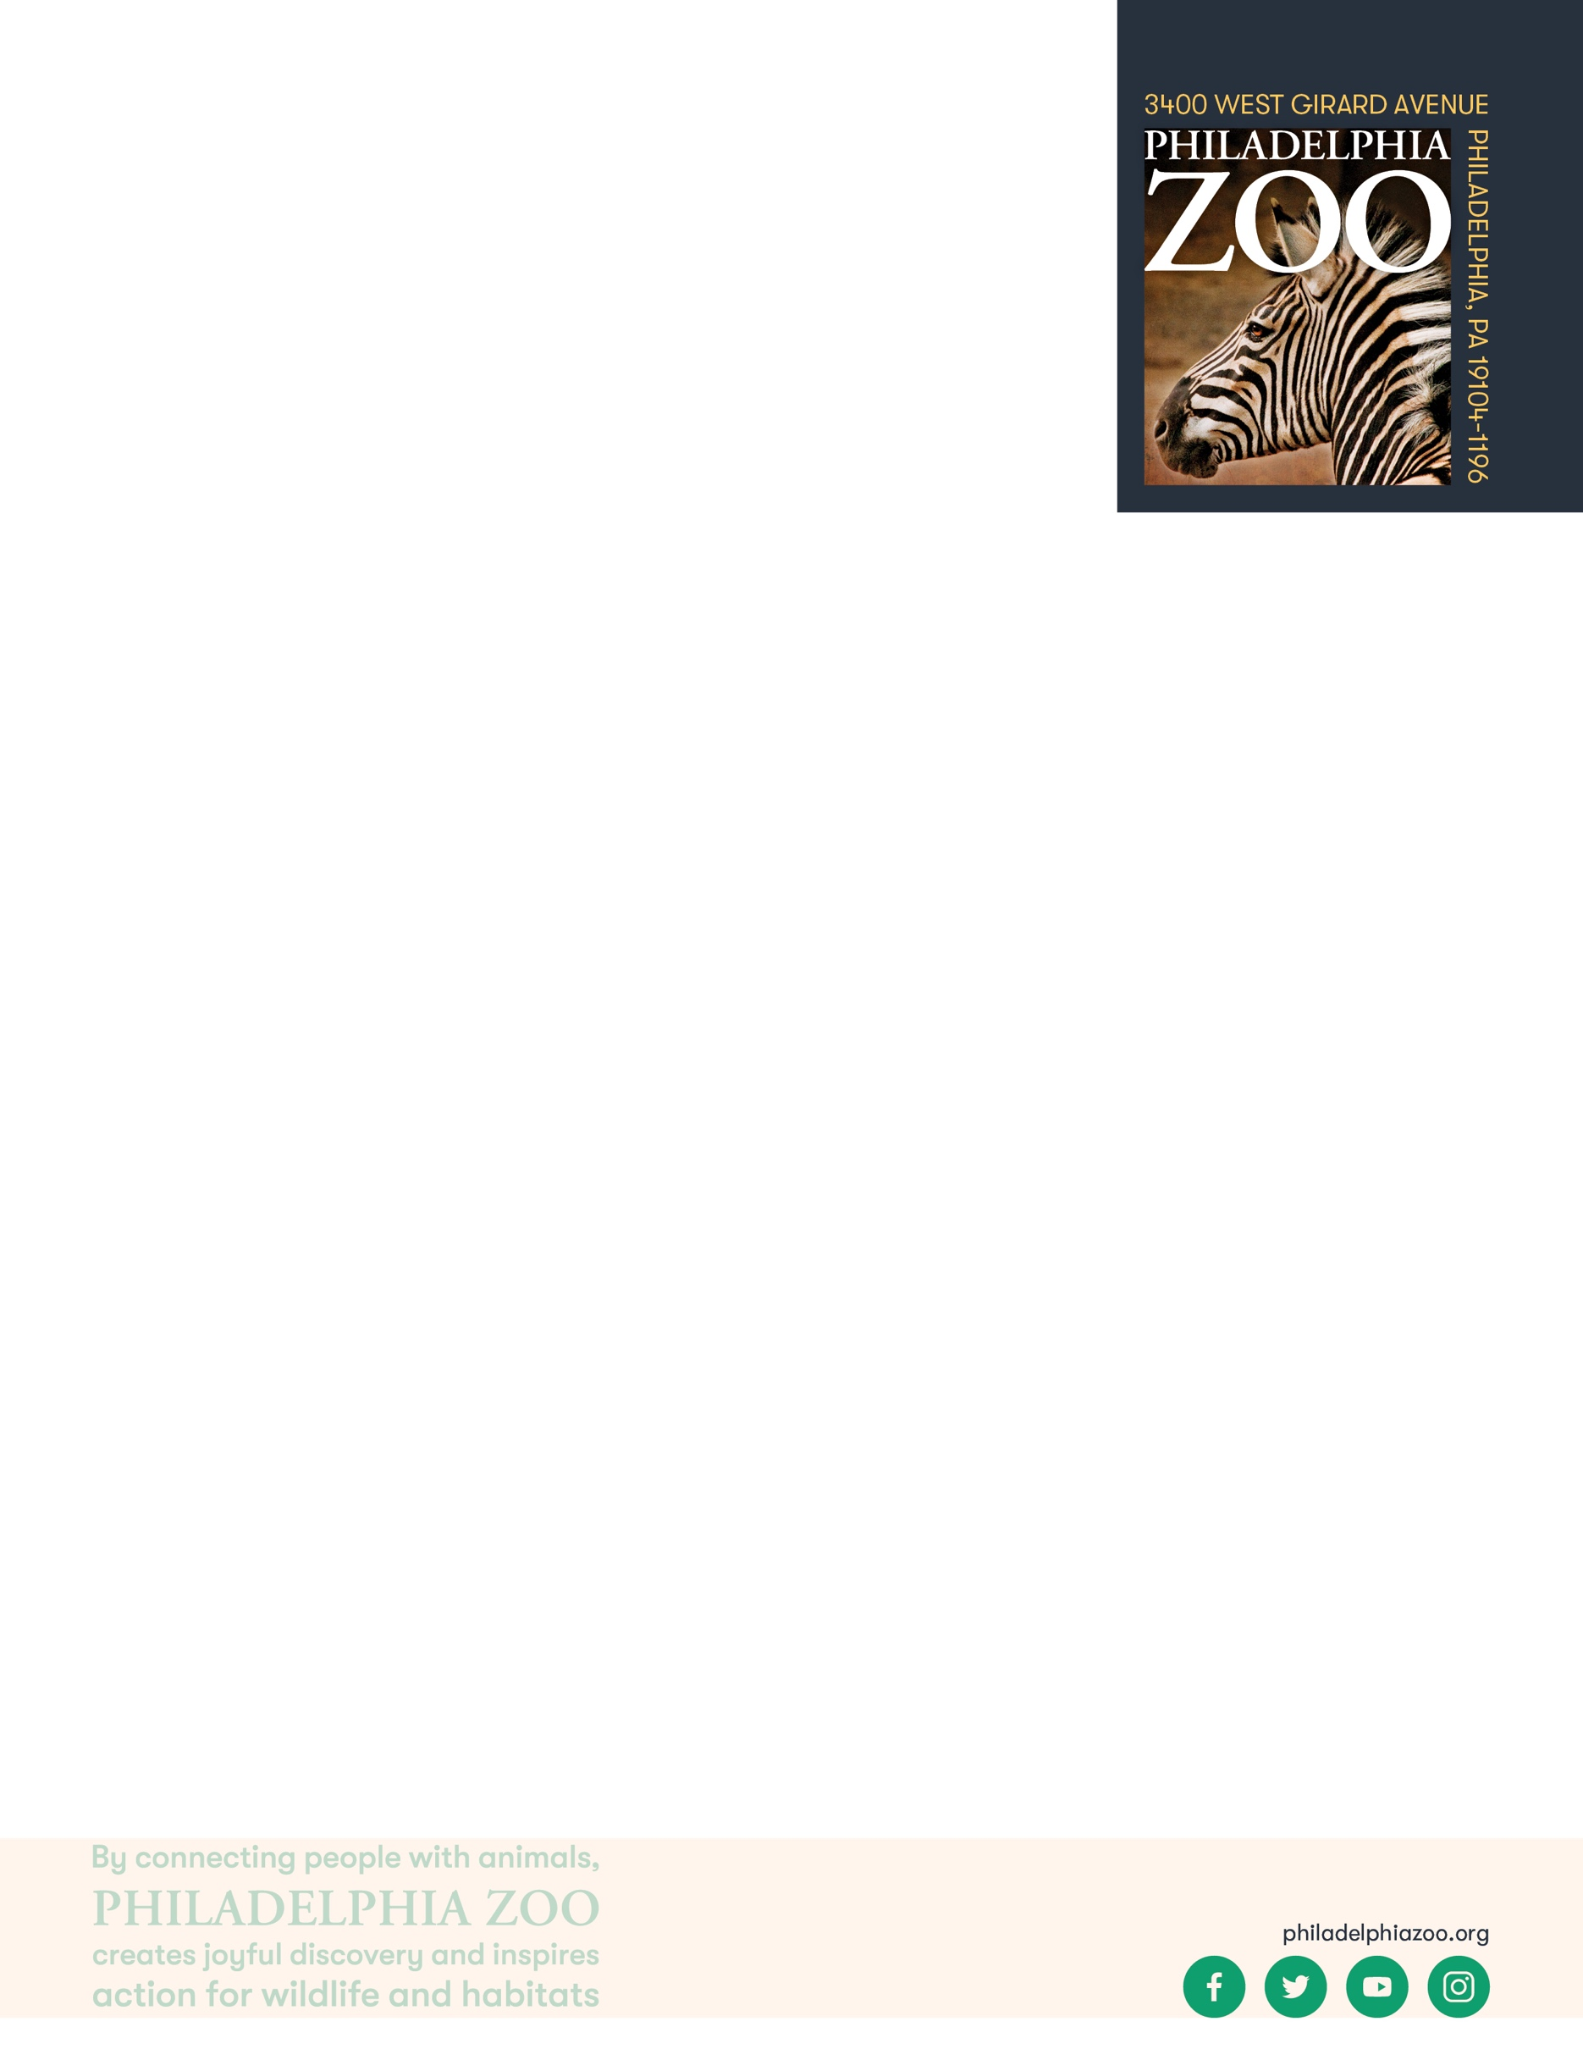

**Objectives**

Students will be able to describe similarities and differences of physical features

Students will be able to consider their observations and implications on taxonomy

**Essential Question**

How are living things similar or different from one another?

**Materials**

* Scrap Paper (or worksheet such as provided at the end of the lesson)
* Writing utensils

**Prep**

1. 1 Week before: Look at the [Zoo map](https://www.philadelphiazoo.org/zoo-map/) to determine locations for observations
2. 1 Day before: Print out worksheets as needed (1 for each student)
3. 15 minutes before: Prep students for expectations

**Key Terms**

* **Classification:** the assignment of organisms to groups that share characteristics
* **Taxonomy:** the system of organisms to categorizations based on shared characteristics and relation
* **Nonliving:** not having life
* **Living:** having life, able to breathe, eat, drink, move, grow, and reproduce

**Background**

There are many ways in which organisms(living things) can be classified. This process involves grouping organisms together based on shared characteristics. Some of these characteristics might include habitat, presence of a backbone, food source, diet, how they move, etc. By observing these organisms and sorting through their similarities and differences, we gain a better understanding of them and their needs, and are therefore able to better work toward protecting and preserving all living things!

**Implementation**

1. Excite: Welcome the students to the Zoo and ask them to share which animals they are most excited to see!
2. Explore: As you walk around the Zoo, verbally discuss some similarities and differences you notice between the animals you see.
3. Explain: Remind students that scientists classify animals to understand them better. Classifying animals provides a better understanding of how animals are similar or different from each other. Specifically, classifying through taxonomy provides a fuller picture of how related or similar two animals might be.
4. Elaborate: Locate at least 2 different animals (either in the same place or in different buildings throughout the Zoo) for the students to observe, draw, and describe in detail. The animals should have at least some visible features in common.
5. Follow up student observations, with discussion comparing and contrasting these animals. Does it appear that the two animals they observed have more in common or less in common?
6. Then, ask the students to consider if their observations and commonalities that they identified might be able to indicate how closely these animals might be related. Are the features they observed enough to be able to declare the animals as closely related?
   1. In some cases, it might! For example, Amur Tigers and Amur Lions may look very different based off of their fur patterns – tigers with stripes and lions covered in a solid color. However, they do also have many similar features. In fact, these two animals only diverge from each other at the species taxonomic category, being in the same Panthera genus.
   2. In other cases, it might not. For example, Rodrigues Fruit Bats and Turkey Vultures are both animals with dark-colored wings that help them to fly. However, these animals have many other differences, included the structure of their wing, the coverings on their body, the way they have young, and more. In fact, these animals are so different from each other, they diverge at the Class taxonomic category. Rodrigues Fruit Bats are in the class Mammalia and Turkey Vultures are in the class Aves. These very different animals are considered to be analogous, being very distantly related but having features that serve similar functions with different structures.
   3. In either case, likely more information and research is needed.
7. Evaluate: Ask students to share what additional things they may have learned about these animals through their deeper observations.

**PA STEELS Curriculum Standards**

3.1.6-8.P

Name: __________________________________________________________

Teacher: ________________________________________________________

School: _________________________________________________________

Date: ___________________________________________________________

Welcome to the zoo! As you explore around, look around to observe similarities and differences between the animals that you see. Pick 2 animals to spend extra time on. Draw and describe these animals, then identify some of the features these animals have in common. Consider how much these animals have in common and if that might be an indicator for how related they might be.

Animal 1: __________________________________

Description: ________________________________

____________________________________________________________________________________

Animal 2: __________________________________

Description: ________________________________

____________________________________________________________________________________

What do these animals have in common? ________________________________________________________

Do these animals appear to have more in common or less in common? ________________________________

Do you think these animals would be classified similarly taxonomically? Why or why not?

__________________________________________________________________________________________

__________________________________________________________________________________________

__________________________________________________________________________________________