**Characteristics of Life**

**6-8 Post-Activity**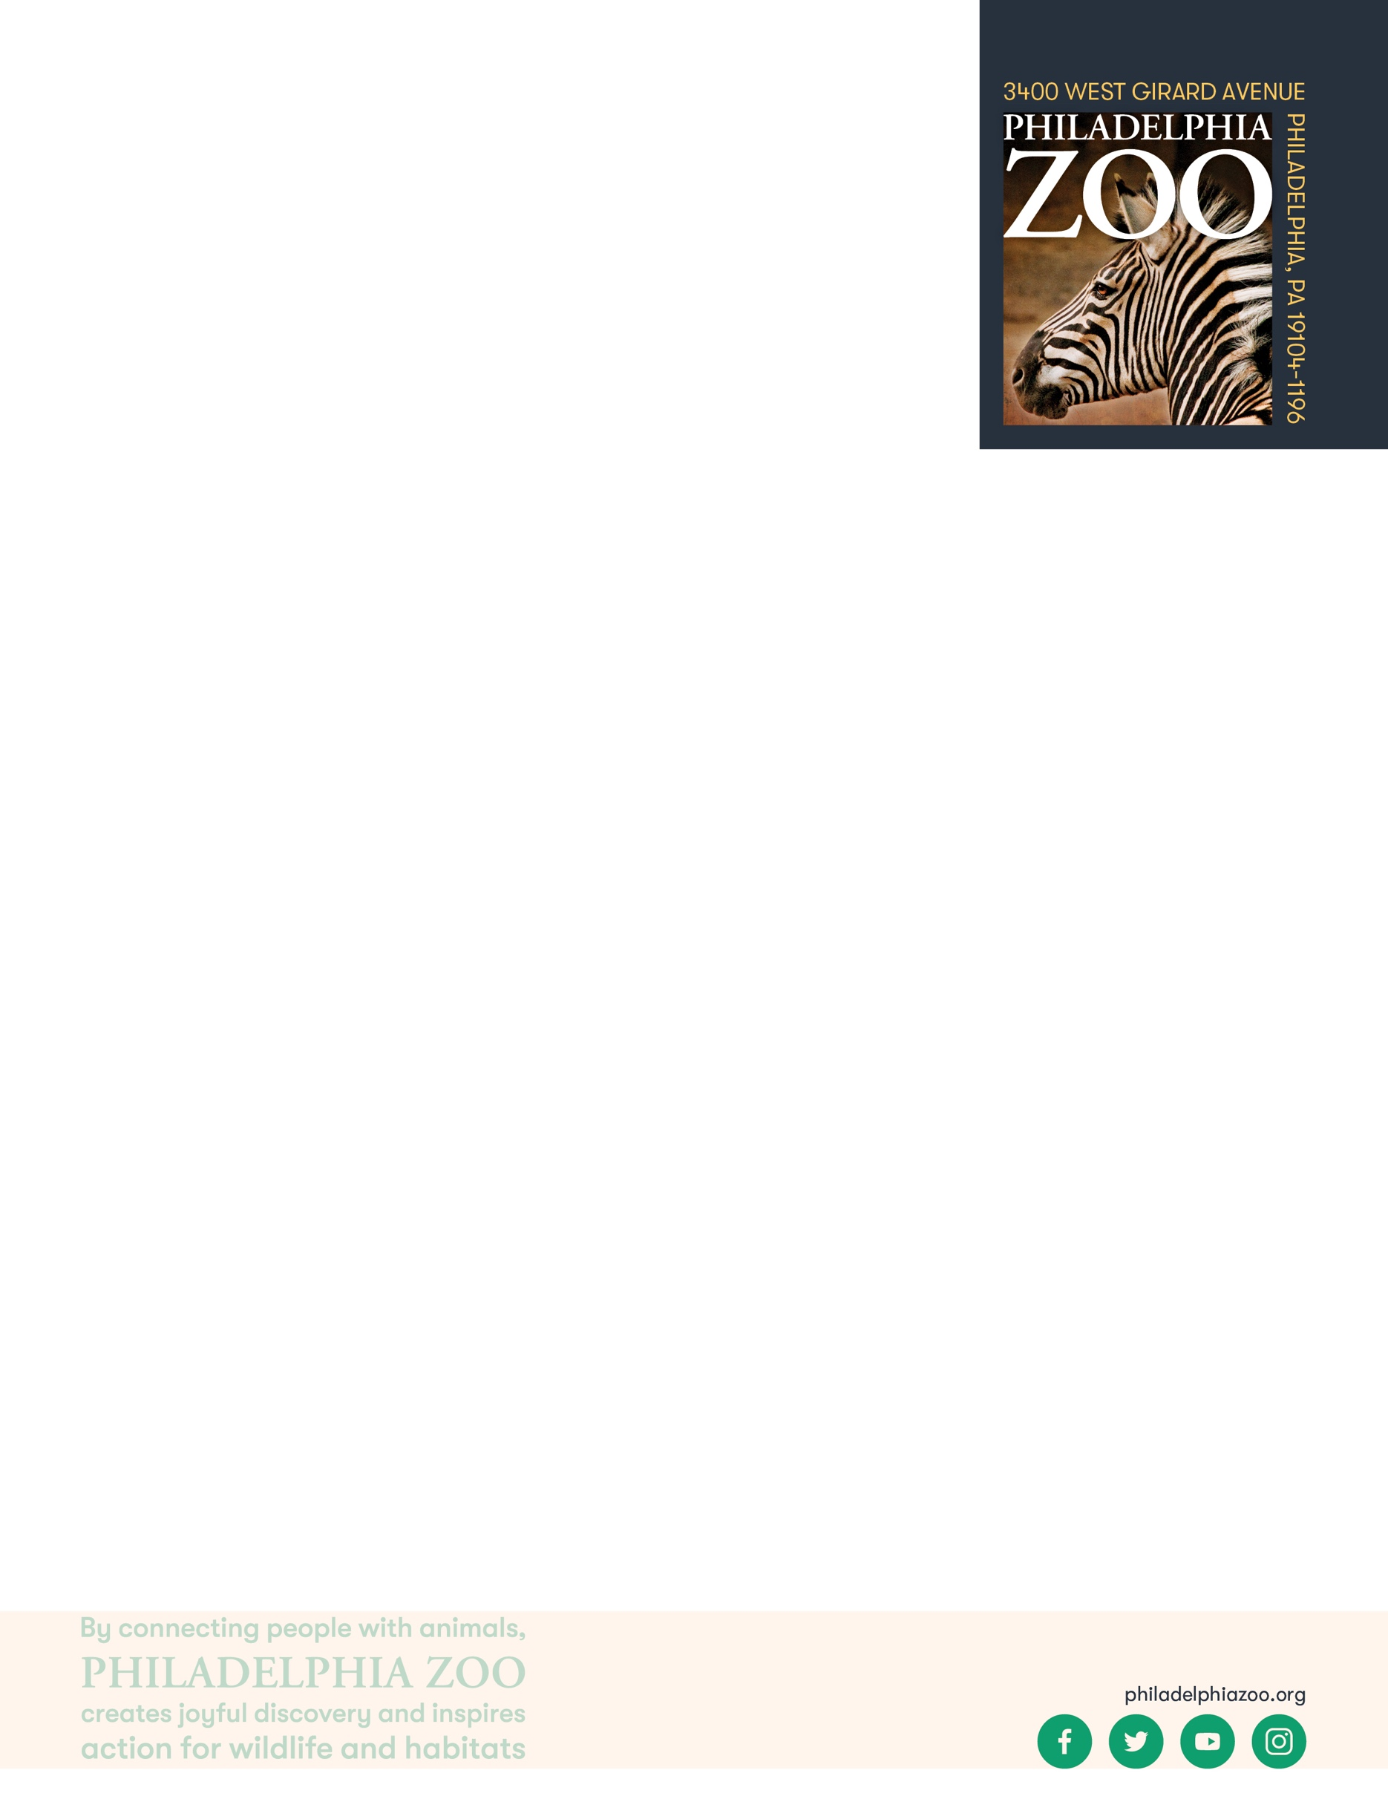

**Lesson Summary**

Students examine a series of animal photos. Students then determine commonalities amongst all the animals by using their observations and prior knowledge to identify true or false statements regarding the animals.

**Objectives**

Students will be able to designate statements as true true and false to a given sample

Students will be able to consider shared characteristics of all animals and all life

Students will be able to identify cells as the basic unit of all living things

**Essential Question**

What are characteristics that all living things share?

**Materials**

* Photos of different animals (examples provided at end of the lesson)
* Correct and incorrect statements about animals (examples provided at end of the lesson)
* Scrap paper
* Writing utensils

**Prep**

1. 1 week before: Select photos to present to students. Select true and false statement to distribute.
2. 1 day before: Print and cut photos and statements for students. Prepare as many sets as there will be groups.

**Key Terms**

* **Living:** having life, able to breathe, eat, drink, move, grow, and reproduce
* **Invertebrate:** an animal without a backbone, including insects, arachnids, worms, mollusks, crustaceans, and more
* **Vertebrate:** an animal with a backbone, including mammals, birds, reptiles, amphibians, and fish
* **Mammal:** any warm-blooded vertebrate having the body more or less covered with hair, nourishing the young with milk from the mammary glands, and giving birth to live young
* **Bird:** any warm-blooded vertebrate having a body covered with feathers, forelimbs modified into wings, scaly legs, a beak (no teeth), and bearing young in a hard-shelled egg
* **Reptile:** any cold-blooded vertebrate having a body covered with scales that shed, and typically bearing young in a soft-shelled egg
* **Amphibian:** any cold-blooded vertebrate in which the larvae being typically aquatic, breathing by gills, and the adults being typically semiterrestrial, breathing by lungs and through the moist, glandular skin
* **Cell:** the basic structural unit of all living things

**Background**

There are many ways in which organisms(living things) can be classified. This process involves grouping organisms together based on shared characteristics. Some of these characteristics might include habitat, presence of a backbone, food source, diet, how they move, etc. By observing these organisms and sorting through their similarities and differences, we gain a better understanding of them and their needs, and are therefore able to better work toward protecting and preserving all living things!

**Implementatio****n**

1. Excite: Ask students to share their favorite animal. Once a number of students shared, ask the students to consider what some commonalities exist between the listed animals.
2. Explore: Share with the students that they will now be asked to look at other animals and their features. Once distributed out, ask students to make some observations of these photos, and as a group determine what some characteristics that all animals share. Ask someone in the group to record these findings.
3. After the students have had sometime to consider commonalities, ask the groups to share as a class. Review the statements provided and discuss which statements are accurate.
4. Explain: Although classifying and differentiating life is important to better understand each animal, it’s also important to consider the characteristics that they all share to understand life and living things as a whole.
5. Elaborate: Distribute out the correct and incorrect statements to the same group as before. Ask the students to read each statement, and determine which statements are true for all the animals in the pictures in front of them, and which ones are false.
6. Return back as a class to review. Discuss with the class what information or observations they used to determine which statement appropriately applied to all of the animals.
7. Ask the group to consider if the true statements are also accurate for all animals. What about all living things?
8. Evaluate: Ask students to identify the features that all life shares, in addition to the cards in front of them. This may include that all living things move, require energy, respirate, grow, reproduce. Organisms are made up of cells that support the ability to do all of these life processes.

**Expansion**

If you visited the Zoo, consider using the animals that the students saw or observed as examples to compare and contrast, and determine absolute commonalities.

Invite students to explore cell structures and functions to have a deeper understanding of the importance of cells to life, and how cells of different types of living things differentiate.

**PA STEELS Curriculum Standards**

3.1.6-8.P

**Additional Resources**

Here are some image options to print and provide to the students

|  |  |  |  |  |
| --- | --- | --- | --- | --- |
| https://www.philadelphiazoo.org/wp-content/uploads/2019/10/KidZooU_ClimbingStructure_02-1024x685.jpg  Human |  | Rodrigues Fruit Bat |  | Indian Peafowl |
|  |  |  |  |  |
| Giant River Otter |  | Knob-tailed Gecko |  | Hermit Crab  Hermit Crab |
|  |  |  |  |  |
| Long-legged Desert Ant |  | Two-toed Sloth |  | Splendid Tree Frog |
| All animals get their energy from the sun. |  | All animals are warm-blooded. |  | All animals reproduce. |
| False |  | False |  | True |
| All animals nurse their young. |  | All animals have hair. |  | All animals have cells. |
| False |  | False |  | True |
| All animals move at some point in their lives. |  | All animals have a backbone. |  | All animals are multicellular. |
| True |  | False |  | True |