**Characteristics of Life**

**9-12 Onsite Activity**

**Lesson Summary**

Students reflect on their characteristics and identity, and determine if these personal features are inherited or acquired traits. Students then explore some inherited traits by observing visible traits amongst peers.

**Objectives**

Students will be able to reflect on their own identity

Students will be able to distinguish inherited and acquired traits

Students will be able to compare and contrast differences amongst each other

Students will be able to consider why differences may be important

**Essential Question**

Why are living things similar or different from one another?

**Materials**

* Scrap Paper (or worksheet such as provided at the end of the lesson)
* Writing utensils

**Prep**

1. 1 Day before: Print out worksheets as needed (1 for each student) 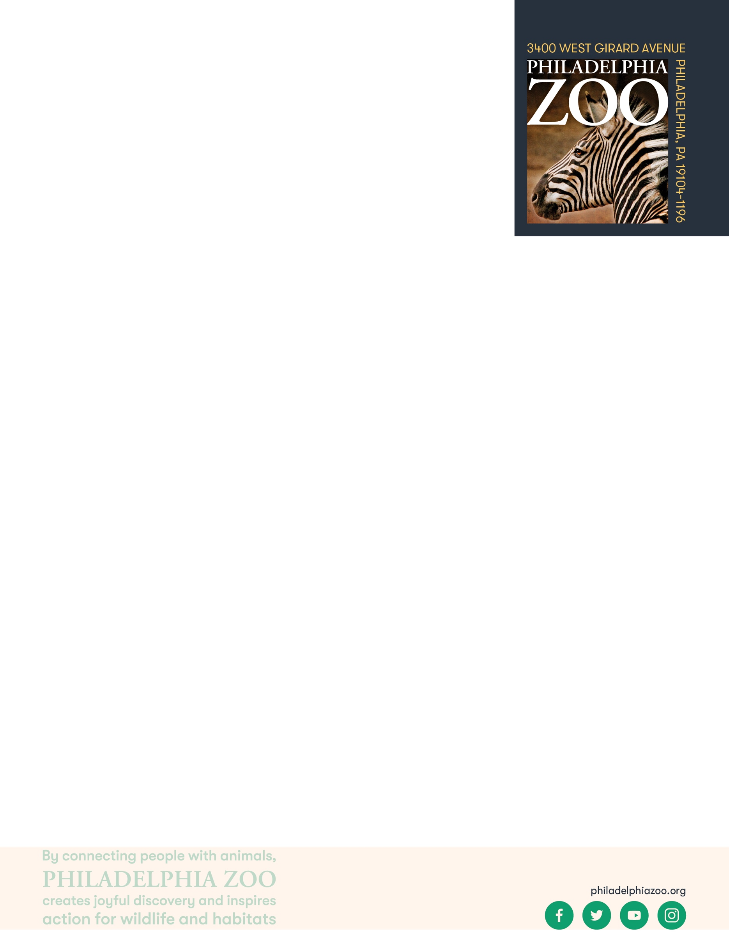

**Key Terms**

* **Classification:** the assignment of organisms to groups that share characteristics
* **Taxonomy:** the system of organisms to categorizations based on shared characteristics and relation
* **Nonliving:** not having life
* **Living:** having life, able to breathe, eat, drink, move, grow, and reproduce
* **Cell:** the basic structural unit of all living things
* **Genes**: the basic unit of heredity that informs the expression of features for a living thing
* **Gene Pool:** the total genetic information of all individuals in a population
* **Dominant Gene**: a variant of a gene that expresses itself more strongly by itself than other versions
* **Recessive Gene**: a variant of a gene whose expression is masked in the presence of a dominant gene
* **Inherited trait:** a characteristic received through family genes
* **Acquired trait:** a characteristic caused by environmental factors (not transferred genetically)

**Background**

There are many ways in which organisms(living things) can be classified. This process involves grouping organisms together based on shared characteristics. Some of these characteristics might include habitat, presence of a backbone, food source, diet, how they move, etc. By observing these organisms and sorting through their similarities and differences, we gain a better understanding of them and their needs, and are therefore able to better work toward protecting and preserving all living things!

**Implementation**

1. Excite: Ask students to reflect on some of their favorite characteristics (physical or behavioral) about themselves. This can be through drawing, writing, discussion, or other ways of expression.
2. Invite students to share their responses in pairs or in groups depending on their comfort levels.
3. Explore: Ask the students to consider and identify where these characteristics might have come from. Were these traits that they have from their experiences or could they have come from their families?
   1. For example, one of their favorite traits might be that they are a good at sports, which could be partially due to genes (such as greater flexibility), but is mainly from learned experiences. Alternatively, a student might share that they love their hair, which could be affected by environmental factors (like hair products) but the color and texture come from genetics and their family.
4. Explain: Certain features of ourselves are gained overtime from experiences, while others we are born with and get from our parents. Features of ourselves that are gained through experiences are called acquired traits, and features that we receive from our families through birth are inherited traits. These traits are determined by our genes, and can be physical, behavioral, or physiological.
5. Elaborate: Invite students to explore some visible inherited traits. Split the class into groups and instruct students to interview and observe from their peers what inherited traits they have. This can include the presence of dimples, the presence of freckles, the presence of unattached earlobes, the presence of a longer second toe, the ability to roll their tongue, the color of their hair, and the color of their eyes.
6. After students have had time to discuss within groups, bring the class together as a class. For each trait, discuss with the class which features appeared more than the alternative (i.e. Did having dimples occur more than not having dimples?) and ask them to consider why that might be.
7. Ask the students to consider other traits that people might have, and if they would be classified inherited or acquired.
8. Evaluate: Invite students to discuss why these genetic differences be important. If time allows, ask students to reflect on themselves and their uniqueness, considering what makes them different and unique and why that’s important.

Expansion

Invite students to explore dominant and recessive traits further, including understanding Punnett squares and the likelihood of traits appearing in a population.

**PA STEELS Curriculum Standards**

3.1.9-12.P,3.1.9-12.Q, 3.1.9-12.R

Name: __________________________________________________________

Date: ___________________________________________________________

Certain features of ourselves are gained overtime from experiences, while others we are born with and get from our families. Interview different people nearby to see what inherited traits they have. Fill in your answers in the chart below. Then, consider which of these traits occurs more and why that might be.

|  |  |  |  |  |  |
| --- | --- | --- | --- | --- | --- |
| Traits | Name: | Name: | Name: | Name: | Which appeared most? |
| Dimples or no dimples? |  |  |  |  |  |
| Freckles or no freckles? |  |  |  |  |  |
| Attached or unattached earlobes? |  |  |  |  |  |
| Able to roll tongue or not? |  |  |  |  |  |
| Short or long second toe? |  |  |  |  |  |
| Hair color: |  |  |  |  |  |
| Eye color: |  |  |  |  |  |