**Characteristics of Life** 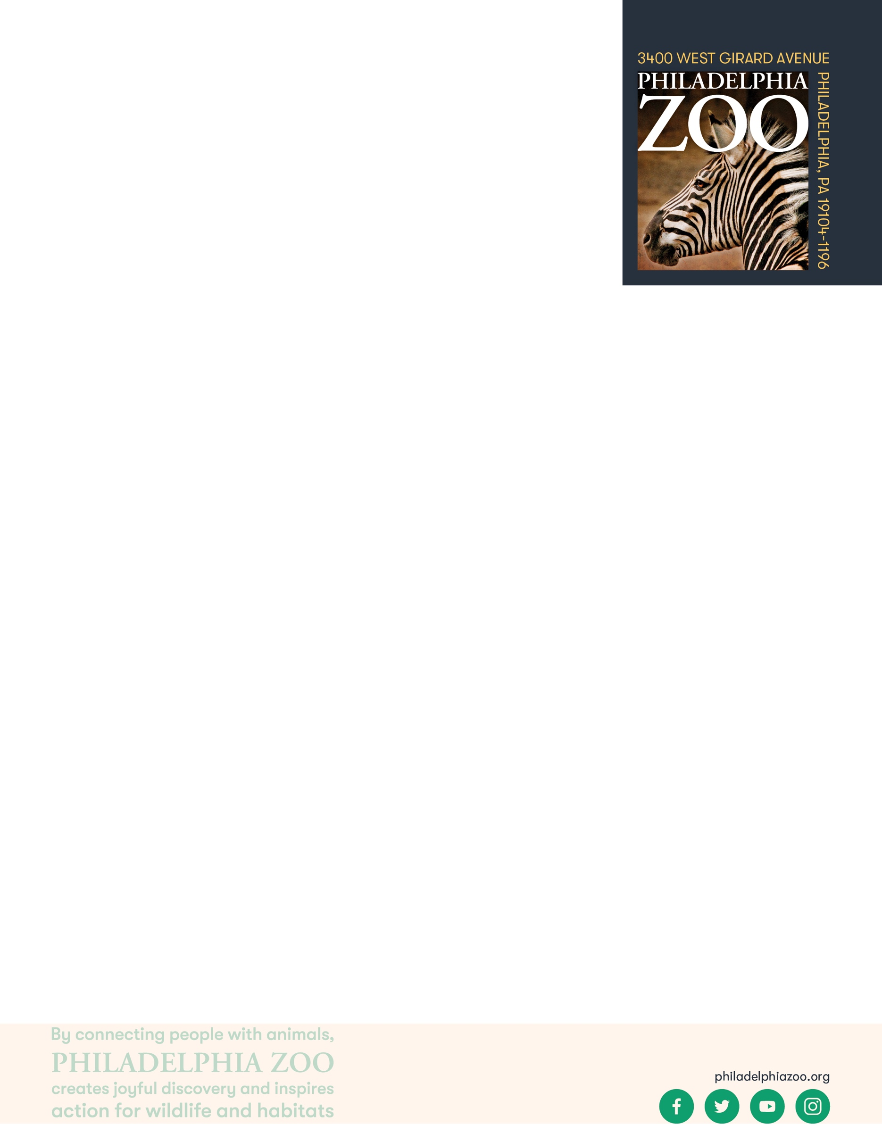

**9-12 Post-Activity**

**Lesson Summary**

Students simulate a bottleneck with objects and analyze a cheetah’s population, considering the gene pool’s viability in a changing environment.

**Objectives**

Students will be able to articulate the importance of genetic diversity

**Essential Question**

Why are living things similar or different from one another?

**Materials**

* Red, Pink, Orange, Yellow, Green, Blue, Purple, Black, and White colored pieces of paper (about 5 of each)
* Empty bottle (such as a water bottle)
* Changes cards (provided at the end of the lesson)
* Scrap Paper (or worksheet such as provided at the end of the lesson)
* Writing utensils

**Prep**

1. 1 Week before: Gather empty bottle and paper as needed.
2. 1 Day before: Print out worksheets as needed (1 for each student), print out the Changes cards (as many sets that would allow each group to select 4). Crumple up each piece of colored paper so that it can fit inside the mouth of the bottle, place all of them inside the empty bottle, and place a cap on top to secure.

**Key Terms**

* **Classification:** the assignment of organisms to groups that share characteristics
* **Taxonomy:** the system of organisms to categorizations based on shared characteristics and relation
* **Nonliving:** not having life
* **Living:** having life, able to breathe, eat, drink, move, grow, and reproduce
* **Cell:** the basic structural unit of all living things
* **Genes**: the basic unit of heredity that informs the expression of features for a living thing
* **Gene Pool:** the total genetic information of all individuals in a population
* **Genetic Diversity**: diversity within a population in which there is enough variety of genetic combinations within the group
* **Biodiversity:** diversity between an individual, diversity between a species, and diversity within a ecosystem all which strengthen the ecosystem
* **Population bottlenecks:** a phenomena within a population when the number of individuals decreases to the extent that variety of genes within the population also decreases
* **Dominant Gene**: a variant of a gene that expresses itself more strongly by itself than other versions
* **Recessive Gene**: a variant of a gene whose expression is masked in the presence of a dominant gene
* **Inherited trait:** a characteristic received through family genes
* **Acquired trait:** a characteristic caused by environmental factors (not transferred genetically)

**Background**

There are many ways in which organisms(living things) can be classified. This process involves grouping organisms together based on shared characteristics. Some of these characteristics might include habitat, presence of a backbone, food source, diet, how they move, etc. By observing these organisms and sorting through their similarities and differences, we gain a better understanding of them and their needs, and are therefore able to better work toward protecting and preserving all living things!

**Implementation**

1. Excite: Invite students to share some of their favorite characteristics of another student in the room.
2. After the students share, ask students how the activity made them feel. Hopefully, the group will share that the activity was a positive one. Point out to the group that highlighting the different strengths of individuals and made the whole group feel stronger.
3. Ask students to then consider why there are different types of genes exhibited in different individuals, and why that might important in a population. Share with students that variation in genes result in visible differences, such as hair colors, and also not visible differences, such as a higher immunity to different diseases. With greater differences, a population of individuals has a large gene pool (the total genetic information of all individuals in a population) with great genetic diversity. This allows for a stronger population with greater longevity.
4. Ask students to consider what detrimental effects could result of low genetic diversity.
5. Explore: Share with students that we will be focusing on one species, cheetahs, and observing their population dynamics. Ask students to share what they know about cheetahs. Add to the students understanding with the following:

Cheetahs are the fastest land animal, able to reach speeds up to 75 miles per hour. Their speed is an important part of their survival, allowing them to catch prey of any speed. Many of their features facilitate their ability to run including their small heads, long legs, slim bodies, and tan-colored coat with black spots.

1. Share with the class that the bottle filled with beads represents a population’s gene pool, with each color representing a different gene. Share with the students what gene each color gene represents. As a class, consider how each characteristic present in this population could be advantageous for an individual or group of individuals. (Ensure this list is available for students for the entire length of the activity)
   * Yellow - camouflage
   * Black - precise vision
   * Green - accurate sense of hearing
   * Purple - adaptability in hunting
   * Orange - strong legs
   * Pink - quick eating ability
   * Blue - solitary tendencies
   * Red - healthy rate of reproduction
   * White - strong immune system
2. Share with the students that they will be split up into groups to represent a new cheetah population. Just as would occur in a wild population, they will be receiving a random assortment of these genes to represent the gene pool of their group’s cheetahs.
3. Split the class into groups. Shake the bottle of genes to mix the colors and distribute a small handful of the colored paper balls to each group of students (Note: they should not receive all 9 colors). Once students have received their papers, invite them to calculate the genetic diversity of the population.
   1. Nine genres (colors) represent 100% genetic diversity in the original population. Therefore, the genetic diversity of the population can be calculated by the following formula: $\frac{\# of genes received}{ 9 original genes} x 100$
4. Then, ask the students to identify which genetic characteristics are present and which were lost as a result of the bottleneck. From this, ask students to describe their cheetah population based on the genetic diversity that is present.
5. Pass out a random selection of 4 “Environmental Changes” card to each group. Provide students some time to read the scenarios presented to them in full, and consider what affect these changes would have on their specific population of cheetahs with the genetic makeup present.
6. Then, ask students to make a prediction of what would happen to their population of cheetahs given the gene pool in that population and all of the environmental changes they were then affected by. Is their population genetically equipped to survive in this environment? Why or why not?
7. Invite the students to return as a class to share their results with others.
8. After the groups have heard about the different cheetah populations with varying gene diversity due to the bottle neck and different outcomes due to environmental changes, ask the students to share any patterns that they may have noticed.
   1. Note: Students will likely have noticed that a greater genetic diversity helped equip a population as a whole to better survive through changes in the environment.
9. As a group, invite students to a discussion on how and why genetic diversity helped to protect a population.
10. Ask students to then examine why a smaller population of animals have a higher risk of becoming extinct.
11. Explain: Many endangered species experience a bottleneck in their gene pool as their population declines and is at risk of extinction – cheetahs are an example. Share the following information about cheetahs:

Research shows that cheetahs have likely reached population sizes where bottleneck events occurred twice already in their history. Once, about 100,00 years ago, after they expanded their range into Asia, Europe, and Africa. And for a second time at the end of the last ice age, about 10,000 years ago, when North American and European cheetahs went extinct.

When these bottleneck events occur, fewer individuals remain and inbreeding becomes very prominent due to a decrease in mate availability. Inbreed reduces the size of the gene pool, and therefore genetic diversity. With fewer offspring and less genetic diversity, the population struggles to grow and adapt to changes in the environment.

Today, cheetahs face many challenges including climate change, hunting, and habitat loss, all resulting in a continued decrease in population. While experiencing these challenges, cheetahs also have a slow reproductive rate which hinders the ability for the population to rebound and make up for a loss in population size. Unfortunately, cheetahs are experiencing another genetic bottleneck now as their populations decline to fewer than 8,000 individuals.

1. Elaborate: Ask students to consider what aspects of this activity were realistic, and which weren’t in regard to genetic makeup and bottlenecks. Some comments may include:
   1. Although genes would not literally go through a bottleneck bottle as was symbolically done in this activity, but there are various events (natural disasters, habitat loss, disease transmission) that could occur to a large population of animals with a large gene pool, that would then minimize the gene pool and genetic variation amongst the individuals.
   2. Although the activity demonstrated how a gene pool could decrease and limit a population’s success in an environment that is experiencing changes, there are many genes that exist within a species that may not be accounted for by only focusing on a select few.
   3. In this activity, we saw a population that exhibits all of the same genes with no variation. This is not always the case with a real population where there are variations with recessive and dominant types. However, the likelihood of lost variations increases as the population becomes smaller and inbreeding becomes more probable. In this case, recessive genes also have a higher likelihood of becoming more prominent.
2. Ask students to consider solutions of how a population can rebound from reduced populations and increase genetic diversity.
3. Evaluate: Ask students to restate the importance of genetic diversity, and differences between individuals, and what implications it has.

**Expansion**

Invite students to research a threatened species from their local area. Ask them to look into if genetic diversity had an effect on their population or decline, and consider what solutions there may be to supporting that species.

**PA STEELS Curriculum Standards**

3.1.9-12.P,3.1.9-12.Q, 3.1.9-12.R

**Additional Resources**

Environmental Changes Cards

|  |  |
| --- | --- |
| Due to food availability changes, leopards increasingly are finding cheetahs as a good option for food. Being equipped with speed to outrun the leopards could be a great benefit. | Precise vision and camouflage allow cheetahs to sneak up on their prey as closely as possible, decreasing the distance necessary to outrun them. |
| A new road has been built across cheetah habitat, fragmenting the large area of land that cheetahs typically rely on. With a smaller area for cheetahs to roam, they may overlap with a greater number of cheetahs. | Unlike other predators, cheetahs do not typically eat the remains of animals. Therefore, they do not tend to build up an immunity to anthrax. However, cheetahs may eat prey that is sickened with the disease. A strong immunity may be able to help them survive. |
| A new generation of captive-born cheetahs, who have the ability to live in the wild, are ready to be released at a nearby reintroduction site. | To avoid competition for food with other scavengers like lions or hyenas, once they’ve captured prey to eat, cheetahs must eat quickly and listen out for others trying to capitalize on their food. |
| A farmer is angered by the loss of his livestock, and wants to send a message to any wild predator he sees. Camouflage helps to stay hidden and undetected. | The size of protected land has doubled due to land donations, allowing the populations of cheetah to experience fewer threats over a greater amount of space. |
| Antelopes, gazelles, impalas, and warthogs, are common prey of cheetahs that have become increasingly popular food options for people as well. As a result, these animals are becoming less available. Adaptability in preying on different foods could be beneficial. | Law enforcement has increased patrolling to reduce the number of cheetahs trafficked and poached. This could help prevent a decline in population. However, depending on the amount of space, cheetahs may have to live closer and may experience greater competition. |
| Half of the cheetah habitat is repurposed for commercial agriculture, shrinking the area availability for cheetahs to meet their basic needs. Cheetahs will have to be able to live together and may experience greater competition. | Livestock of neighboring farms could be an option of food to eat in desperation. However, listening out of the farmers and moving quickly will be important to get away safely. |

Name: __________________________________________________________

Date: ___________________________________________________________

The larger cheetah population has shrunk due to a major event. This new population of cheetahs has experienced a bottleneck, resulting in a few individuals. Just as would occur in a wild population, the individuals of this new population have a random assortment of genes from the larger gene pool.

What percentage of all available genes does your population have?

Nine genes (colors) represent 100% genetic diversity in the original population.

$\frac{\# of different genes received}{ 9 original genes} x 100$ $\frac{}{ 9 } x 100$ = __________%

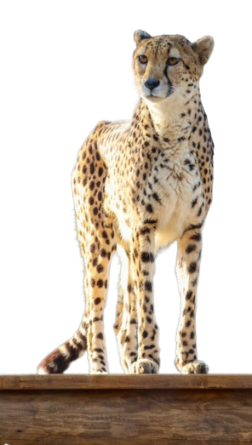

|  |  |
| --- | --- |
| Which genetic characteristics are present in your population after the bottleneck? | Which genetic characteristics did your population lose due to the bottleneck? |
|  |  |

Describe this cheetah population according to the genetic diversity present:

Based on the “Environmental Changes” cards provided, what changes will your population experience?

Make a prediction of what would happen to your population of cheetahs, with their gene pool and the experienced environmental changes. Is your population genetically equipped to survive in this environment? Why or why not?