**Endangered Species**

**3-5 Onsite Activity**

**Lesson Summary**

Students visit two endangered species, read and review their conservation stories, and answer questions in regards to those animals.

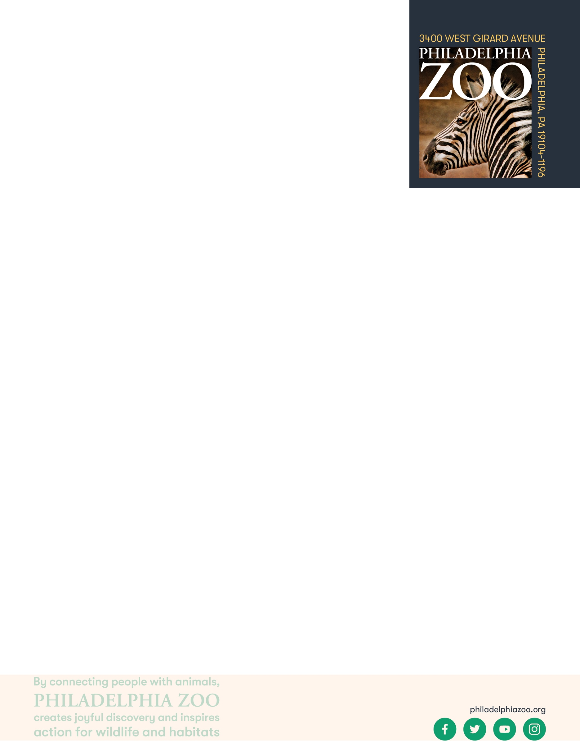

**Objectives**

Students will be able to identify some endangered species and their threats

Students will be able to analyze conservation stories and solutions

Students will be able to consider the ways in which people and communities can work to protect endangered species

**Essential Question**

What is an endangered species and how can people help them?

**Materials**

* Golden Lion Tamarin conservation story and question sheet (attached at the end of the lesson)
* Guam Kingfisher conservation story and question sheet (attached at the end of the lesson)
* Paper (or worksheet such as provided at the end of the lesson)
* Writing utensils

**Prep**

1. 1 Week before: Look at the [Zoo map](https://www.philadelphiazoo.org/zoo-map/) to determine locations for observations (in this case, the PECO Primate Reserve and McNeil Avian Center are good places to start)
2. 1 Day before: Print out informational text (1 for facilitator) and question sheets as needed (1 for facilitator or 1 for each student)
3. 15 minutes before: Prep students for expectations

**Key Terms**

* **Species:** a group of living things that can mate with one another but not with those of other groups
* **Population:** a grouping of the same species
* **Community:** all the plants and animals that live together in the same area
* **Habitat:** the natural environment of an animal or plant, where that living thing can find their food, water, shelter, and space
* **Resources:** materials in the environment necessary for organism health and wellbeing, such as food, water, and shelter
* **Competition:** the process of trying to get something that others are also trying to get
* **Safe:** free from the risk of harm or endangerment
* **Threatened species:** species at risk of harm or endangerment
* **Endangered species:** species of plant or animal that is in danger of becoming extinct
* **Extinct:** species that are no longer existing
* **Conservation:** the study of nature and how to protect it
* **Breed**: to produce young
* **Breeding program**: a program in which endangered species are bred in zoos or other facilities to build a healthy population of those animal

**Background**

All living things need air, food, water, shelter and space and these resources must be present for a species to survive in its habitat. Within that habitat, animals need to share those resources amongst their species and will other animals that may also require those resources. When those resources become diminished due to habitat loss, introduced species, pollution, population size and overharvesting, animals become threatened, endangered, or even extinct. All of us have the opportunity to protect endangered species through our choices, our voices, and our collective actions.

**Implementation**

1. Excite: Welcome students to the Philadelphia Zoo and them to share in what ways they want to support and protect species.
2. Explore: Share with the students that today, they will be hearing about different conservation programs that the Zoo is a part of to help support endangered species. As you head over to PECO Primate Reserve to visit the Golden Lion Tamarins and/or McNeil Avian Center, invite students visit a few exhibits to learn more about the conservation status and stories of various animals.
3. Explain: Once in front of the Golden Lion Tamarins and/or the Sihek (Guam Kingfisher), inform the students that you will be reading a story about these animals. Read the passage aloud for the students to hear or provide each students a print out to read (attached).
4. Elaborate: After finishing the story, answer any questions the students may have about these animals. Ask the students a few questions for fun as well as to assess their understanding.
5. Evaluate: Invite students to a discussion about the importance of the conservation work being done to protect endangered species, how there are many species that are endangered and need help, and how people can play a role in having a positive impact on animals.

**Expansion**

Invite students to engage in a discussion about the similarities and differences between the conservation stories of different animals that they’ve learned about at the Zoo.

**PA STEELS Curriculum Standards**

3.4.3-5.F, 3.4.3-5.E, 3.4.3-5.A

**Golden Lion Tamarin Conservation Story**

The Golden Lion Tamarin is a small monkey that is native to the Atlantic Forest found in Brazil. This monkey, while small, plays an important role in its habitat. These monkeys eat many foods including fruit, and while doing so they spread the seeds and help support new plant growth in the forest. However, the habitat was also being used for other purposes, and golden lion tamarins got very close to extinction. The forest trees were getting knocked down to make room for sugar cane and coffee plantation, for grazing cattle, for logging and to make room for houses and buildings. Parts of the forest also became fragmented and there became many isolated patches of forest instead, keeping the tamarins stuck in one area and not allowing them to be able to get to each other. These Golden Lion Tamarins were also being taken from their home as pets illegally. Due to this habitat loss, habitat fragmentation, and the pet trade golden lion tamarins and the resources they needed became so limited that by the 1970’s, there were less than 200 Golden Lion Tamarins living in the wild.

With so few Golden Lion Tamarins left in the wild, zoos and biologists came together to come up with a plan to save the Golden Lion Tamarins from going extinct. It started with lots of research on these animals. Golden Lion Tamarins are a small monkey, with bright orange fur and they live high in the trees of the forest. These tamarins are territorial and will use scent marking and vocalizations to defend their home. They are omnivores and so they eat fruits and insects. They have long, skinny fingers that allow them to reach into tree crevices and other hiding spaces to find their food. These social animals live in family groups and will spend the day looking for food, playing and grooming each other. Their breeding season is during the warm, wet months and they give birth after 4.5 months and can have 1-2 babies. All members of the group help take care of the new babies and the father is usually the one that will carry them around the forest. They sleep in tree holes to help protect them against predators and are usually are diurnal, so they sleep at night. Knowing all of this information, allows scientists and zoos to come up with ways to help.

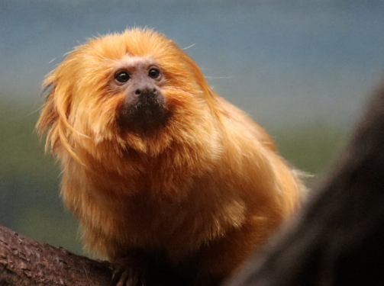 One way to help this species was to create a captive breeding program. A captive breeding program is when zoos will try to breed animals that are living in zoos to help increase the number of those animals and to make sure that they have a very healthy population. 143 zoos became a part of this breeding program and during the 1980’s and through the 1990’s, 146 Golden Lion Tamarins that were living in zoos, were sent back to Brazil to be reintroduced into the wild. A conservation group called the Golden Lion Tamarin Association was created to continue to support the work being done to save this species. A biological reserve was created so that part of the forest would be safe for tamarins and in today there are over 2,500 Golden Lion Tamarins living in the wild. There is still a lot of work that needs to be done to keep them safe including creating ways to connect parts of the forest together through special forested bridges and keeping them safe from yellow fever through vaccines. Today, the Philadelphia Zoo supports the work of the Golden Lion Tamarin Association and is part of the breeding program, as ways to help protect Golden Lion Tamarins.

**Golden Lion Tamarin Questions**

Question 1:

Where are Golden Lion Tamarins native to?

Question 2:

How many Golden Lion Tamarins were left in the wild during the 1970’s.

Question 3:

What do Golden Lion Tamarins eat?

Question 4:

What were some threats they caused the Golden Lion Tamarins to become endangered?

Question 5:

True or False: Are Golden Lion Tamarins social?

Question 6:

Which member of the family usually carries the baby tamarins?

Question 7:

What are some ways a Golden Lion Tamarin might defend its home?

Question 8:

Why are forested bridges important?

Question 9:

What are some ways you think we can help Golden Lion Tamarins?

Question 10:

How many Golden Lion Tamarin are living in the forest today?

**Answers:**

Question 1: Atlantic Forest in Brazil

Question 2: less than 200

Question 3: Fruits and insects

Question 4: Habitat loss, habitat fragmentation, pet trade

Question 5: True

Question 6: the father

Question 7: scent marking and vocalizing/yelling

Question 8: they help connect patches of forest together so that Golden Lion Tamarins can get to each other and fine places to eat

Question 9: Supporting the zoo, sharing the story of Golden Lion Tamarins, reduce/reuse and recycle

Question 10: 2500

**Sihek/Guam Kingfisher Conservation Story**

The Guam Kingfisher, also known as Sihek, is a type of small bird that was once native to the Island of Guam in the Pacific Ocean. Today, this bird is considered extinct in the wild as there are no more Guam Kingfishers that live in the wild. However, this animal would be completely extinct if not for the help of zoos. During World War II, the brown tree snake was introduced to the island of Guam even though this snake was native to Australia, New Guinea and Indonesia. Scientists believe this snake was accidentally brought over to Guam on a cargo ship that was carrying goods to the island. Once the brown tree snake was on the island, it had no predators because it wasn’t native and began to feed on kingfishers, their eggs and other birds. The Guam Kingfishers were not adapted to avoid the brown tree snake and many were killed, leading to a very low population. These events led to an effort to protect the remaining birds and was led by the Philadelphia Zoo.

In 1984, some staff members from the Philadelphia Zoo and others, went to Guam and rescued 29 kingfishers. These birds became the start of breeding program both at the Philadelphia Zoo and a few other zoos across the country. At first, breeding these birds proved to be very hard. Not a lot of information was known about these birds but the zoo tried many different things to make it work and spent a lot of time learning about them. Guam Kingfishers are small birds with large heads and a very strong beak. These kingfishers, unlike many other types of kingfishers, do not rely on fish as food but instead eat grasshoppers, small lizards, insects and other small animals it can find on land. Learning this, the Philadelphia Zoo began feeding the Guam Kingfishers in their care anoles, a type of small lizard and they told other zoos to do the same. They also learned that Guam Kingfishers make nests in the trees by using their beak to jab the tree bark over and over. Both the males and females help make the nest and the eggs take 21-23 days to hatch. They are also not a very social bird and only usually pairs live together but finding the right pair can be challenging. But learning all of this allowed for zoos to breed these birds more successfully and help increase the number.

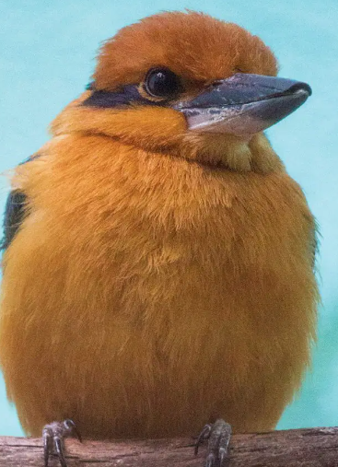 Over the years, many chicks have hatched at the zoo and some have moved to other zoos to breed there or some have even moved to a facility on the island of Guam. While, the kingfishers are still extinct in the wild, there are many efforts to help reduce the number of brown tree snakes on the island. Once the island is safer, one day some of the Kingfishers can be reintroduced back onto the island and with the help of locals living on the island, may no longer be extinct. There are even ways you can help. By visiting the zoo and sharing this story, you can help Guam Kingfishers. You can also help local birds that live near you. Some ways to help local birds is to put things on your windows to prevent bird strikes, you can put our bird feeders and you can limit the amount of light you use during migration.

**Sihek/Guam Kingfisher Questions**

Question 1: 

True or False: Guam Kingfishers are extinct in the wild.

Question 2:

How many kingfishers were rescued by the Philadelphia Zoo?

Question 3:

What do kingfishers eat?

Question 4:

What animal was introduced to the island of Guam that led to the extinction of the kingfishers?

Question 5:

What is another name for the Guam Kingfisher?

Question 6:

How to kingfishers build a nest?

Question 7:

How long does it take for a Guam Kingfisher to hatch?

Question 8:

How did the brown tree snake likely get to the island of Guam?

Question 9:

True or False: Guam Kingfishers have been reintroduced into the wild on Guam?

Question 10:

What are some ways to help local birds?

**Answers**:

Question 1: True

Question 2: 29

Question 3: Small lizards, grasshoppers and other small animals

Question 4: Brown tree snake

Question 5: Sihek

Question 6: Use their beak to jab into a tree

Question 7: 21-23 days

Question 8: Cargo ship

Question 9: False

Question 10: Putting things on windows, reducing light use and bird feeders