**Endangered Species**

**3-5 Post-Activity**

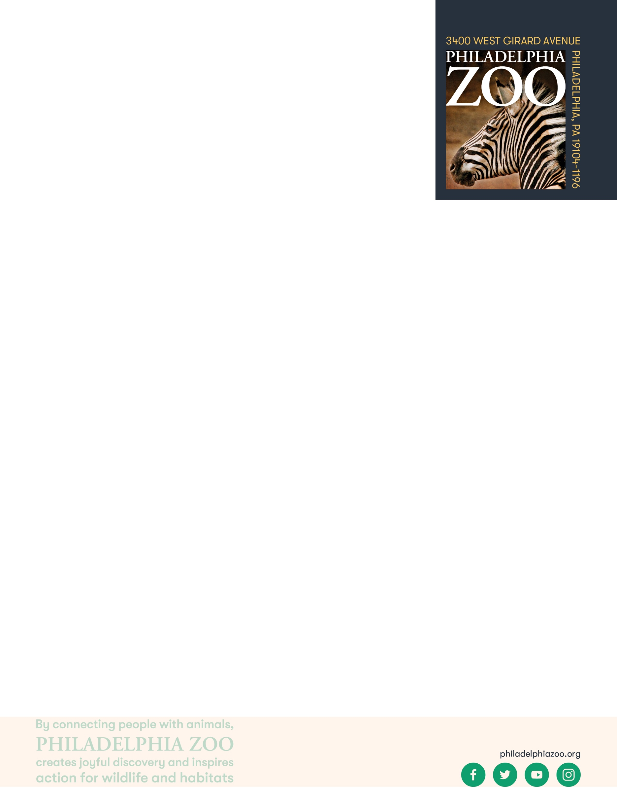

**Lesson Summary**

Students explore to learn more about endangered species, make a plan on how they are going to support these species, and create a educational tool to spread the word.

**Objectives**

Students will be able to define threatened, endangered species, and extinct

Students will be able to problem solve and consider possible solutions they can use to support endangered species

**Essential Question**

What is an endangered species and how can people help them?

**Materials**

* Scrap paper (or worksheet such as provided at the end of the lesson)
* Access to the [Philly Zoo website](https://www.philadelphiazoo.org/animals/) (or other research resources)
* Writing utensils
* Coloring utensils

**Prep**

1. 1 week before: Select photos to present to students.
2. 1 day before: Print and cut out photos for students. Prepare as many sets of media as there will be groups.

**Key Terms**

* **Species:** a group of living things that can mate with one another but not with those of other groups
* **Population:** a grouping of the same species
* **Community:** all the plants and animals that live together in the same area
* **Habitat:** the natural environment of an animal or plant, where that living thing can find their food, water, shelter, and space
* **Resources:** materials in the environment necessary for organism health and wellbeing, such as food, water, and shelter
* **Competition:** the process of trying to get something that others are also trying to get
* **Safe:** free from the risk of harm or endangerment
* **Threatened species:** species at risk of harm or endangerment
* **Endangered species:** species of plant or animal that is in danger of becoming extinct
* **Extinct:** species that are no longer existing
* **Conservation:** the study of nature and how to protect it
* **Breed**: to produce young
* **Breeding program**: a program in which endangered species are bred in zoos or other facilities to build a healthy population of those animal

**Background**

All living things need air, food, water, shelter and space and these resources must be present for a species to survive in its habitat. Within that habitat, animals need to share those resources amongst their species and will other animals that may also require those resources. When those resources become diminished due to habitat loss, introduced species, pollution, population size and overharvesting, animals become threatened, endangered, or even extinct. All of us have the opportunity to protect endangered species through our choices, our voices, and our collective actions.

**Implementation**

1. Excite: Ask students to consider their favorite animal, and ask them to share some ways they would like to help their favorite animal.
2. Explore: Ask students to think about how they would put a plan in place to help their favorite animal. Who would need to be involved? What resources would they need? Are there unique features about the animal that would need to be considered to help the animal? What other questions would we need to find answers to?
3. Share with students that while there are many animals around the world, and many endangered species that exist today, there is hope that many can be helped if people come together and make an effort to protect wildlife and save them from extinction.

1. Explain: Remind students of some of the threats that animals face in the wild and how people can act in ways to lessen those threats. Sometimes people may cut down forests to make items, sometimes they will hunt animals for food, sometimes people harm animals because they might bother the people that live nearby, sometimes a natural disaster hits and that causes an animal to become endangered. When we learn about animals and what is causing issues for them, we can all work together to find solutions that help both the people and the animals to be able to live together.
2. Elaborate: Invite students to consider some endangered species that they are familiar with, and choose one to learn more about. Ask students to use researching resources to look into what threats that animal might be experiencing.
3. Ask students to think of actions they could practice and ask others to adopt that could help conserve and protect this animal from extinction. This can include planting trees, writing letters to governments, teaching people about these animals, and much more. Saving wildlife can be very difficult and there is not one easy solution but people can make changes that positively impact wildlife.
4. Evaluate: Invite students to create an informational tool, such as a poster or flyer, to spread awareness about their chosen endangered species. Ask students to include helpful information about these animals and why they are endangered, as well as what they are planning on doing to help these animals.

1. Bring the class together for a gallery walk, allowing students to spread awareness and learn about other endangered species. Consider displaying these informational tools for other school students to see.

**Expansion**

If you visited the Zoo, have student consider the animals and the information they learned about these animals to create an informational tool of what is threatening these animals and suggestions of how to help them.

Explore native species that are endangered. Invite students to organize a few events to support the endangered species in their area.

There are a few species of animal that were close to extinction but were helped due to the hard work of many people. As a class, pick one or two examples of this and research together to learn what causes these animals to become almost extinct, how these animals were saved and how students can continue to support these animals. Examples include Golden Lion Tamarins, Giant Pandas, Snow Leopards, Guam Rails and American Alligators.

**PA STEELS Curriculum Standards**

3.4.3-5.F, 3.4.3-5.E, 3.4.3-5.A 

|  |  |  |
| --- | --- | --- |
| THREATENED | ENDANGERED | EXTINCT |