**Endangered Species**

**6-8 Onsite Activity**

**Lesson Summary**

Students observe Zoo animals and then add those observations and information they learned into the field guide they created. compare and contrast these features, and determine how similar or different these animals may be classified based on these findings.

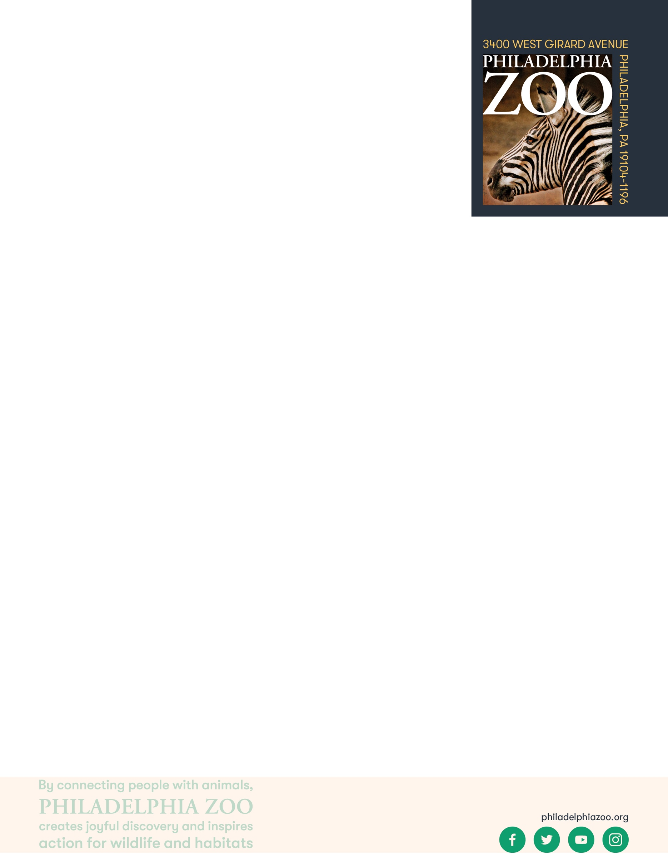

**Objectives**

Students will get hands-on experience by observing animals and learn the importance of studying wildlife.

**Essential Question**

How does observing endangered species help with conservation work?

**Materials**

* Field Guide (created during the pre-activity)
* Writing utensils or coloring utensils for drawings

**Prep**

1. 1 Week before: Look at the [Zoo map](https://www.philadelphiazoo.org/zoo-map/) to determine locations for observations and potential animals.
2. 1 Day before: Make sure students completed their field guides
3. Before leaving for the zoo: Make sure students packed their field guides and all materials needed
4. 15 minutes before: Prep students for expectations

**Key Terms**

* **Species:** a group of living things that can mate with one another but not with those of other groups
* **Population:** a grouping of the same species
* **Habitat:** the natural environment of an animal or plant, where that living thing can find their food, water, shelter, and space
* **Resources:** materials in the environment necessary for organism health and wellbeing, such as food, water, and shelter
* **Threatened species:** species at risk of harm or endangerment
* **Endangered species:** species of plant or animal that is in danger of becoming extinct
* **Extinct:** species that are no longer existing
* **Conservation:** the study of nature and how to protect it

**Background**

There are many factors that could lead to an animal to becoming endangered. Habitat loss, disease, human/wildlife conflict, climate change and much more. Scientists across the world research these animals to learn about the issues they face and work together to help conserve these species. One way to help endangered species is to spread awareness about these animals and educate

others about ways that people can protect them. By understanding what animals

need, scientists can work with other scientists, local people and other

organizations to find ways to help protect these animals from becoming extinct.

Many species have been assessed and their conservation level has been

determined that includes their extinction risks. These levels include Least

Concern, Near Threatened, Vulnerable, Endangered, Critically Endangered,

Extinct in the wild, Extinct, Not evaluated or Data Deficient (IUCN Red List).

These different levels help scientists determine best practices to help these

species. These assessments are made in collaboration with many scientific

groups but work in the field, studying these animals is where the information is

gathered.

**Implementation**

1. Excite: Welcome the students to the Zoo and ask them to share which

animals they are most excited to see and which animals they hope to focus on!

1. Explore: As you walk around the Zoo, have students read the signs around the zoo and check out the conservation status of the animals we have here at the Philadelphia Zoo.
2. Explain: Remind students that spending time observing animals in zoos and in the wild, allows conservationists to come up with solutions for helping animals that are endangered.
3. Elaborate: Locate at least 3 different animals (either in the same place or in different buildings throughout the Zoo) for the students to observe, draw, and describe in detail. Students should be putting these observations and any drawings or notes inside their field guide book.
4. Follow up student observations, with discussion about the conservation levels of these animals, what they observed and why they think this information can help scientists.
5. Evaluate: Ask students to share what additional things they may have learned about these animals through their deeper observations. What are the ecological significances of these animals and the threats they face. Do the students think they have any solutions to help these endangered animals?

**PA STEELS Curriculum Standards**

3.4.6-8.H