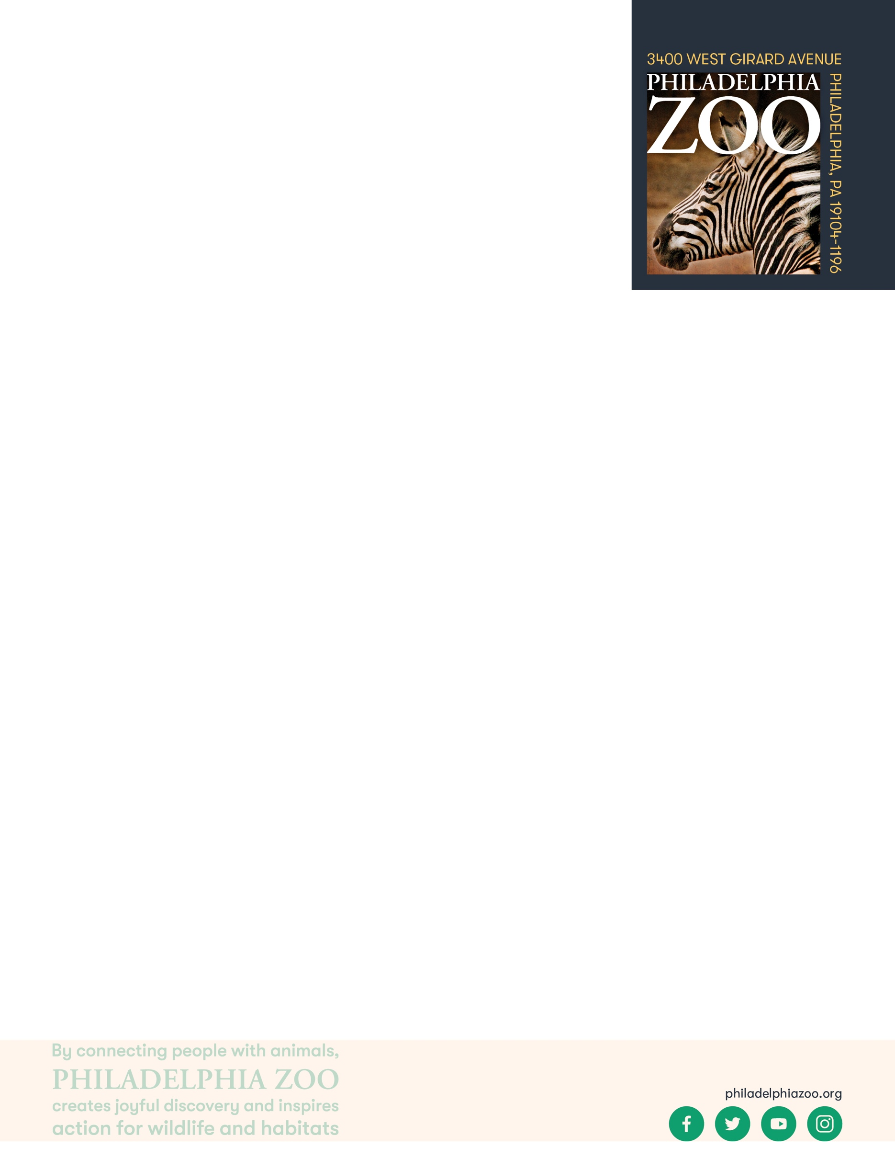**Endangered Species**

**6-8 Post-Activity**

**Lesson Summary**

Students share the field guides they created with their classmates. Students then have a discussion using a list of questions about endangered species.

**Objectives**

Students will be able to share their understanding of endangered species and the process of observing animals. Students will also be able to discuss what it means for an animal to be endangered and how that impacts the ecosystem.

**Essential Question**

What would happen if an endangered species went extinct?

**Materials**

* Field guides created in previous activities
* Discussion questions

**Prep**

1. 1 Week before: Make sure all students have completed their field guides
2. 1 Day before: Share the discussion questions with students so they may begin formulating their responses

**Key Terms**

* **Species:** a group of living things that can mate with one another but not with those of other groups
* **Population:** a grouping of the same species
* **Habitat:** the natural environment of an animal or plant, where that living thing can find their food, water, shelter, and space
* **Resources:** materials in the environment necessary for organism health and wellbeing, such as food, water, and shelter
* **Threatened species:** species at risk of harm or endangerment
* **Endangered species:** species of plant or animal that is in danger of becoming extinct
* **Extinct:** species that are no longer existing
* **Conservation:** the study of nature and how to protect it
* **Ecosystem:** a biological community of organisms that interact and their environment

**Background**

There are many factors that could lead to an animal to becoming endangered. Habitat loss, disease, human/wildlife conflict, climate change and much more. Scientists across the world research these animals to learn about the issues they face and work together to help conserve these species. One way to help endangered species is to spread awareness about these animals and educate

others about ways that people can protect them. By understanding what animals

need, scientists can work with other scientists, local people and other

organizations to find ways to help protect these animals from becoming extinct.

Many species have been assessed and their conservation level has been

determined that includes their extinction risks. These levels include Least

Concern, Near Threatened, Vulnerable, Endangered, Critically Endangered,

Extinct in the wild, Extinct, Not evaluated or Data Deficient (IUCN Red List).

These different levels help scientists determine best practices to help these

species. These assessments are made in collaboration with many scientific

groups but work in the field, studying these animals is where the information is

gathered.

When an animal disappears from their habitat, it can cause issues for

its entire ecosystem. Saving wildlife is valuable because when there are changes

it can cause problems for wildlife, including us.

**Implementation**

1. Excite: Ask students to break up into groups and share their field guide with their classmates.
2. Explore: Have students talk about the different endangered animals they encountered at the zoo, share their conservation status and the information they thought was important enough to include in their field journal. Why did they find that information to be important?
3. Explain: After students have shared in groups, have them come back together as a class and discuss the information they gathered when creating their field journal.
4. Then to keep the discussion going, teachers should pose the following questions to the students, with the idea that they pick one of the animals they researched and observed.
   1. Why is this animal important to its habitat?
   2. What do you think would happen if this animal went extinct?
   3. What do you think people can do to help this species?
   4. Is there anything you think you can do to help this species?
5. Elaborate: Discuss the above questions
6. Share with students that this is an importance of conservation work and why protecting animals is important. Once students discuss, ensure students have come to the consensus that saving endagered species is important and that everyone should act to help wildlife.
7. Evaluate: Ask students to share their takeaway from this assignment with the class.

**Expansion**

Ask students to think about potential solutions to the threats that are leading to animals being threatened or endangered. Habitat loss, habitat degradation, overexploitation, climate change and invasive species or some of those threats. Discuss how these factors affect animals and what can be done to protect and support them.

**PA STEELS Curriculum Standards**

3.4.6-8.H

**Additional Resources**

Investigation Steps to be printed, cut out and separately placed into labeled envelopes.

|  |  |
| --- | --- |
| SCENARIO 1: THE PROBLEM STEP #1  Many local residents have gone to the hospital with similar symptoms of illness. Doctors have figured out that their patients all have a similar diagnosis.  From your understanding, what is the issue here?   1. There is a disease that is spreading 2. There is something unwanted in the air 3. There is something stopping the plants from growing |  |
| If answers A: | If answers B or C: |
| SCENARIO 1: THE TOOLS STEP #2  Scientists agree that a disease is spreading. They’ve figured out that the disease is being carried around by mice that live in the area. The scientists want to control the rat population.  What tool could we use to fix the problem?   1. Trees 2. Compost 3. Predators 4. Pollen | SCENARIO 1: THE PROBLEM TRY AGAIN  Scientists haven’t found that to be the main issue at hand because there doesn’t seem to be any evidence. Try again by reading Step #1 again and remember to think about only the information given to you. |
| If answers C: | If answers A, B, or D |
| SCENARIO 1: THE SERVICE STEP #3  Scientists agree that a predator would be helpful to control the mouse population. Limiting the mouse population would stop the spread of the disease.  What kind of animal would we need?   1. An animal that eats dead stuff (a decomposer or scavenger) 2. An animal that eats meat (a carnivore) 3. An animal that spreads pollen (a pollinator) 4. An animal that spreads nuts and seeds (a seed disperser) | SCENARIO 1: THE TOOLS TRY AGAIN  Scientists don’t think that would have a big impact on the situation. Read Step #2 again and think about the abilities that these different tools have that would be the most useful for this issue. |
| If answers B: | If answers A, C, D: |
| SCENARIO 1: THE SOLUTION STEP #4  That’s the kind of animal we need!  Which local animal helps to provide the service from Step #3?   1. Turkey Vultures 2. Eastern Box Turtles 3. Timber Rattlesnakes 4. Honeybees | SCENARIO 1: THE SERVICE TRY AGAIN  Try again and read the service needed in Step #3 very carefully. |
| If answers C: | If answers A, B, D |
| SCENARIO 1: THE OUTCOME  Awesome! Supporting species like timber rattlesnakes was a great idea.  Snakes like Timber Rattlesnakes are carnivores that eat many smaller animals like mice. In this way, they are controlling populations which is especially helpful when those animals become pests and cause the spread of disease. | SCENARIO 1: THE SOLUTION TRY AGAIN  Look back at Step #4 and think about the capabilities of the different animals to figure out who would be able to provide the help needed. |

|  |  |
| --- | --- |
| SCENARIO 2: THE PROBLEM STEP #1  Local residents have noticed that the air in the area has been looking gray, even when the sun comes out. They think there is a slight smell, and that the air just doesn’t feel fresh.  From your understanding, what is the issue here?   1. There is a disease that is spreading 2. There is something unwanted in the air 3. There is something stopping the plants from growing |  |

|  |  |
| --- | --- |
| If answers B: | If answers A or C: |
| SCENARIO 2: THE TOOLS STEP #2  Scientists agree that there is something bad and unwanted in the air called pollutants. They’ve figured out that the factories nearby and the cars on the road have released a great deal of harmful substances, like carbon dioxide, into the air. They want to replace the harmful substances with safer ones, like oxygen.  What tool could we use to fix the problem?   1. Trees 2. Compost 3. Predators 4. Pollen | SCENARIO 2: THE PROBLEM TRY AGAIN  Scientists haven’t found that to be the main issue at hand because there doesn’t seem to be any evidence. Try again by reading Step #1 again and remember to think about only the information given to you. |
| If answers A: | If answers B, C, or D: |
| SCENARIO 2: THE SERVICE STEP #3    Scientists agree that planting trees would be a helpful tool to clean the air. Trees can create oxygen through a process called photosynthesis. They now want to support the growth of new plants and trees.  What kind of animal would we need?   1. An animal that eats dead stuff (a decomposer or scavenger) 2. An animal that eats meat (a carnivore) 3. An animal that spreads pollen (a pollinator) 4. An animal that spreads nuts and seeds (a seed disperser) | SCENARIO 2: THE TOOLS TRY AGAIN  Scientists don’t think that would have a big impact on the situation. Read Step #2 again and think about the abilities that these different tools have that would be the most useful for this issue. |
| If answers D: | If answers A, B, or C: |
| SCENARIO 2: THE SOLUTION STEP #4  That’s the kind of animal we need!  Which local animal helps to provide the service from Step #3?   1. Turkey Vultures 2. Eastern Box Turtles 3. Timber Rattlesnakes 4. Honeybees | SCENARIO 2: THE SERVICE TRY AGAIN  Try again and read the service needed in Step #3 very carefully. |
| If answers B: | If answers A, C, or D: |
| SCENARIO 2: THE OUTCOME  Awesome! Supporting species like Eastern Box Turtles was a great idea.  Eastern Box Turtles eat plants, and often leave uneaten food behind. The remains and seeds can grow into plants, and plants are helpful in building habitats and producing oxygen! | SCENARIO 2: THE SOLUTION TRY AGAIN  Look back at Step #4 and think about the capabilities of the different animals to figure out who would be able to provide the help needed. |

|  |  |
| --- | --- |
| SCENARIO 3: THE PROBLEM STEP #1  Some local residents have reported the inability to find fresh, local produce to eat. They are hoping to find fruits and veggies to eat to be able to get the nutrients and vitamins they need to stay healthy.  From your understanding, what is the issue here?   1. There is a disease that is spreading 2. There is something unwanted in the air 3. There is something stopping the plants from growing |  |
| If answers C | If answers A or B: |
| SCENARIO 3: THE TOOLS STEP #2  Scientists agree that there is something stopping the plants from growing as they normally do. They’ve figured out that the plants are not able to grow fruits or vegetables because they not been pollinated.  What tool could we use to fix the problem?   1. Trees 2. Compost 3. Predators 4. Pollen | SCENARIO 3: THE PROBLEM TRY AGAIN  Scientists haven’t found that to be the main issue at hand because there doesn’t seem to be any evidence. Try again by reading Step #1 again and remember to think about only the information given to you. |

|  |  |
| --- | --- |
| If answers D: | If answers A, B, or C |
| SCENARIO 3: THE SERVICE STEP #3    Scientists agree that using pollen will support the plants ability to grow fresh produce. Although wind can play a role in pollination, alone it is not growing the fruits and vegetables efficiently enough. The Scientists now want to support animals that can help fertilize plants.  What kind of animal would we need?   1. An animal that eats dead stuff (a decomposer or scavenger) 2. An animal that eats meat (a carnivore) 3. An animal that spreads pollen (a pollinator) 4. An animal that spreads nuts and seeds (a seed disperser) | SCENARIO 3: THE TOOLS TRY AGAIN  Scientists don’t think that would have a big impact on the situation. Read Step #2 again and think about the abilities that these different tools have that would be the most useful for this issue. |
| If answers C: | If answers A, B, or D: |
| SCENARIO 3: THE SOLUTION STEP #4  That’s the kind of animal we need!  Which local animal helps to provide the service from Step #3?   1. Turkey Vultures 2. Eastern Box Turtles 3. Timber Rattlesnakes 4. Honeybees | SCENARIO 3: THE SERVICE TRY AGAIN  Try again and read the service needed in Step #3 very carefully. |
| If answers D: | If answers A, B, or C: |
| SCENARIO 3: THE OUTCOME  Awesome! Supporting species like honeybees was a great idea.  Honeybees feed on plants and pick up pollen on their bodies. As they visit plant to plant, the pollen is left behind, allowing for many plants to become fertilized and grow the produce that we rely on. | SCENARIO 3: THE SOLUTION TRY AGAIN  Look back at Step #4 and think about the capabilities of the different animals to figure out who would be able to provide the help needed. |

|  |  |
| --- | --- |
| SCENARIO 4: THE PROBLEM STEP #1  Some local residents have noticed the plants in their neighborhood to be looking especially sad and dull. The plants don’t seem to be growing as beautifully or healthy as they normally do.  From your understanding, what is the issue here?   1. There is a disease that is spreading 2. There is something unwanted in the air 3. There is something stopping the plants from growing | SCENARIO 4: THE PROBLEM TRY AGAIN  Scientists haven’t found that to be the main issue at hand because there doesn’t seem to be any evidence. Try again by reading Step #1 again and remember to think about only the information given to you. |
| If answers C: | If answers A or B: |
| SCENARIO 4: THE TOOLS STEP #2  Scientists agree that there is something stopping the plants from growing as they normally do. They’ve figured out that the plants are not growing as nicely because they do not have nutrients. They want to give the plants something that would provide them nutrients.  What tool could we use to fix the problem?   1. Trees 2. Compost 3. Predators 4. Pollen | SCENARIO 4: THE PROBLEM TRY AGAIN  Scientists haven’t found that to be the main issue at hand because there doesn’t seem to be any evidence. Try again by reading Step #1 again and remember to think about only the information given to you. |
| If answers B: | If answers A, C, or D: |
| SCENARIO 4: THE SERVICE STEP #3    Scientists agree that compost could help give nutrients to the plants. Compost can be made up of food scraps, dead plants, and animal waste to create healthy soil filled with nutrients. However, we would need an animal that could break apart dead organic matter to help spread the nutrients back into the habitat.  What kind of animal would we need?   1. An animal that eats dead stuff (a decomposer or scavenger) 2. An animal that eats meat (a carnivore) 3. An animal that spreads pollen (a pollinator) 4. An animal that spreads nuts and seeds (a seed disperser) | SCENARIO 4: THE TOOLS TRY AGAIN  Scientists don’t think that would have a big impact on the situation. Read Step #2 again and think about the abilities that these different tools have that would be the most useful for this issue. |
| If answers A: | If answers B, C, or D: |
| SCENARIO 4: THE SOLUTION STEP #4  That’s the kind of animal we need!  Which local animal helps to provide the service from Step #3?   1. Turkey Vultures 2. Eastern Box Turtles 3. Timber Rattlesnakes 4. Honeybees | SCENARIO 4: THE SERVICE TRY AGAIN  Try again and read the service needed in Step #3 very carefully. |
| If answers A: | If answers B, C, or D: |
| SCENARIO 4: THE OUTCOME  Awesome! Supporting species like Turkey Vultures was a great idea.  Turkey vultures are decomposers eat dead stuff that can break up the dead stuff (like food scraps, dead plants, and animal waste) into tiny pieces and nutrients. Once broken up, these nutrients can be recycled and put back into the soil. Thus, they are able to give nutrients to plants that are still living. | SCENARIO 4: THE SOLUTION TRY AGAIN  Look back at Step #4 and think about the capabilities of the different animals to figure out who would be able to provide the help needed. |

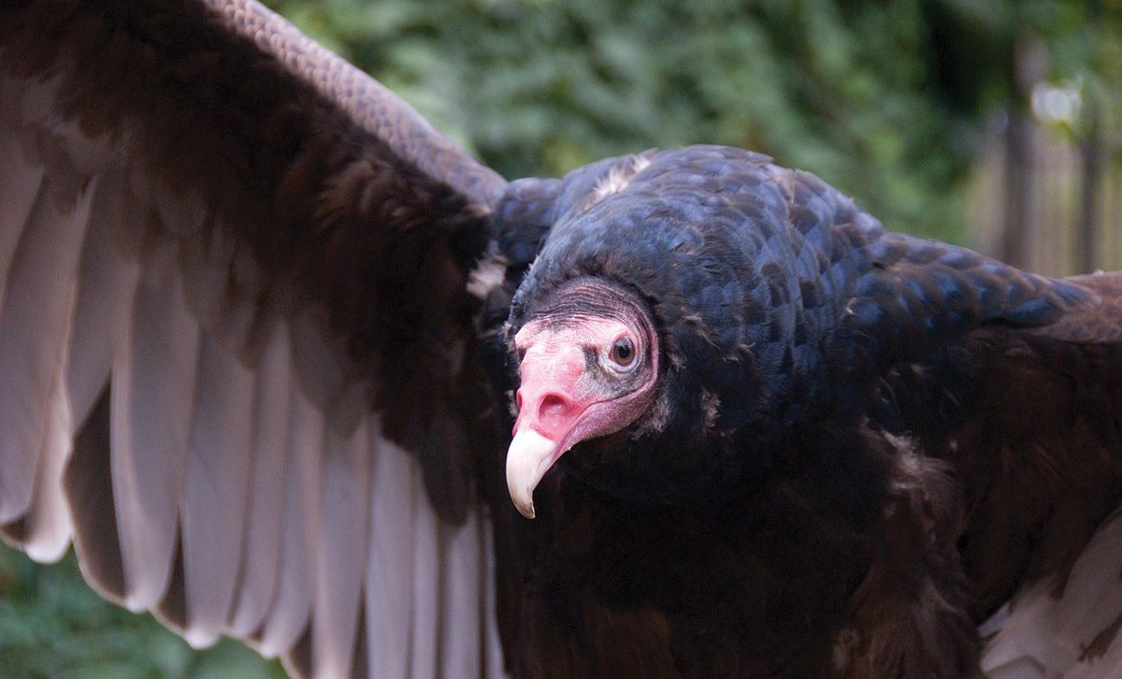

Turkey Vulture

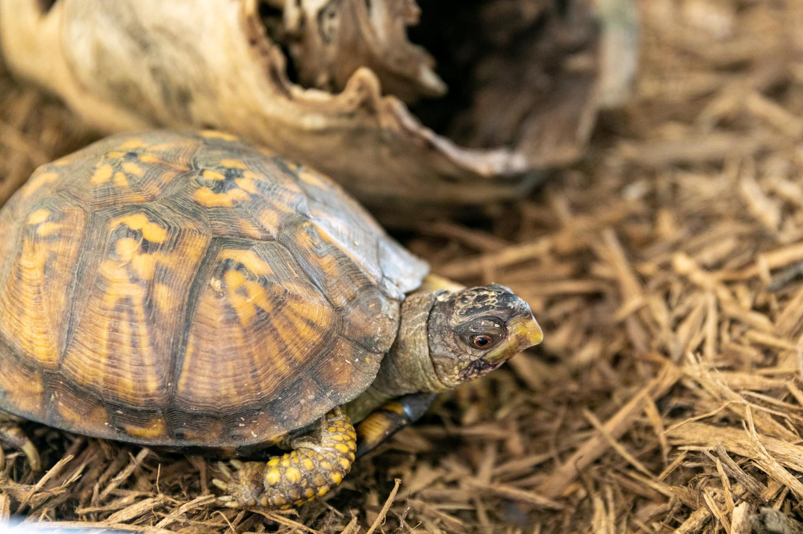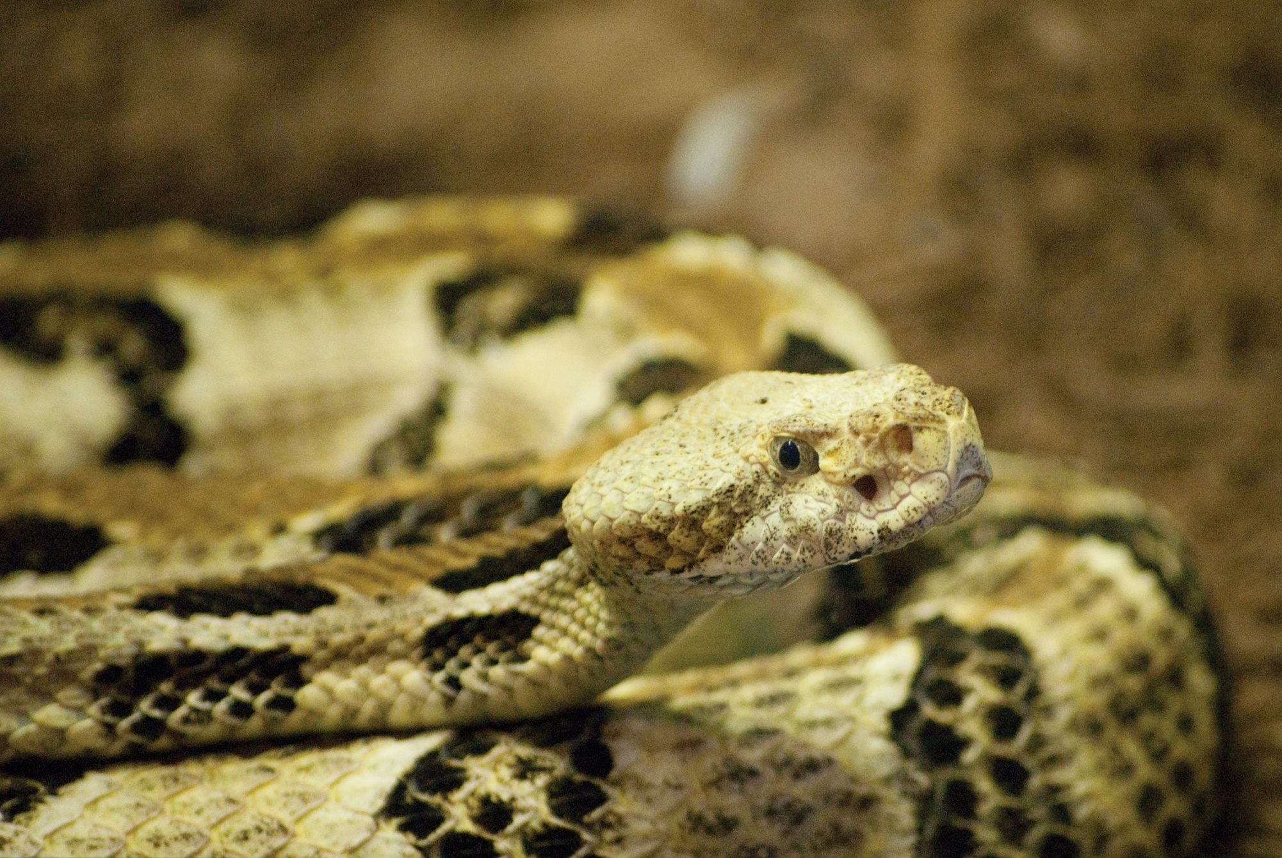

Eastern Box Turtle

Timber Rattlesnake

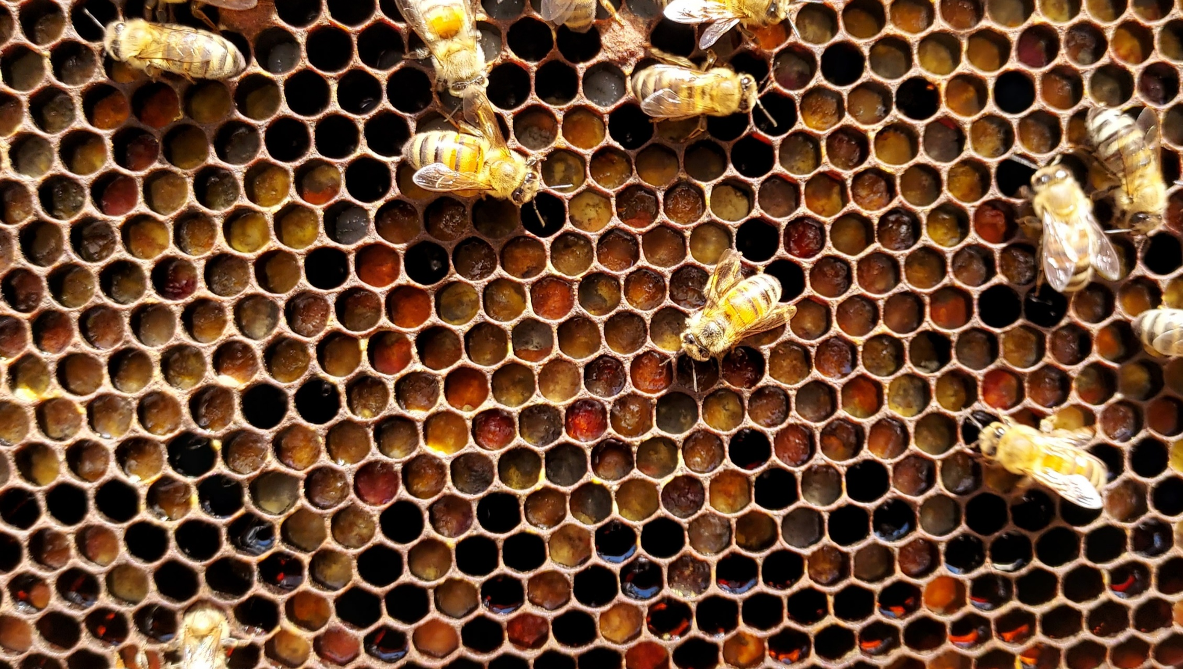

Italian Honeybee

Name: __________________________________________________________

Date: ___________________________________________________________

|  |  |  |  |
| --- | --- | --- | --- |
|  |  |  |  |
| **Turkey Vulture** | **Eastern Box Turtle** | **Timber Rattlesnake** | **Italian Honeybee** |

.

|  |  |  |  |
| --- | --- | --- | --- |
|  | **Answer Choice Letter** | **Answer Choice Details** | **Which animal do you think can help?** |
| Part 1: The Problem |  |  |  |
| Part 2: The Tools |  |  |  |
| Part 3: The Service |  |  |  |
| Part 4: The Solution |  |  |  |
| Part 5: The Outcome |  |  |  |

What other animals also support similar services? ____________________________________________________

What other services can animals provide in a habitat? _________________________________________________

__________________________________________________________________________________________

Why would it be important to have many different types of plants and animals within a habitat? _________________

__________________________________________________________________________________________

What could happen if one of these animals were removed from their habitat? _______________________________



__________________________________________________________________________________________