**Endangered Species**

**9-12 Onsite Activity**

**Lesson Summary**

Students will consider different perspectives when it comes to managing land that is shared by endangered species and people on the island of Madagascar.

**Objectives**

Students will become familiar with some of the challenges facing endangered

species and conservation work to protect. Students will learn that conservation

work is about people as well as animals. Students will learn to work together to

find solutions.

**Essential Question**

How do conservationists work with different groups of people to create solutions that help wildlife and people?

**Materials**

* Laminated map of Madagascar (see below)
* Dry erase markers (red, green and blue if possible)
* Eraser
* Role Cards (8)
* Team Cards (4)

**Prep**

1. 1 Day before: Print out ma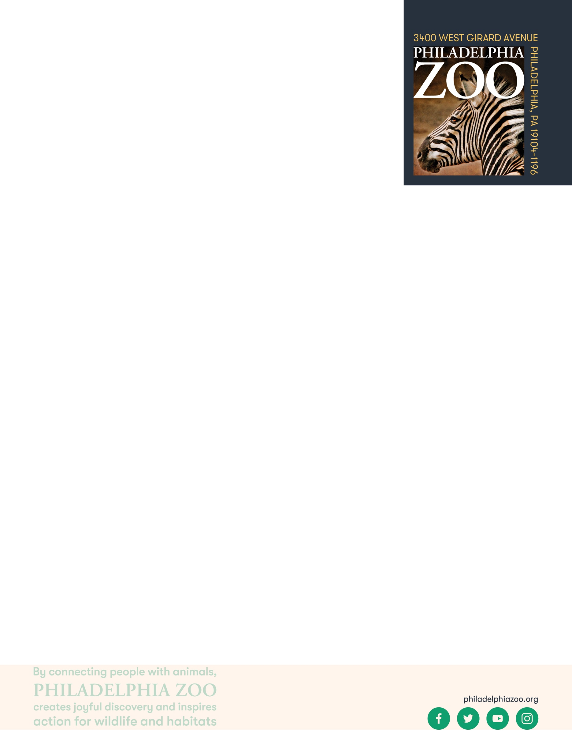terials and gather any other materials

**Key Terms**

* **Endangered species:** species of plant or animal that is in danger of becoming extinct
* **Extinct:** species that are no longer existing
* **Conservation:** the study of nature and how to protect it
* **Endemic**: native to a certain place
* **Human encroachment**: the spread of humans and development into natural areas

**Background**

On the island of Madagascar, many of the species are endemic and are only found on the island, including over 100 different species of lemur. There are several conservation groups that are working to help protect lemurs and their habitat. Madagascar is the 4th largest island in the world and has a population of over 29 million people. With that many people living on the island, the wildlife of Madagascar are facing numerous threats including habitat loss from deforestation for mining, slash-and-burn agriculture and logging, human encroachment, collection for the illegal pet trade, climate change issues, introduction of invasive species and more. Much of the wildlife on Madagascar is threatened with extinction and conservationists across the world are trying to find solutions to help prevent extinction. But these issues can be challenging to solve in a way that benefits both the people and wildlife.

**Implementation**

1. Excite: Ask students if they % know about any animals or any information about the island of Madagascar. Have them share with the class any information they might know.
2. If students do not bring it up, talk about how a lot of the wildlife on Madagascar are endemic and only found on the island and no where else in the world. One well known animal is the lemurs. There are over 100 lemur species and all of them live somewhere on Madagascar.
3. Explore: Ask the students to do some research about lemurs and the island of Madagascar.
4. Explain: Because many of the plants and animals found on the island are only found on Madagascar, conservationists work to help protect many of those species. Only about 10% of forest remains on the island and habitat loss is one of the biggest threats impacting wildlife. However, Madagascar is not just inhabited by lemurs and other animals but also by people. Therefore, conservationists must work with the local people and consider them when coming up with solutions to help wildlife.

1. Elaborate: Invite students to complete the Madagascar Conservation Activity. Divide the students into 8 groups and give 1 role card to each group. Then have each group share their assigned role with the class. Participants have to stay “in character” for the rest of the activity and should think with the interest of their role in mind.
2. Reveal the team cards and place them at four sides of the Madagascar map, face up and place the corresponding markers or eraser with card they belong with. Considering their role, have each team choose the team that they think fits their role.
3. Now each team takes turn filling in the map of Madagascar following the team cards. Only one person on a team should draw at a time. Start with the green team, then red, then blue and lastly gray. When it is time for a team to draw, it should be for 10 seconds at a time. Please remind the gray team that they can only erase a small area at a time and never the entire map. Complete 5 rounds and feel free to change up the order after the first round if desired. Once complete, have everyone check out the map to see how it ended up.

1. Evaluate: Invite students to discuss the end results of the map and explain the decisions they made. Ask questions like what it difficult to come to a compromise? Are there any other roles you think need to be considered? In real life, there are many interests competing for the land of Madagascar, as well as many other places across the world.

**PA STEELS Curriculum Standards**

3.4.9-12.A,3.4.9-12.B,3.4.9-12.D,3.4.9-12.G

**Role Cards (8)**

You are a…

**Nickel/Cobalt Miner**

You work a local nickel/cobalt mine and that is how you make a living. Conditions may not always be the best but with the high demand for nickel and cobalt, I have a job that helps me afford food and a place to live.

You are a…

**Local Villager**

You live on the island and rely on the forest too for its resources. Sometimes you need to clear the trees for firewood or for making charcoal to help you cook your food. You rely on the forest but there is becoming less and less forest.

You are a…

**Government**

**Legislator**

You are a member of the local government. You have taken on the responsibility of determining what is best for your people and your land. This often means choosing to help either business or conservation.

You are a…

**Mining Company**

You represent a company which manages a large cobalt/nickel mine. The demand for this product is high (nickel and cobalt are in most electronic devices) and so the company makes millions of dollars and employs many people.

You are a…

**Lemur**

You are an animal that lives in the forest on the island. You rely on the forest for food, shelter, water and everything else you need. This island is the only place you live and you are threatened with extinction.

You are an…

**American**

**Consumer**

You live far away in the United States. You may not know it, but the decisions you make about what to buy has a lot to do with the rest of the world. How do you feel about that?

You are a…

**Conservationist**

You are dedicated to saving wild places and endangered species of the world. You try to save as much habitat as possible and prevent destruction of the forest but still understand the importance of helping the local people too.

You are an…

**Eco-Tourist Guide**

You make your living by serving as a guide for people who are visiting Madagascar to be out in nature and see wildlife. You need wild places to remain, in order to make money by showing tourists.

**Team Cards (4)**

**Your team wants…**

**More Development**

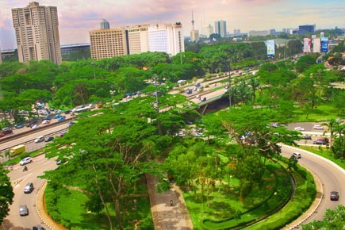

Draw blue boxes on the map to represent

cities and blue lines to represent roads.



**Your team wants…**

**More Mines**

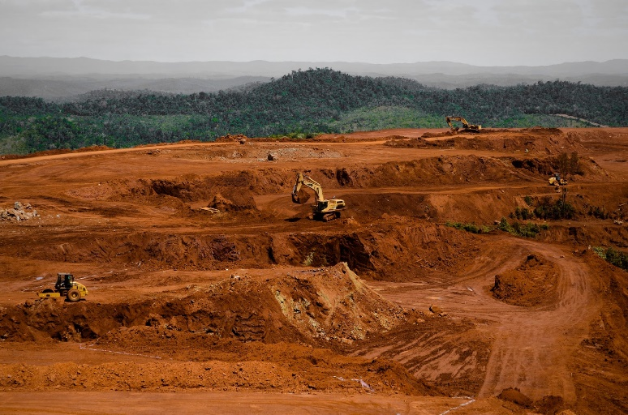

Draw red X’s on the map to mark areas of

plantation.

**Your team wants…**

**More Forest**

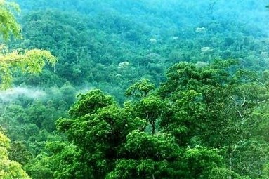

Draw green circles on the map to represent

trees and rainforest.



**Your team wants…**

**Compromise**

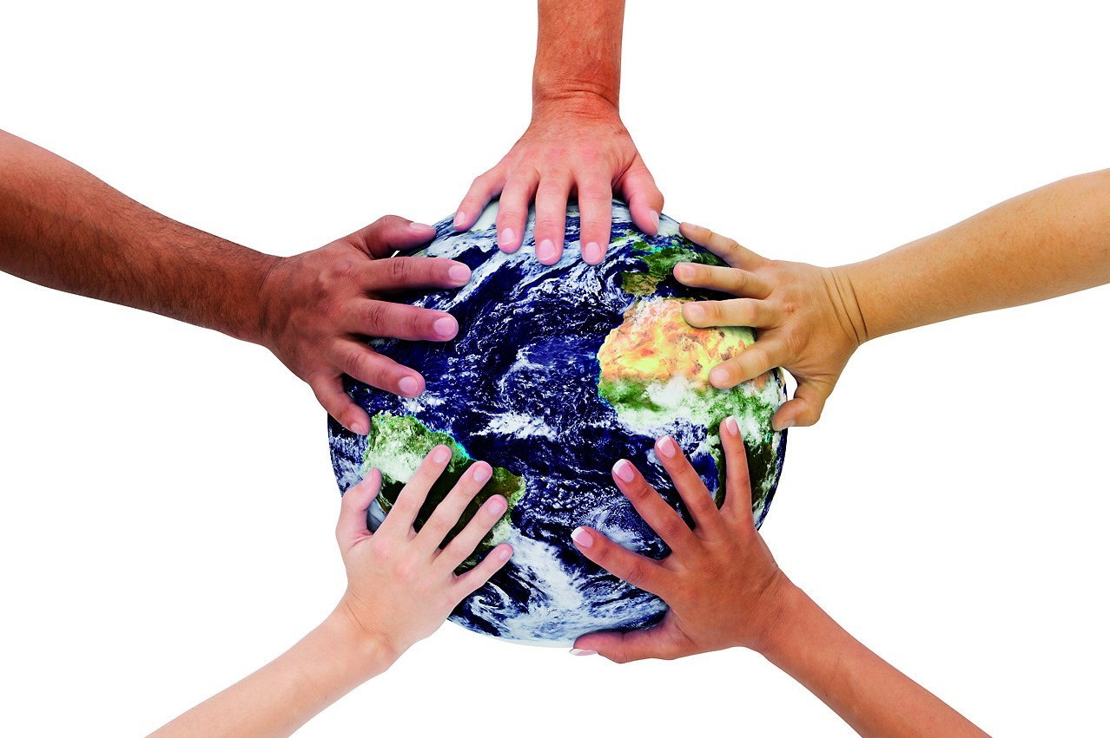

You hold the eraser. On your turn you can

erase lines others have made.



**Map of Madagascar**

**Madagascar**

