**Endangered Species**

**9-12 Onsite Activity**

**Lesson Summary**

Students observe and learn about endangered species that live at the Philadelphia Zoo.

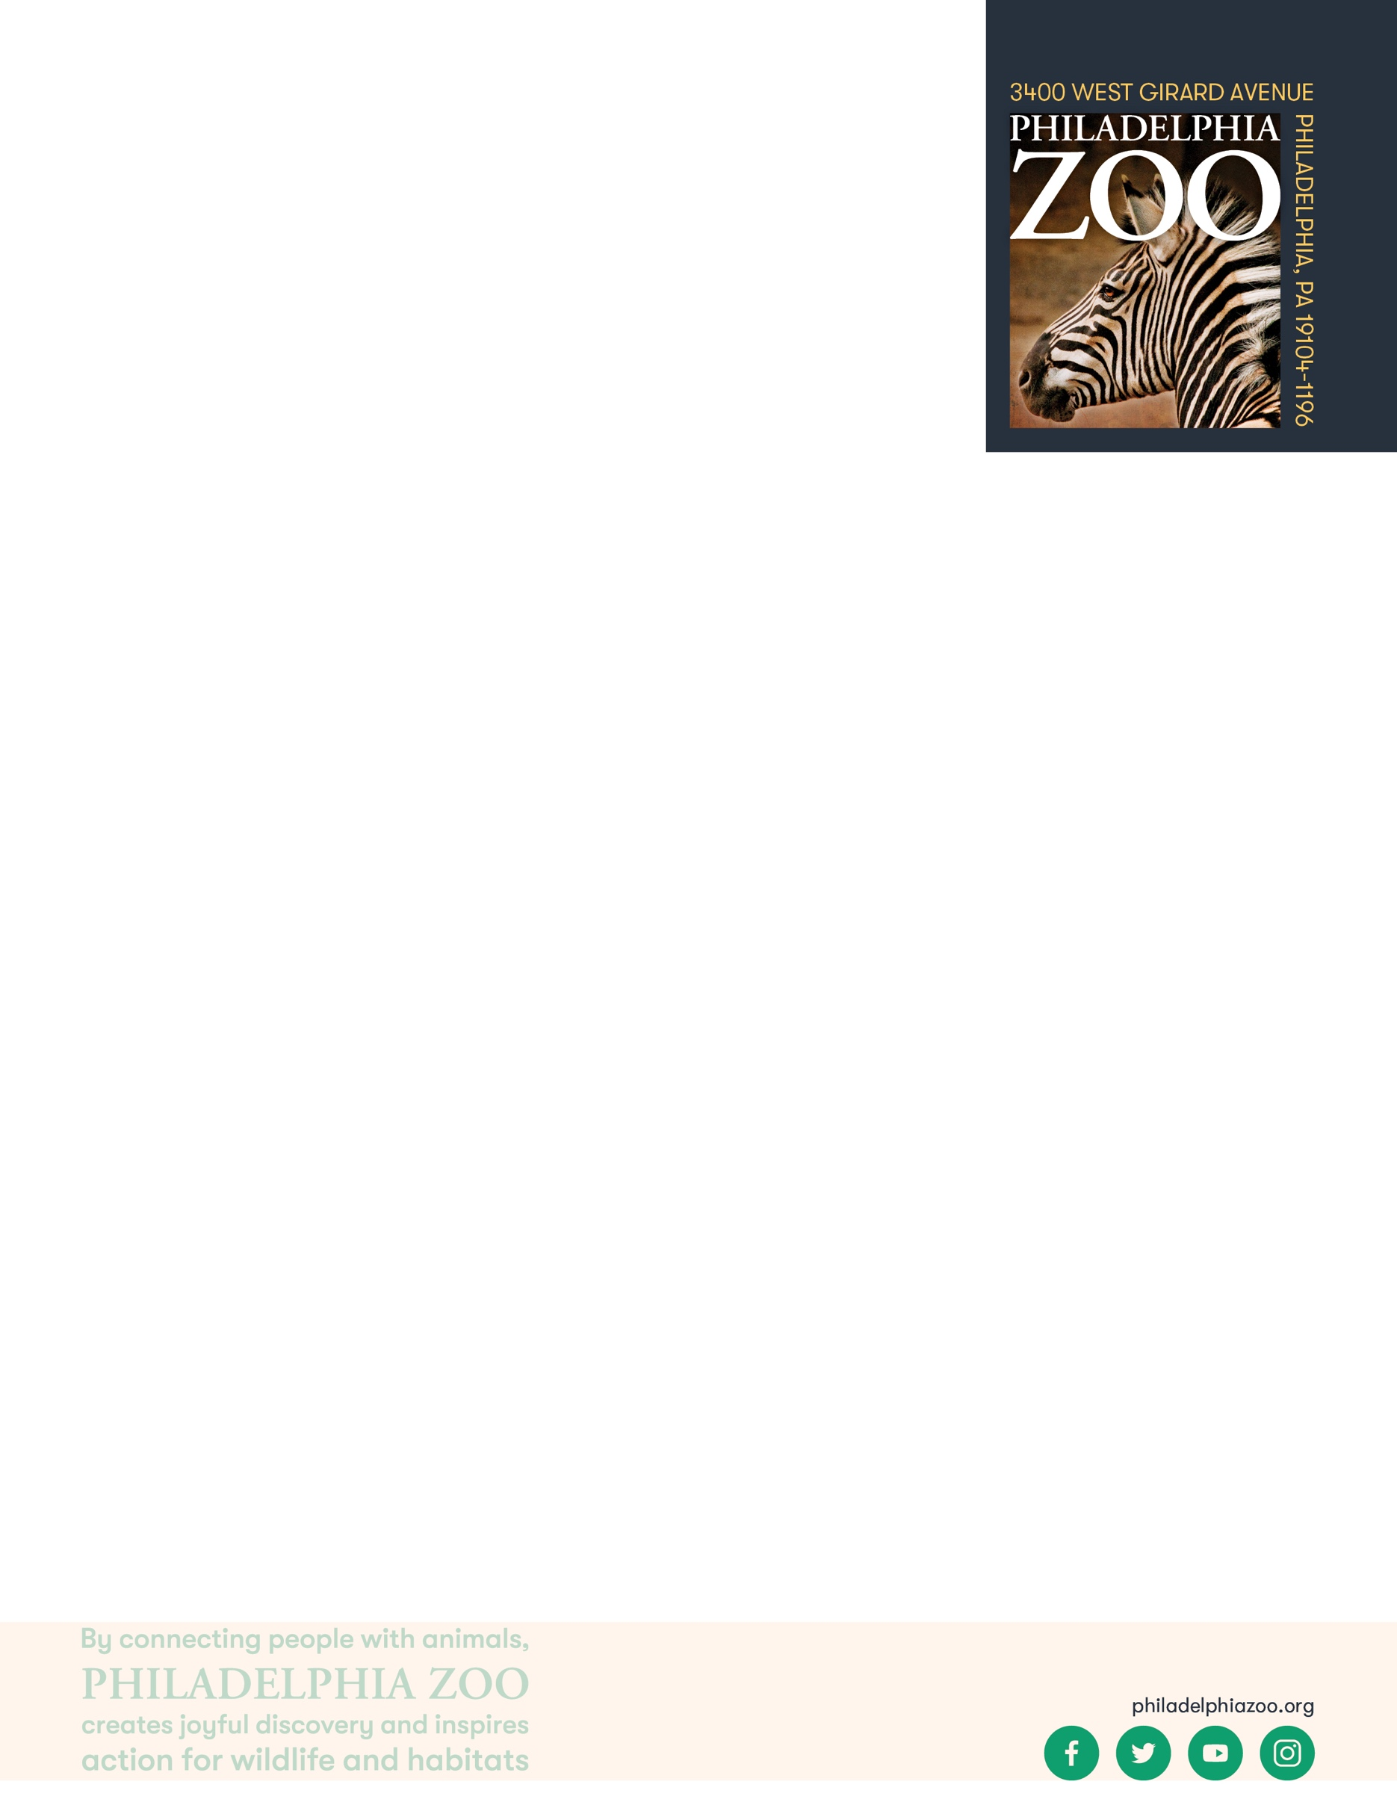

**Objectives**

Students will be able to observe endangered species

Students will be able to learn about the threats and reasons that an animal is endangered and learn about some solutions to helping those species

**Essential Question**

How does an animal become endangered and what must we learn about them in order to prevent their extinction?

**Materials**

* Notebook or loose-leaf paper
* Writing utensils

**Prep**

1. 1 Week before: Look at the Zoo’s [website](https://www.philadelphiazoo.org/animals/) to see which endangered species are found at the Philadelphia Zoo, examples include orangutans, gorillas, Sihek (Guam Kingfishers), Golden Lion Tamarins and Galapagos Tortoises. Look at the [Zoo map](https://www.philadelphiazoo.org/zoo-map/) to determine locations for observations. Then have students begin researching a few of the endangered animals each student is most interested in.
2. 15 minutes before: Prep students for expectations

**Key Terms**

* **Endangered species:** species of plant or animal that is in danger of becoming extinct
* **Extinct:** species that are no longer existing
* **Conservation:** the study of nature and how to protect it
* **Empathy:** the ability to understand, recognize and share the thoughts and feelings of another person, animal or fictional character.

**Background**

The Philadelphia Zoo is home to many animals that are endangered. Having endangered species at the Zoo is important for helping these species from becoming extinct. Many of our species are part of the Species Survival Plan which is a program to help increase genetic diversity within AZA (Association of Zoos and Aquariums) facilities and help increase populations. Animals at zoos are also ambassadors for their wild counterparts and help connect people with wildlife with the goal of increasing empathy for wildlife and teaching others about how to help species from going extinct.

The Zoo also partners with several conservation organizations that work to protect endangered species. These organizations include New Nature Foundation, Save the Golden Lion Tamarin, Cheetah Conservation Fund and other organizations. The Zoo also has a conservation

education team that shares information with the Zoo’s visitors and students

across the area about endangered species. Endangered species face many

threats including habitat loss, hunting, climate change, human encroachment,

disease and more. The Zoo works to teach others about these threats and how

people can help these animals.

**Implementation**

1. Excite: Welcome the students to the Zoo! As you walk around the Zoo, verbally discuss the importance of zoos as it relates to endangered species.
2. Explore: Have students travel to the area of the Zoo that one of the endangered animals they researched lives. Have students take notes about the information they gather while at the Zoo about the animal they would like to focus on. Students should be reading the signs, taking pictures or making drawings, observing the species and talking with any available Zoo staff.
3. Explain: Remind students that conservationists around the world must gather as much information as possible to then be able to find solutions to protecting endangered species.



1. Elaborate: While observing their chosen animal, have students think about what they think the zoo might be doing to save this species and why it is important to save endangered species. What would happen if this animal went extinct? Why is protecting this species so important?

1. Evaluate: Have students discuss their findings and why they feel the animal they observed is important and why they need help.

**PA STEELS Curriculum Standards**

3.4.9-12.A,3.4.9-12.B,3.4.9-12.D,3.4.9-12.G