**Endangered Species**

**K-2 Pre-Activity**

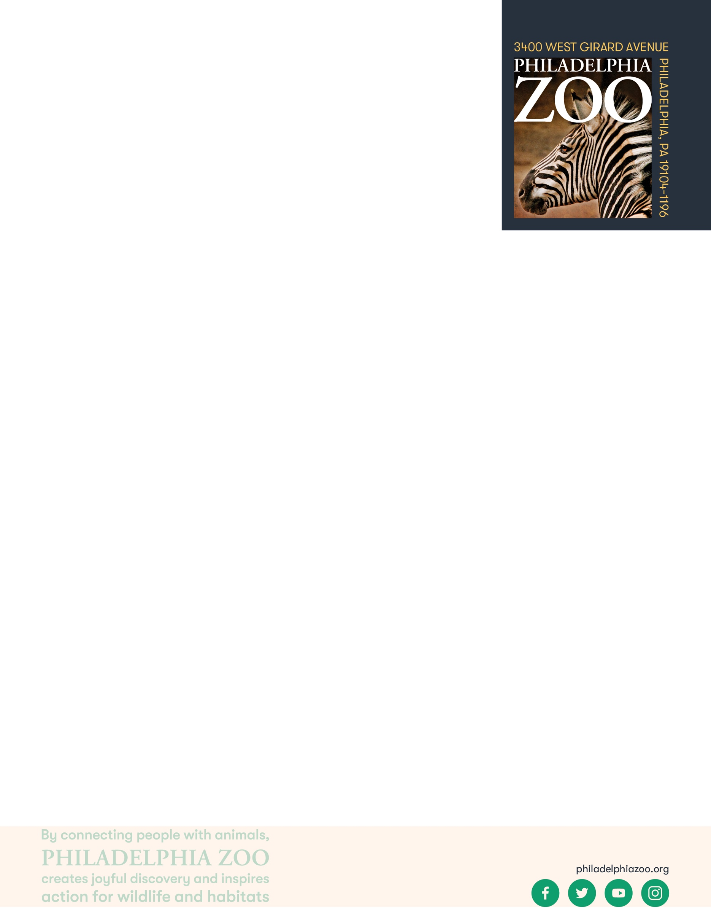

**Lesson Summary**

Students play a simulation game to explore how resources are shared, and examine ways that resources can become less available.

**Objectives**

Students will be able to explore how people and animal share resources

Students will be able to provide reasons for why species become endangered

Students will be able to define what an endangered species is and what makes an animal threatened, endangered or extinct.

**Essential Question**

What is an endangered species?

**Materials**

* Provided resources cards (provided at the end of the lesson, print as many copies that would allow every student to have one of each resource)
* Envelopes (for as many as there are students)
* Scrap paper
* Writing utensils

**Prep**

1. 1 Day before: Print and cut out resource cards. Place all of the resources together in a bowl or bucket

**Key Terms**

* **Species:** a group of living things that can mate with one another but not with those of other groups
* **Population:** a grouping of the same species
* **Community:** all the plants and animals that live together in the same area
* **Producer:** organisms that generate food and energy for themselves and others
* **Consumer:** organisms that rely on producers or other consumers for food and energy
* **Food Chain:** a series of living beings in which each serves as food for the next
* **Food Web:** the interlocking food chains within an ecological community
* **Habitat:** the natural environment of an animal or plant, where that living thing can find their food, water, shelter, and space
* **Resources:** materials in the environment necessary for organism health and wellbeing, such as food, water, and shelter
* **Competition:** the process of trying to get something that others are also trying to get
* **Safe:** free from the risk of harm or endangerment
* **Threatened species:** species at risk of harm or endangerment
* **Endangered species:** species of plant or animal that is in danger of becoming extinct
* **Extinct:** species that are no longer existing
* **Conservation:** the study of nature and how to protect it

**Background**

All living things need air, food, water, shelter and space and these resources must be present for a species to survive in its habitat. Within that habitat, animals need to share those resources amongst their species and will other animals that may also require those resources. When those resources become diminished due to habitat loss, introduced species, pollution, population size and overharvesting, animals become threatened, endangered, or even extinct. All of us have the opportunity to protect endangered species through our choices, our voices, and our collective actions.

**Implementation**

1. Excite: Have students share what some of their favorite animals and what those animals need to survive. Refresh students’ memories that a habitat is where an animal gets all of the basic needs that they rely on.
2. Explore: Share with the students that they be acting as their favorite animals exploring looking for the things that they need.
3. Provide each student an envelope and invite them to write their name on the envelope. Share with them that this envelope will represent their habitat. As they are doing that, scatter the pieces of paper throughout the room with the blank side facing up (don’t share with the students what the colors or symbols on the paper represents).
4. When the students and the room are all ready, demonstrate to the students that they will leave their habitats at their desk, walk and move around the room collecting their resources (represented by the pieces of paper) one at a time, and returning the resources to the habitat every time they pick one up.
5. Gather the students in a central location. At your signal, the students will begin to walk through the habitat collecting items needed in their habitat. Students should all of the resources until they are gone.
6. Once students have collected all the of the available resources, have students return to their seats where their habitats are.
7. Explain: Share with the students that each color and symbol represent a basic need. The brown triangle represents their shelter, the blue droplet represents water, and the green leaf represents food. Ask the students to assess what they were able to gather.
8. Ask students to raise their hand if they were able to get at least one of each basic need. Ask students to raise their hand if they were able to get at least 2 of the basic needs. Ask students to raise their hand if they were only able to get one of the basic needs.
9. In smaller groups, invite students to discuss what they think having all the resources or not having all the resources could mean if they were their animal in a wild habitat. Have students return to the class to share out. Obtaining all of the resources could mean having all the basic needs to survive, but not having all the resources could mean that the animal wouldn’t have all the things it needs to survive.
10. Share with the group that in a habitat, even if there are enough resources to go around, there is natural competition between the animals that live there. Ask the students if they think the same amount of resources will always be available to all the animals.
11. All living things need air, food, water, shelter and space to live but when those resources are not all available, these animal populations could go down. If resources do not become available again and population sizes continue to drop, the animals could become threatened or endangered and could eventually go extinct.
12. Elaborate: Ask students to consider why would any of the resources become less available. Some discussion topics might include how cutting down trees (deforestation) could cause habitat loss and a loss of access to resources like food, water, and shelter. Or hunting could cause there to be fewer animals, which impacts not only those animals but the other animals that rely on them.
    1. Habitat loss is disappearance of natural environment, caused by natural reasons (like floods, earthquakes, volcanic eruptions) or by humans (such as to clear the land to build or farm)
    2. Introduced Species are living things that have been brought to new habitats (either purposely or accidentally) which creates more competition for resources
    3. Pollution is the presence of harmful materials in natural environments (air, water, land) making it difficult for survival
    4. Population size refers to relative population sizes of different animals. All living things are related and if any population gets too small or too big, it can have impacts on other species. Causes increase in competition for resources and then a decline in the availability for these resources
    5. Overharvesting is the removal of too many resources from the environment, including hunting or harvesting of plants or animals by people
13. Offer to play the game again with different rounds representing different situations that may occur. For example, to represent a drought, take away some of the water cards to make it less available. Or, to represent habitat loss such as deforestation, take away some shelter as well as some food cards to demonstrate their decreased availability.

1. Evaluate: Asks students to define what threatened, endangered or extinct animal is and reasons why animals may become classified as such.

**Extension**

Introduce a predator into the habitat for one or multiple rounds. Elect one student to be a predator that will start from a “den” off to the side, and then when given the signal, they will hop around the habitat “tagging” an animal. When the predator tags an animal, the animal joins the predator. Discussion topics could discuss the interactions between animals in a habitat, and how predator and prey relationships help to keep population sizes in balance and decrease natural competition amongst animals.

**PA STEELS Curriculum Standards**

3.4.K-2.A, 3.4.K-2.D

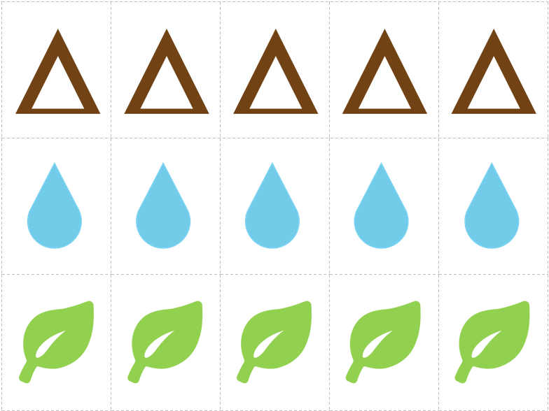

|  |  |  |
| --- | --- | --- |
| THREATENED | ENDANGERED | EXTINCT |