**Endangered Species**

**K-2 Onsite Activity**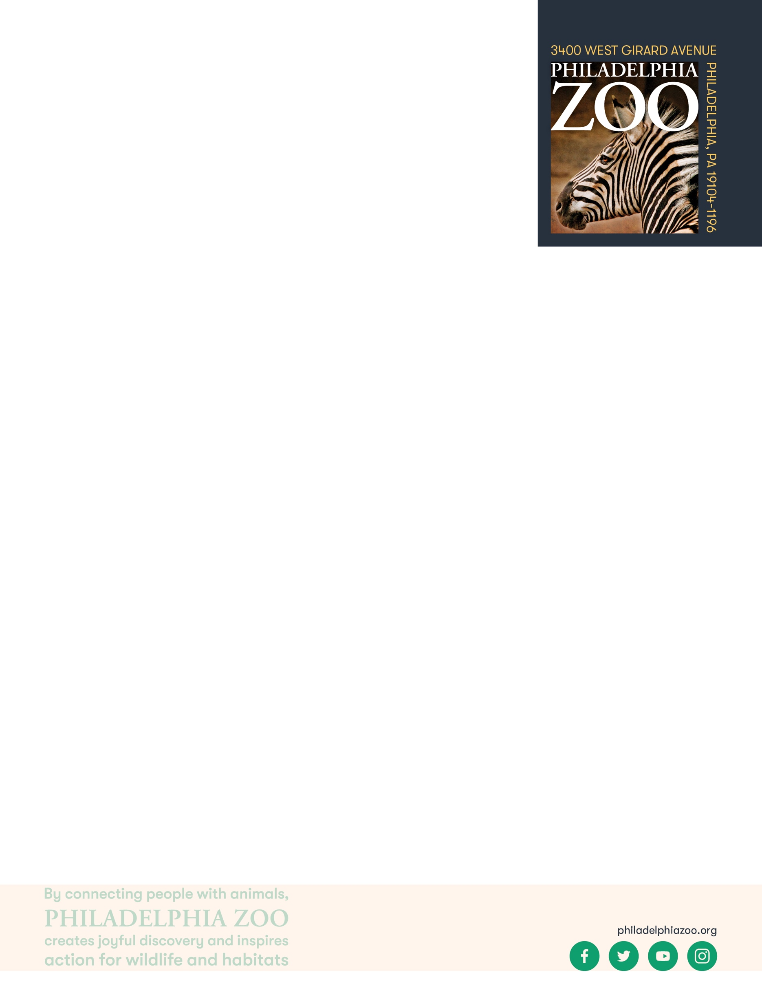

**Lesson Summary**

Students visit a species at the Zoo to learn more about an example of an endangered species, consider why this species might have become endangered, and to problem solve how to support this species.

**Objectives**

Students will be able to apply knowledge of endangered species to understand an example of an endangered species deeper

Students will be able to use context to consider ways to support endangered species

**Essential Question**

What is an endangered species and how can people help them?

**Materials**

* Access to the story of the Rodrigues Fruit physically or digitally (provided at the end of the lesson)
* Paper (or worksheet such as provided at the end of the lesson)
* Writing utensils

**Prep**

1. 1 Week before: Look at the [Zoo map](https://www.philadelphiazoo.org/zoo-map/) to determine locations for observations (in this case, the Rare Animal Conservation Center is a great place to start)
2. 1 Day before: Print out informational text (1 for facilitator) and worksheets as needed (1 for each student)
3. 15 minutes before: Prep students for expectations

**Key Terms**

* **Species:** a group of living things that can mate with one another but not with those of other groups
* **Population:** a grouping of the same species
* **Community:** all the plants and animals that live together in the same area
* **Habitat:** the natural environment of an animal or plant, where that living thing can find their food, water, shelter, and space
* **Resources:** materials in the environment necessary for organism health and wellbeing, such as food, water, and shelter
* **Competition:** the process of trying to get something that others are also trying to get
* **Safe:** free from the risk of harm or endangerment
* **Threatened species:** species at risk of harm or endangerment
* **Endangered species:** species of plant or animal that is in danger of becoming extinct
* **Extinct:** species that are no longer existing
* **Conservation:** the study of nature and how to protect it
* **Breed**: to produce young
* **Breeding program**: a program in which endangered species are bred in zoos or other facilities to build a healthy population of those animal

**Background**

All living things need air, food, water, shelter and space and these resources must be present for a species to survive in its habitat. Within that habitat, animals need to share those resources amongst their species and will other animals that may also require those resources. When those resources become diminished due to habitat loss, introduced species, pollution, population size and overharvesting, animals become threatened, endangered, or even extinct. All of us have the opportunity to protect endangered species through our choices, our voices, and our collective actions.

**Implementation**

1. Excite: Welcome students to the Philadelphia Zoo and ask students to share why they think the animals live at the Zoo and how they got there.

1. Explore: Share with students that today they will be focusing on learning more about the histories of the animals. As you head over to the Rare Animal Conservation Center, invite students to visit a few exhibits to gather information about why the animals might live at the Zoo.
2. Explain: Once in front of the Rodrigues Fruit Bat habitat, inform students that you will be reading a story about the Fruit Bats. Read the passage aloud for the students to hear (attached).
3. After finishing the story, answer any questions students may have about the Fruit Bats (see attached information sheet).
4. Reiterate to students what it means to be a threatened, endangered, and extinct species.
5. Elaborate: Challenge the students to find other animals at the Zoo that are classified as endangered species (signage at the Zoo may be able to help with this). Are the reasons these animals are endangered similar or different? also think of some ways that they can help endangered species.
6. Evaluate: Invite students to share some of the endangered species they learned about.

**Expansion**

While at the zoo, have students draw pictures of some of the other endangered animals that are living at the zoo, a few examples include gorillas, orangutans, lemurs, Galapagos tortoises and Bali mynahs.

**PA STEELS Curriculum Standards**

3.4.K-2.A, 3.4.K-2.D

**Conservation Story: Rodrigues Fruit Bats**

The Rodrigues Fruit Bat is a type of bat that lives on a small island called ****Rodrigues. This small island is in the middle of the Indian Ocean, near Africa. For many years there were bats that lived all over the island. Fruit bats eat lots of fruits and other plants. As they eat, they spread seeds and pollen around the forest, which allows more plants to grow.

However, people started to settle down on the island and built homes and farms to live in. As a result, a lot of the forest habitat was destroyed, and with less habitat for the bats to get the food, water, shelter and space to survive, there became less bats. The bats decreased in number until there were only about 100 bats left living on the island. A large cyclone hit and more habitat was destroyed.

At this point, these bats were an endangered species. There were so few of these bats left, there were at risk of becoming extinct and potentially gone forever. Scientists began to research and work together to come up with a plan to help protect this species from losing any more of its population. One of the things they did, was collect about 25 bats to start a breeding program. A breeding program would help to support the birth of more bats. As more bats were being born, they were moved to a few zoos across the country, like the Philadelphia Zoo and then those bats, grew up and started to have families too. Some of those bats were even sent back to the island of Rodrigues to start a breeding program there. Now today, there are more than 20,000 bats and more than 60 that live right here at the Philadelphia Zoo.

Although, there are now many more bats, we still need to work hard to keep these bats protected and to keep them from going extinct. Today, the Philadelphia Zoo works with a conservation group on the Rodrigues Environmental Education Project, where they work to spread awareness about the amazing bats and plants that share the island with them. Not only can people who live on the island help the bats, but people from around the world can help them too! By sharing this important information about the fruit bats with others and by teaching them about how awesome bats are, we can help the Rodrigues Fruit Bats!

**Rodrigues Fruit Bat Additional Information**

* 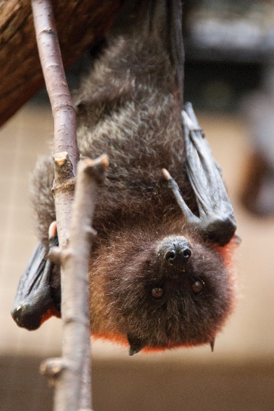The Philadelphia Zoo is home to a colony of Fruit Bats. There are over 60 individuals.
* Fruit Bats weigh around 10-12 ounces.
* They live only on the island of Rodrigues, which is located in the middle of the Indian Ocean, off the coast of Madagascar.
* In the wild they eat different types of fruits like guava, figs, bananas and papaya. At the zoo, they are fed fruit nectar, fresh fruit and vegetables.
* They can live to be around 20 years old.
* Their conservation status, as listed by the IUCN, is Endangered.
* Usually, females give birth to only 1 baby (pup) at a time and they are pregnant for about 5-6 months.
* Baby bats can start to fly at around 2 months old and are fully grown at 6-7 months.
* All of the bats at the Philadelphia Zoo have a small colored band (different colors) so zoo keepers can tell the different bats apart.

Name: __________________________________________________________****

Teacher: ________________________________________________________

School: _________________________________________________________

Date: ___________________________________________________________

All living things need air, food, water, shelter and space to live but when those resources are not all available, these animal populations could go down. If resources do not become available again and population sizes continue to drop, the animals could become threatened or endangered and could eventually go extinct. As you

visit the Zoo, discover some animals that are at risk of extinction and what they are threatened by.

|  |  |  |
| --- | --- | --- |
| Animal | Conservation Status | Why are these animals at risk of extinction? |
|  |  |  |
|  |  |  |
|  |  |  |

Why do these animals live at the Zoo?

__________________________________________________________________________________________

__________________________________________________________________________________________ __________________________________________________________________________________________

What are some ways that we can help these animals and support their conservation?

__________________________________________________________________________________________