**Endangered Species**

**K-2 Post-Activity**

**Lesson Summary**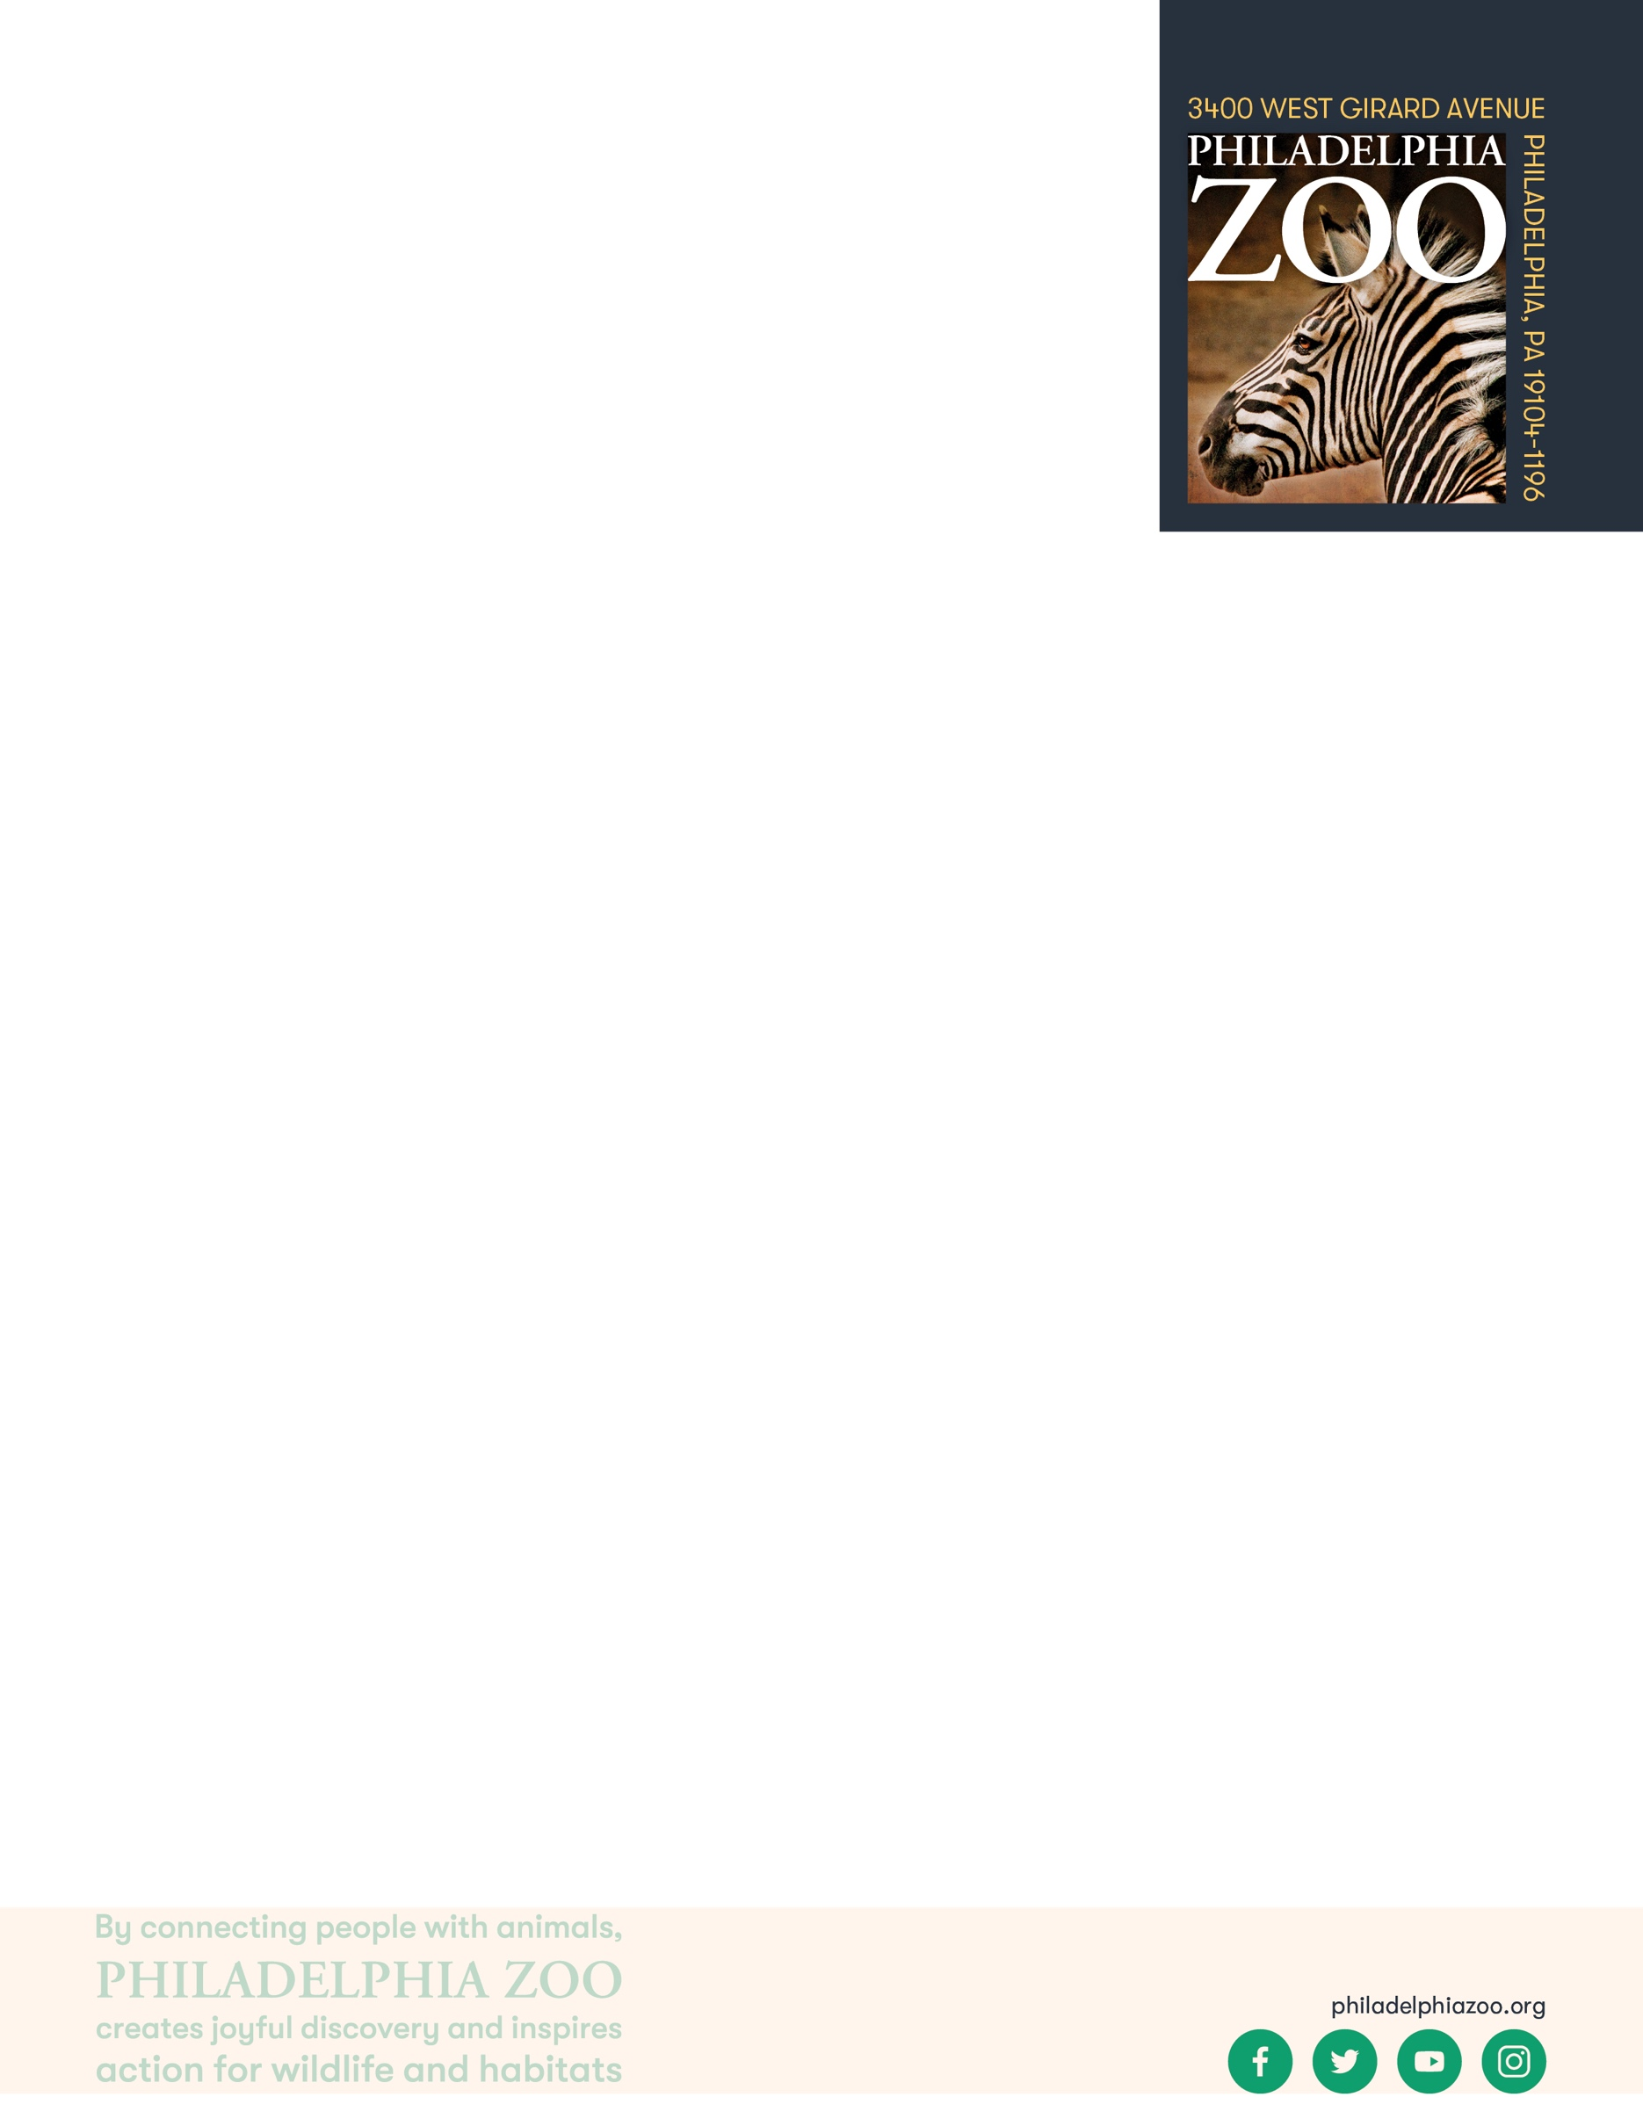

Students will consider effective ways to share information that will interest others, and find ways to advocate for endangered species.

**Objectives**

Students will be able to reflect on thing they are passionate about

Students will be able to define threatened, endangered species, and extinct

Students will be able to problem solve and consider possible solutions they can use to support these species

**Essential Question**

What is an endangered species and how can people help them?

**Materials**

* Scrap paper (or worksheet such as provided at the end of the lesson)
* Writing utensils
* Coloring utensils

**Prep**

1. 1 day before: Print out worksheets as needed (1 for each student)

**Key Terms**

* **Species:** a group of living things that can mate with one another but not with those of other groups
* **Population:** a grouping of the same species
* **Community:** all the plants and animals that live together in the same area
* **Habitat:** the natural environment of an animal or plant, where that living thing can find their food, water, shelter, and space
* **Resources:** materials in the environment necessary for organism health and wellbeing, such as food, water, and shelter
* **Competition:** the process of trying to get something that others are also trying to get
* **Safe:** free from the risk of harm or endangerment
* **Threatened species:** species at risk of harm or endangerment
* **Endangered species:** species of plant or animal that is in danger of becoming extinct
* **Extinct:** species that are no longer existing
* **Conservation:** the study of nature and how to protect it

**Background**

All living things need air, food, water, shelter and space and these resources must be present for a species to survive in its habitat. Within that habitat, animals need to share those resources amongst their species and will other animals that may also require those resources. When those resources become diminished due to habitat loss, introduced species, pollution, population size and overharvesting, animals become threatened, endangered, or even

extinct. All of us have the opportunity to protect endangered species through our choices, our voices, and our collective actions.

**Implementation**

1. Excite: Ask students to share about something they really care about or are passionate about.
2. Explore: Ask students to share in pairs or groups how they would encourage other people to be passionate about that too.
3. Ask students how they think people could also be share information to help endangered species. What strategies could be helpful? What would we want people to know?
4. Explain: Remind students that all living things need air, food, water, shelter and space to live but when those resources are not all available, these animals become threatened or endangered and could eventually go extinct. Sometimes people may cut down forests to make items, sometimes they will hunt animals for food, sometimes people harm animals because they might bother the people that live nearby, sometimes a natural disaster hits and that causes an animal to become endangered. When we learn about animals and what is causing issues for them, we can all work together to find solutions that help both the people and the animals to be able to live together.
5. Share with students that while there are many endangered species that exist today, there is hope that many can be saved if people come together and make an effort to protect wildlife and support the efforts being made. People all across the world can take small steps that can turn in to big impacts.
6. Ask students to collectively generate a list of things that people could do to help endangered species. This can include planting trees, teaching people about these animals, reaching out to government officials, and so much more.
7. Elaborate: Invite students to choose one way they would they would want to help animals, specially endangered species. This can be from the list generated or an idea of their own. Ask them to provide more detail of how they envision they would be able to make a difference. They can do this through conversing, writing, drawing, or a combination.
8. Evaluate: Invite students to share their ideas with each other in pairs, groups, or as a class the ways in which they hope to support the animals they care about.

**Expansion**

If you visited the Zoo, have student consider the animals and the information they learned about these animals consider suggestions of how to help them.

 **PA STEELS Curriculum Standards**

3.4.K-2.A, 3.4.K-2.D

|  |  |  |
| --- | --- | --- |
| THREATENED | ENDANGERED | EXTINCT |

Name: __________________________________________________________

Date: ___________________________________________________________

People’s actions are the reasons why many endangered species are in trouble,

but people can also do a lot to help endangered species and prevent extinction.

Write about one way you plan to make a difference for wildlife and include a drawing of you making it happen below.

I plan to help wildlife by…_____________________________________________________________________

________________________________________________________________________________________________________________________________________________________________________________________________________________________________________________________________________________________________________________________________________________________________________