**Habitats & Adaptations**

**K-2 Onsite Activity**

**Lesson Summary**

Students 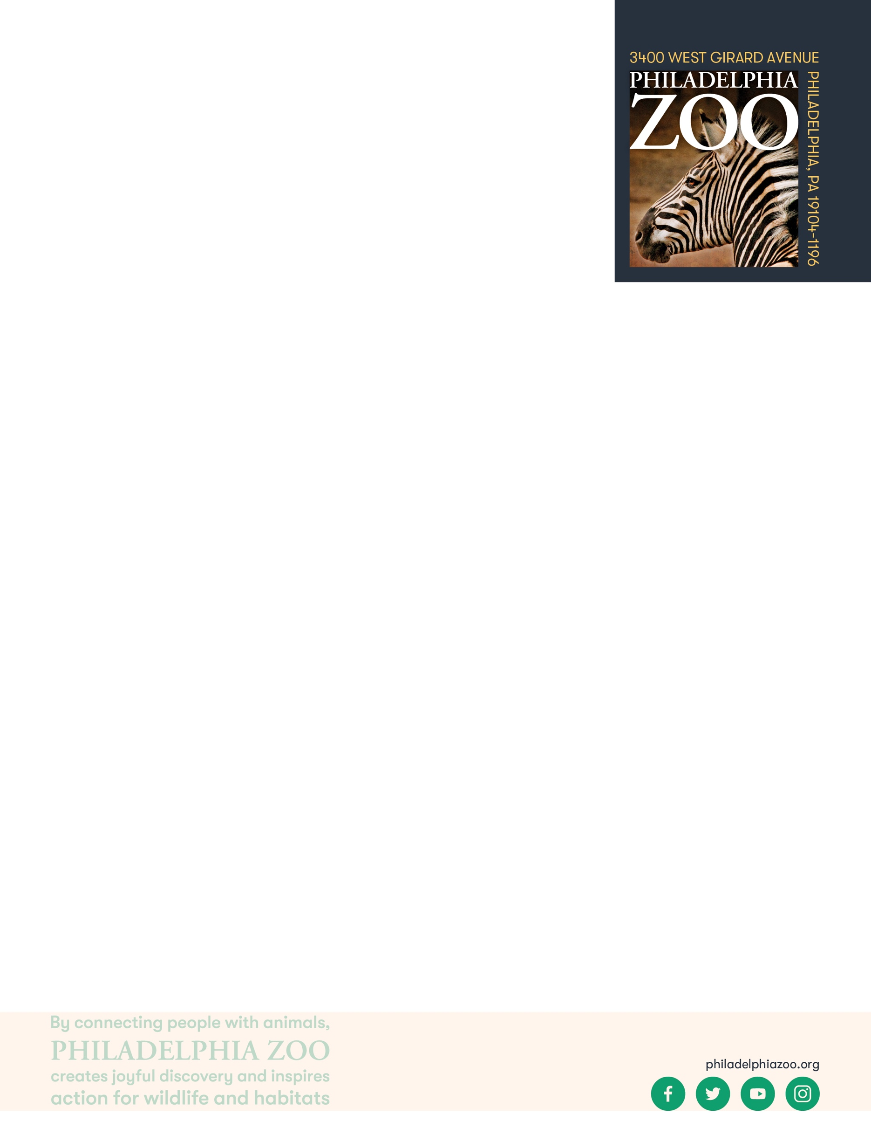explore habitats by making observations of a Zoo exhibit and identifying basic needs.

**Objectives**

Students will be able to observe and describe basic needs of an animal in a habitat

**Essential Question**

What is a habitat?

**Materials**

* Paper (or worksheet such as provided at the end of the lesson)
* Writing utensils
* Coloring utensils

**Prep**

1. 1 Week before: Look at the [Zoo map](https://www.philadelphiazoo.org/zoo-map/) to determine locations for observations
2. 1 Day before: Print out worksheets as needed (1 for each student)
3. 15 minutes before: Prep students for expectations

**Key Terms**

* **Basic needs**: the absolute minimum resources necessary for long-term physical well-being and survival
* **Habitat:** the natural environment of an animal or plant, where that living thing can find their food, water, shelter, and space

**Background**

All animals require food, water, and shelter in order to survive. Where an animal finds these basic needs are within their habitat. There are many different habitats, and they are characterized by physical and biological features. For a population of animals living in the habitat, there is competition amongst the individuals for these needed resources available.

**Implementation**

1. Excite: Welcome the students to the Zoo and ask them share some of the things that would make the animals they see happy and healthy. Would those things be similar or different from us?
2. Explore: As you walk around the Zoo, verbally discuss some of the items you are noticing in the animal exhibits. Are there repurposed items for the animals to interact with (toys, paper products, etc)? Are there things to climb on? Are there things for them to hide in? What could other items you see be used for?
3. Explain: Remind students that all living things need food, water, shelter, and space in their habitats. These are the basic needs that an animal needs to survive. They get their basic needs from the habitat that they live in. At the Zoo, we make sure that the animals are still able to meet all of their basic needs in their habitat here.
4. Elaborate: Locate an animal exhibit for the students to spend some time making observations of. Invite the students to draw the habitat they see in detail.
5. Follow up student observations, with discussion on identifying the things that could make this animal happy and healthy in the habitat they observed. 
6. Evaluate: Ask students to share what additional things they may have learned about these habitats through their deeper observations.

**Expansion**

Compare and contrast students’ drawings of different exhibits. Explore if the animals would have the same types of basic needs and why the habitats might be different between the animals.

Depending on understanding and interest, discuss with students the differences between wild habitats and Zoo habitats. Zoo’s design their habitat in order to ensure the animal is able to meet its basic needs, and monitors necessary temperature and humidity to ensure animal comfort and safety. Additional exhibit features may include:

* Natural looking features (such as plants, logs, rocks) that make the exhibit more closely represent the animal’s wild habitat. This can help give people a better understanding of the animal as well as its natural habitat
* Unnatural features (such as poles or firehose) that are strong and transformable. This allows for frequent changes to the exhibit and sometimes easy clean up too! For especially intelligent animals, like many primates, it is especially important to provide them new experiences to meet the changing needs of that animal.
* Creative features (such as trails or slides) that extend the exhibit beyond its typical parameters. The Philadelphia Zoo designed their Zoo360 trails in order for the animals to explore further, and use their senses experience new things, just like they would in the wild.

**PA STEELS Standards**

3.1.K.A, 3.1.2.C, 3.4.K-2.C

Name: __________________________________________________________

Teacher: ________________________________________________________

School: _________________________________________________________

Date: ___________________________________________________________

Make some observations of an animal exhibit in the Reptile & Amphibian House.

Draw a picture of their habitat below, and include as many details as possible.

What words would you use to describe the habitat in this exhibit? __________________________________________________________________________________________

What 3 things in this exhibit could help this animal survive and get their basic needs?

Food source: _______________________________________________________________________________

Water source: _______________________________________________________________________________

Shelter: ___________________________________________________________________________________

What in this exhibit do you think could keep this animal comfortable in its environment?

__________________________________________________________________________________________