**Habitats & Adaptations**

**3-5 Onsite Activity** 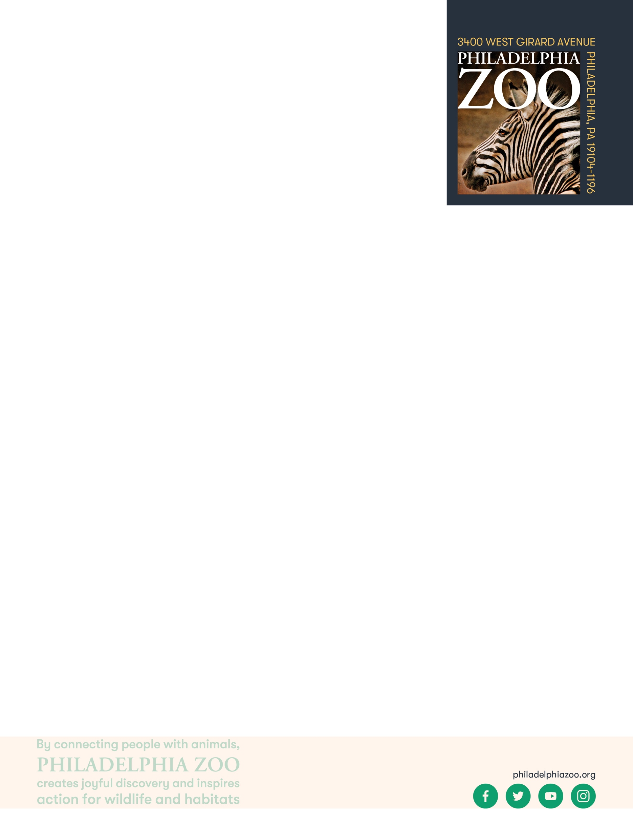

**Lesson Summary**

Students explore physical adaptations by making observations of a Zoo exhibit and determining important adaptations that could support living in that habitat.

**Objectives**

Students will be able to identify adaptations

Students will be able to determine how adaptations help living things get their basic needs and survive in their habitat

**Essential Question**

What is an adaptation and how do they help with survival?

**Materials**

* Paper (or worksheet such as provided at the end of the lesson)
* Writing utensils
* Coloring utensils

**Prep**

1. 1 Week before: Look at the [Zoo map](https://www.philadelphiazoo.org/zoo-map/) to determine locations for observations
2. 1 Day before: Print out worksheets as needed (1 for each student)
3. 15 minutes before: Prep students for expectations

**Key Terms**

* **Habitat:** the natural environment of an animal or plant, where that living thing can find their food, water, shelter, and space
* **Basic needs**: the absolute minimum resources necessary for long-term physical well-being and survival
* **Tundra:** a large plain with freezing or very cold weather
* **Desert:** a very dry, sandy area with few or no plants growing in it
* **Grasslands:** a flat, open plain covered with grass and few trees
* **Forest:** a large area of land covered with many trees and other plants
* **Rainforest:** a dense forest, mostly found in tropical areas, that receives a large amount of rain all year long.
* **Adaptation**: features that an organism has developed that helps them meet their basic needs, survive, and multiple in their habitat
* **Physical/Structural Adaptation:** physical features of an organism that helps the success of the animal, including shape, covering, or armament
* **Survival**: the ability to stay alive, especially through hard conditions
* **Predator:** an animal that hunts other animals for food
* **Prey:** an animal being hunted, caught, and eaten by another animal

**Background**

All animals require food, water, and shelter in order to survive. Where an animal finds these basic needs are within their habitat. There are many different habitats, and they are characterized by physical and biological features.

An adaptation is a trait that helps an organism survive and succeed in the habitat that they live in. They help the animal obtain its basic needs. Adaptations can include physical traits and structures, like body color and wings, as well as behavioral traits, like migration. If an animal is relocated to a different kind of habitat, its adaptations would not necessarily be suited for survival, and could possibly cause harm to its success.

**Implementation**

1. Excite: Welcome the students to the Zoo and ask them share some of the different animals they are most excited to see.
2. Explore: As you walk around the Zoo, verbally discuss some of the features you are noticing on the animals that would help them to survive in their habitats. Are there any features that seem unique or different?

1. Explain: Remind students that all living things have features, or adaptations, that allow them to meet their basic needs of getting food, water, shelter, and space in their habitats.
2. Elaborate: Pick an animal at the Zoo to spend some extra time observing. Invite students to draw that animal’s habitat.
3. Then, ask the students to consider what features an animal could have to help them survive in such a habitat as well as what features could help them meet their basic needs in this habitat. They can use the present exhibit animals as inspiration.
4. Evaluate: Ask students to share what additional things they may have learned about adaptations through their deeper observations.

**PA STEELS Standards**

3.1.4.A,3.1.3.D,3.1.3.F,3.1.3.G, 3.4.3-5.A, 3.4.3-5.F

Name: __________________________________________________________

Teacher: ________________________________________________________

School: _________________________________________________________

Date: ___________________________________________________________

Welcome to the Zoo! An animal’s adaptations help them survive in the habitat that they live in. Spend some time observing a habitat at the Zoo. Draw and describe this habitat in the box below. Then, consider what kinds of features an animal could have to be able to survive in this habitat. You can use the animal that is present in the exhibit as inspiration.

Describe 3 features that an animal could have to help it survive and stay safe in this habitat?

1. ________________________________________________________________________________________

2. ________________________________________________________________________________________

3. ________________________________________________________________________________________

What are 2 features that an animal could have to meet their basic needs in this habitat?

1. ________________________________________________________________________________________

2. ________________________________________________________________________________________