**Habitats & Adaptations**

**3-5 Post-Activity**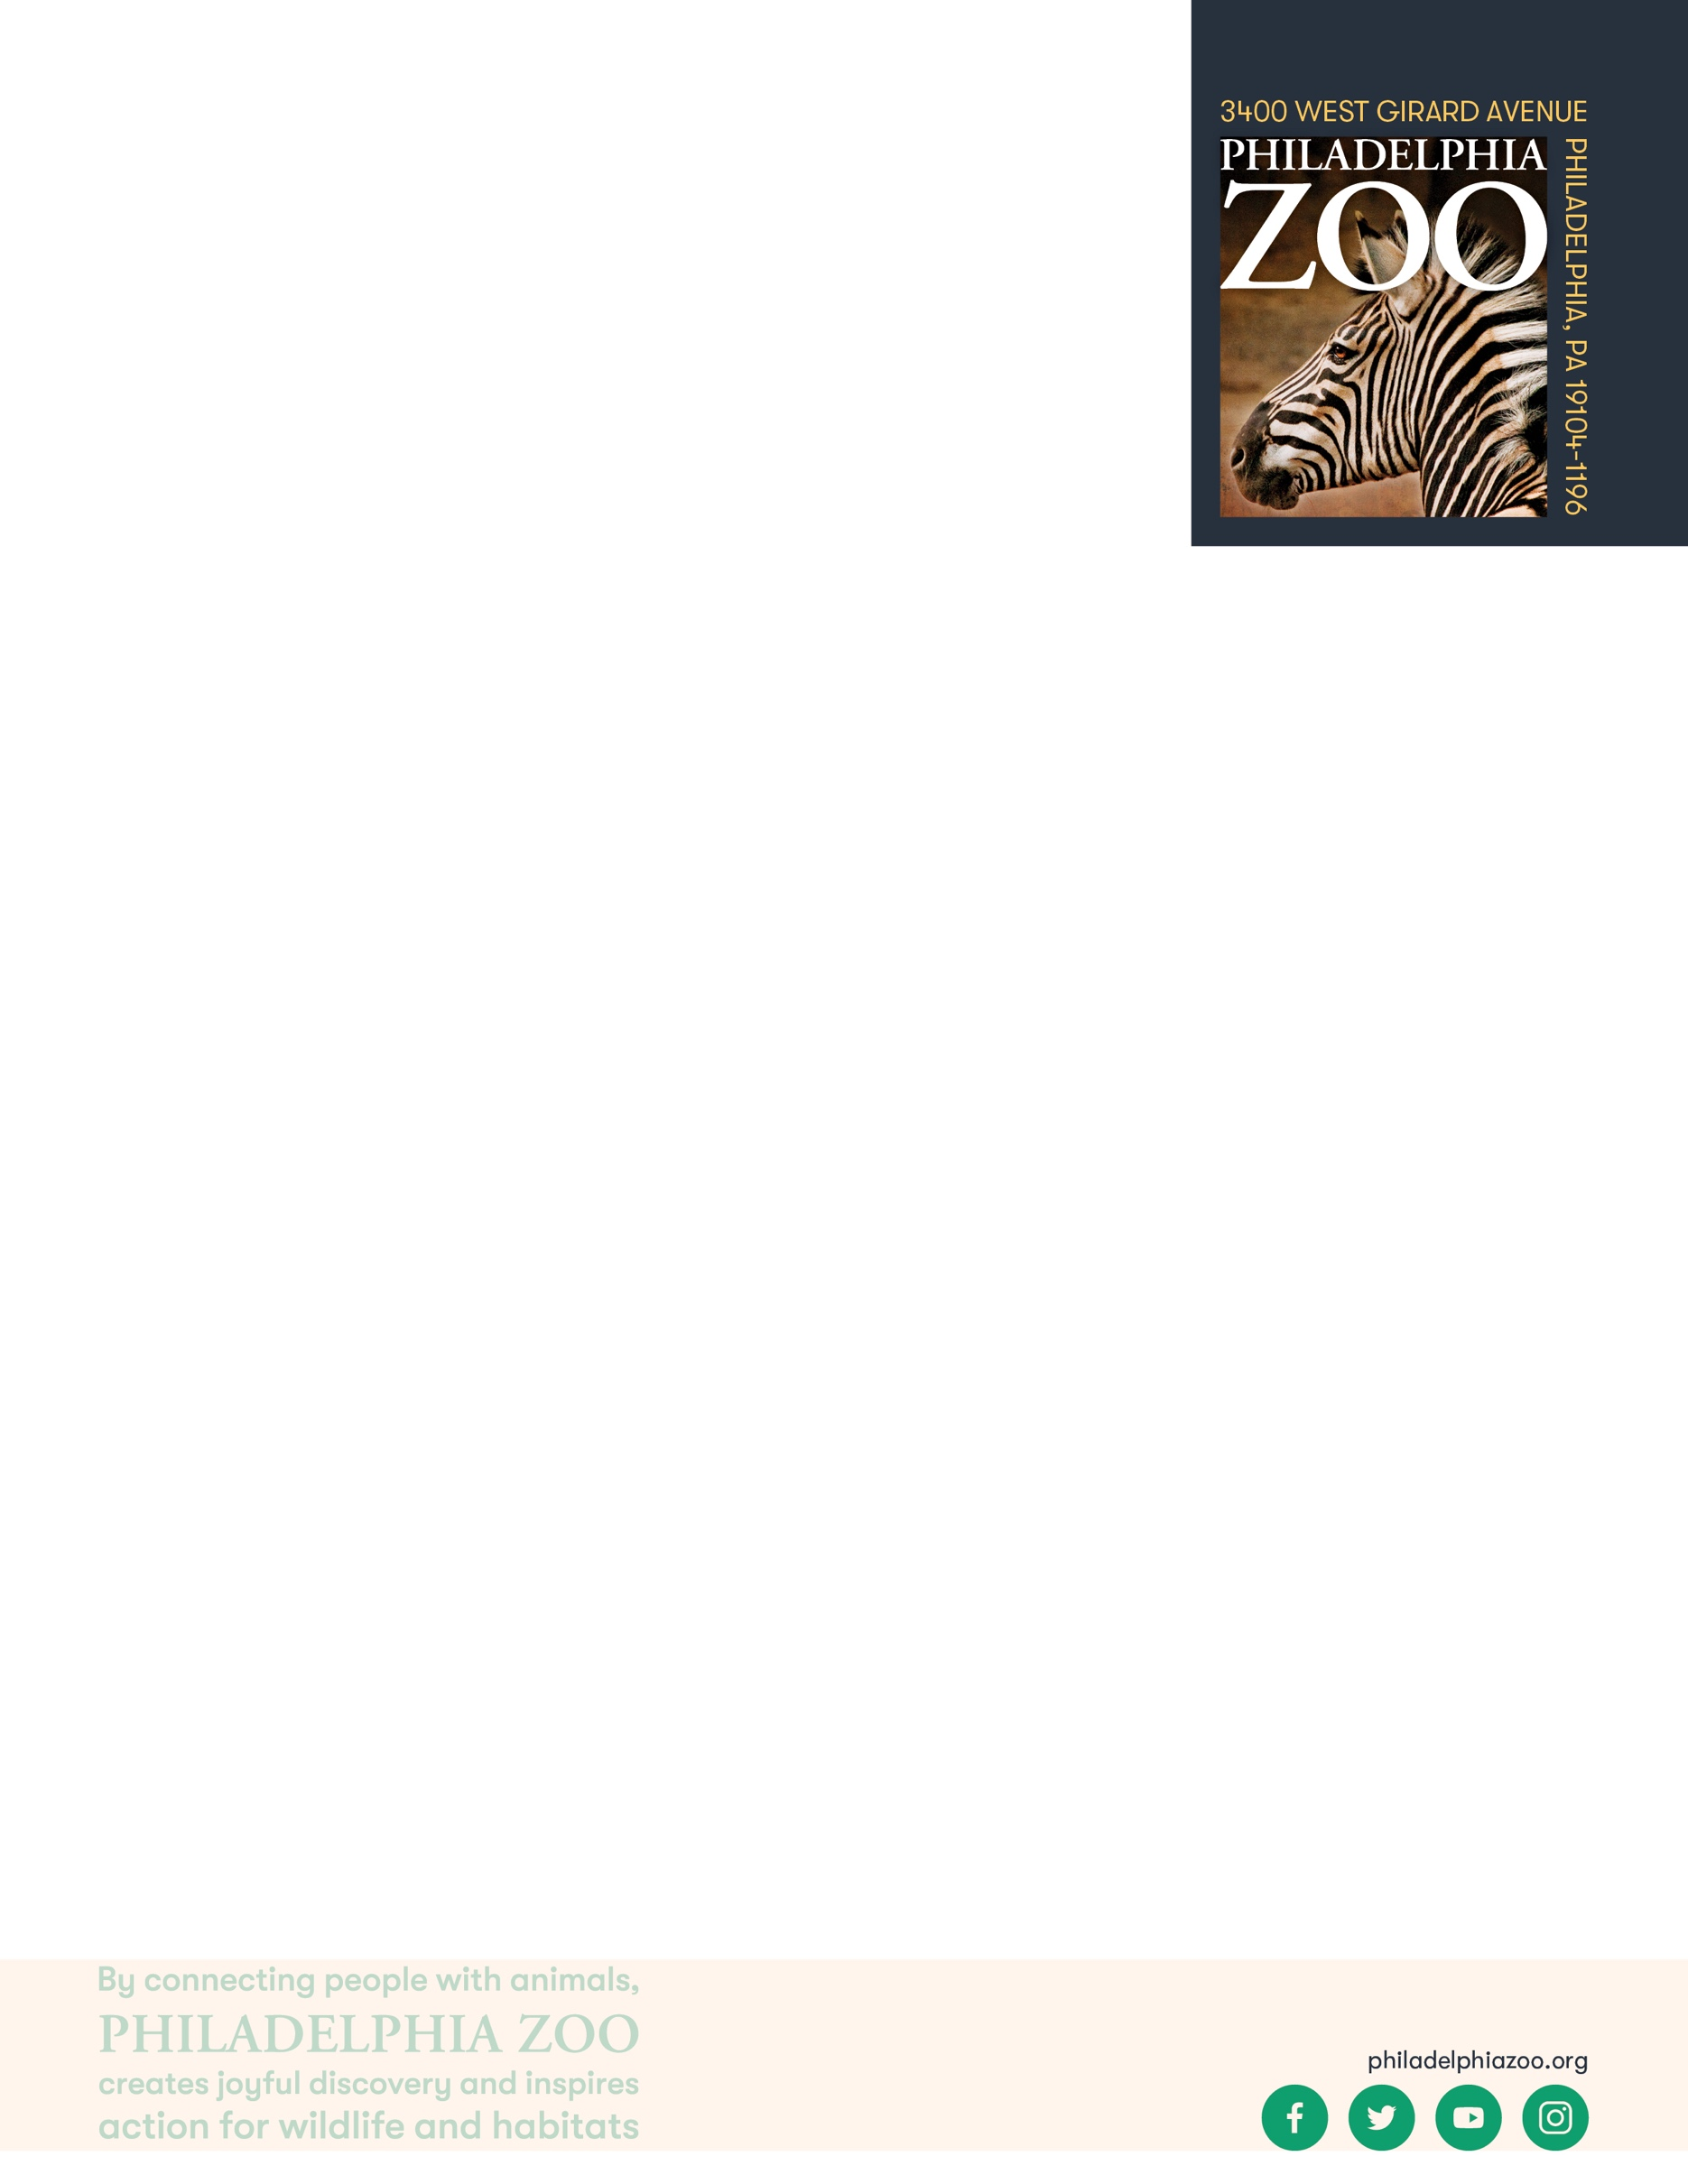

**Lesson Summary**

Students examine specific features of an animal and make inferences of that adaptation’s purpose.

**Objectives**

Students will be able to identify adaptations

Students will be able to determine how adaptations help living things get their basic needs and survive in their habitat

**Essential Question**

What is an adaptation and how do they help with survival?

**Materials**

* Paper (or worksheet such as provided at the end of the lesson)
* Animal photos (either printed or digital, some examples can be found on the [Philly Zoo website](https://www.philadelphiazoo.org/animals/))
* Writing utensils
* Coloring utensils

**Prep**

1. 1 day before: Print photos worksheets for students if needed. Prepare as many as there are students.

**Key Terms**

* **Habitat:** the natural environment of an animal or plant, where that living thing can find their food, water, shelter, and space
* **Basic needs**: the absolute minimum resources necessary for long-term physical well-being and survival
* **Tundra:** a large plain with freezing or very cold weather
* **Desert:** a very dry, sandy area with few or no plants growing in it
* **Grasslands:** a flat, open plain covered with grass and few trees
* **Forest:** a large area of land covered with many trees and other plants
* **Rainforest:** a dense forest, mostly found in tropical areas, that receives a large amount of rain all year long.
* **Adaptation**: features that an organism has developed that helps them meet their basic needs, survive, and multiple in their habitat
* **Physical/Structural Adaptation:** physical features of an organism that helps the success of the animal, including shape, covering, or armament
* **Survival**: the ability to stay alive, especially through hard conditions
* **Predator:** an animal that hunts other animals for food
* **Prey:** an animal being hunted, caught, and eaten by another animal

**Background**

All animals require food, water, and shelter in order to survive. Where an animal finds these basic needs are within their habitat. There are many different habitats, and they are characterized by physical and biological features.

An adaptation is a trait that helps an organism survive and succeed in the habitat that they live in. They help the animal obtain its basic needs. Adaptations can include physical traits and structures, like body color and wings, as well as behavioral traits, like migration. If an animal is relocated to a different kind of habitat, its adaptations would not necessarily be suited for survival, and could possibly cause harm to its success.

**Implementation**

1. Excite: Ask students to share their favorite animal, and to provide some explanation of why those animals are their favorite. They may share that there are certain physical features or behavioral features that their animals have that make them their favorite.
2. Point out to the students that they shared some interesting features about these animals, and provide some examples of what they shared. Remind students that the features that animals have are adaptations that allow an animal to meet its basic needs and survive in its habitat.
3. Explore: Share with students that they will be spending some time focusing on one animal from a specific habitat and it’s features. Have students either choose an animal to focus on or focus on the same animal as a class, but be sure that the animals have a reference. Provide the students time to draw a detailed picture of up to 3 features of this animal.
4. Explain: After students have completed their detailed drawings, remind students that adaptations typically help animals survive in their habitat by assisting them in finding or eating food, moving, finding friends or attracting mates, or staying protected from weather or predators.
5. Elaborate: Ask students to return to their drawings to consider in what ways each feature would help that animal to meet its basic needs and survive in its habitat, with reasoning supporting their choice.
6. Ask students to share in smaller groups or as a class the adaptations they focused on and their explanation of that that features helps the animal to live in its habitat.
7. Evaluate: Ask students to consider if these adaptations would allow for this animal to live in a different type of habitat, either by allowing them to choose a different habitat to examine or choosing one for them.

**Expansion**

If you visited the Zoo, consider using your students’ observations of habitats and adaptations to look more closely at and continue making inferences.

**PA STEELS Standards**

3.1.4.A,3.1.3.D,3.1.3.F,3.1.3.G, 3.4.3-5.A, 3.4.3-5.F



Name: __________________________________________________________

Teacher: ________________________________________________________

School: _________________________________________________________

Date: ___________________________________________________________

Choose a animal to observe. Draw a detailed picture of up to 3 features of this animal, each in a separate box below. Then, with the corresponding questions to the right, consider in what ways this feature would help that animal to survive and provide reasoning for your choice. 

How would this adaptation help the animal survive in its habitat? (Circle one)

1. It helps the animal find and/or eat food
2. It helps the animal move
3. It helps the animal find friends or attract mates
4. It helps the animal stay protected from predators or weather

How so? _______________________________________

______________________________________________

How would this adaptation help the animal survive in its habitat? (Circle one)

1. It helps the animal find and/or eat food
2. It helps the animal move
3. It helps the animal find friends or attract mates
4. It helps the animal stay protected from predators or weather

How so? _______________________________________

______________________________________________

How would this adaptation help the animal survive in its habitat? (Circle one)

1. It helps the animal find and/or eat food
2. It helps the animal move
3. It helps the animal find friends or attract mates
4. It helps the animal stay protected from predators or weather

How so? _______________________________________

______________________________________________