**Habitats and Adaptations**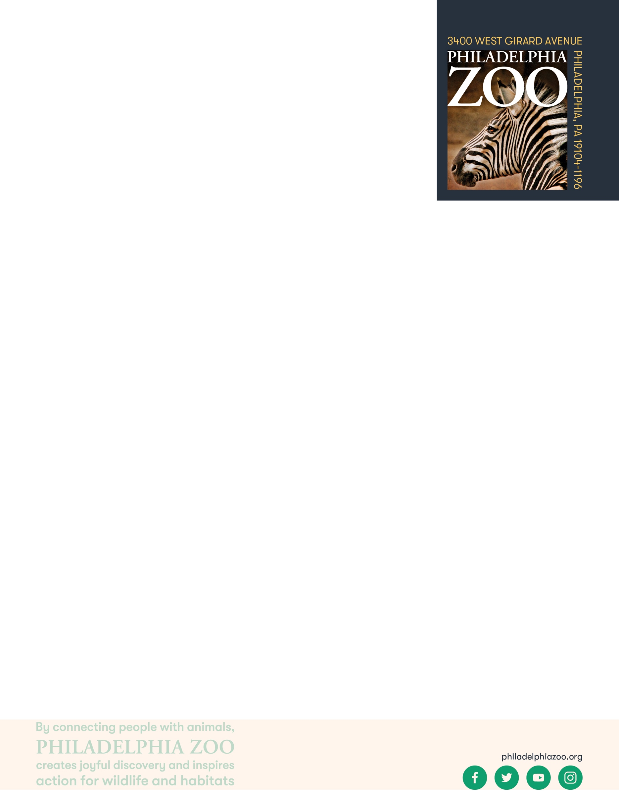

**6-8 Post-Activity**

**Lesson Summary**

Students review a series of questions detailing challenges experienced in a habitat, and determine possible solutions to the provided scenario with animal adaptations in mind.

**Objectives**

Students will be able to utilize problem solving skills to connect animals to the services they can provide

Students will be able to evaluate the impact an organism can have within its habitat

**Essential Question**

Why are adaptations important?

**Materials**

* Investigation steps (provided at the end of the lesson)
* Envelopes to put steps in
* Animal photos (provided at the end of the lesson)
* Scrap paper (or worksheet such as provided at the end of the lesson)
* Writing utensils

**Prep**

1. 1 Day before: Print out the investigation steps (1 total set), animal photos (1 total set), and worksheets as needed (1 for each group). Cut out steps along the dotted line and place in separate, labeled envelopes. Group envelopes together by scenario and in order or expected use.

**Key Terms**

* **Habitat:** the natural environment of an animal or plant, where that living thing can find their food, water, shelter, and space
* **Competition:** the process of trying to get something that others are also trying to get
* **Adaptation**: features that an organism has developed that helps them meet their basic needs, survive, and multiple in their habitat
* **Behavioral Adaptation:** inherited behaviors of an organism that helps the success of the animal, such as searching for food, mating, or vocalizing
* **Physical/Structural Adaptation:** physical features of an organism that helps the success of the animal, including shape, covering, or armament
* **Physiological/Functional Adaptation:** special functions within the animal that helps the success of the animal, such as regulating temperature or making venom
* **Hibernate:** a process in which an animal slows down body processes in a den or burrow to save energy through the winter
* **Basic needs**: the absolute minimum resources necessary for long-term physical well-being and survival
* **Survival**: the ability to stay alive, especially through hard conditions
* **Food Web:** The entire flow of energy in an ecological community
* **Food Chain:** Flow of energy through a series of living things that feed on each other shows how living things get energy from the food they eat
* **Predator:** an animal that hunts other animals for food
* **Prey:** an animal being hunted, caught, and eaten by another animal
* **Biodiversity:** the variety of living things in terms of individuals, species, and ecosystems.
* **Additional helpful definitions:**
  + **Pollution:** is the presence unwanted substances in the natural environment that can cause harm
  + **Photosynthesis:** the process in which plants combine carbon dioxide, water, and light energy from the sun to make food and oxygen
  + **Pollinators:** organisms that assist in the movement or carrying of pollen to a plant, causing the seeds to be fertilized
  + **Seed Dispersers**: an organism that assists in the movement or transport of seeds to different locations through various methods including digestion
  + **Scavengers:** organisms that consume dead organisms (plants, animals, carrion) and break down the organic material
  + **Decomposers:** organisms that consume the broken down particles and recycle nutrients back into the environment (often a invertebrate, fungus, or bacteria)

**Background**

All animals require food, water, and shelter in order to survive. Where an animal finds these basic needs are within their habitat. There are many different habitats, and they are characterized by physical and biological features. For a population of animals living in the habitat, there is competition amongst the individuals for these needed resources available.

An adaptation is a trait that helps an organism survive and succeed in the habitat that they live in. They help the animal obtain its basic needs while. Adaptations can include physical traits and structures, like body color and wings, as well as behavioral traits, like migration. If an animal is relocated to a different kind of habitat, its adaptations would not necessarily be suited for survival, and could possibly cause harm to its success.

**Implementation**

1. Excite: Ask students to think about some professions that we have in our community. Their answers may include doctors, teachers, police, store owners, etc. Ask them what these workers do for our community and how might they interact with other people.
2. Explore: Share with students that they will be exploring some of the roles animals and organisms play in their habitat, particularly with the adaptations that they have. As part of the activity, there are 4 investigations and 5 parts to each investigation. Split the class into 4 groups and share that each group should complete the following:
   1. Each group will receive a scenario. After reading the scenario details with the group, determine what the next step should be from the suggestions provided.
   2. Once the group has come to a unanimous decision, they should alert the leader and request the next step.
   3. If your answer to the previous question was correct, you will receive new information regarding the scenario If your answer was incorrect, you will have the opportunity to try again.
   4. The above steps will repeat until reaching a conclusion to the scenario.
3. Explain: After students have had some time to complete the steps of their provided scenario, invite the students to come back as a class and share the scenario they reviewed and the animal that they determined can have the biggest impact on that issue. Full information regarding the steps of all the scenarios is included below:

|  |  |  |  |  |
| --- | --- | --- | --- | --- |
| **Scenario** | **Answer to** | | | **Animal** |
|  | **Part 1** | **Part 2** | **Part 3** | **Part 4** |
| 1 | A | C | B | C: Timber Rattlesnake  Disease control: Snakes like Timber Rattlesnakes prey on many small animals including mice. Mice can carry an assortment of diseases, including ticks that transmit Lyme disease. When the rattlesnakes eat the mice, they are decreasing the number of animals that could be carrying the disease, and are therefore hindering the spread of disease. |
| 2 | B | A | D | B: Eastern Box Turtle  Clean Air through Seed Dispersal: Eastern Box Turtles eat an assortment of plants including berries. As they eat and leave food on the ground, or even when they go to the bathroom, they leave seeds behind. These seeds often become more plants that produce oxygen from carbon dioxide, thus helping to purify the air. |
| 3 | C | D | C | D: Honeybee  Pollination: As honeybees feed on nectar and pollen from plants, they pick up pollen that travels on their bodies. As they visit plant to plant, the pollen is left behind, allowing for many plants to grow. Honeybees account for 80% of all pollination done by insects and are responsible for 1 out of every 3 bites of food that humans consume. |
| 4 | C | B | A | A: Turkey Vulture  Nutrient Recycling: Turkey Vultures are scavengers that feed on the remains of animals and supporting the recycling of nutrients in a habitat. Turkey vultures break down available dead matter into the soil and the air, and by doing so they provide nutrients to the still living organisms. |

1. As a group, ask students if there were any connections or solutions that they were surprised by. Invite students to share some other animals that they might be familiar with that share similar roles in their habitats, or if they are familiar with other ecological roles that animals can support through their adaptations. Answers could include butterflies and bats pollinating plants, worms or snails decomposing and recycling nutrients, frogs or spiders eating insects and limiting disease spread, deer or birds scattering seeds, beavers creating rich soil to filter water, etc.
2. Elaborate: Share with the students that all of these animals can be found within the same habitat, even here in Pennsylvania. Invite students to a discussion to explore why it’s important to have many different types of plants and animals within a habitat, and to consider what could happen if one of these animals were removed from the ecosystems.
3. Share with students that this is an important part of Biodiversity. Ask students to consider what comes to mind when they hear the word biodiversity or if they might be familiar with what the word means. Once students discuss, ensure students have come to the consensus that biodiversity refers to the variety of living things in terms of individuals, species, and ecosystems.
4. Evaluate: Ask students to consider why biodiversity is important. Their reasons might include that animals make them happy or that animals provide different services for us and other living things.

**Expansion**

Ask students to consider what threats might impact biodiversity and how. Answers may include habitat loss, habitat degradation, overexploitation, and invasive species. Discuss how these factors affect biodiversity and what can be done to protect and support biodiversity.

If you visited the Zoo, invite students to consider some of the animals they saw and to determine what roles they might play in their respective habitats.

**PA STEELS Standards**

3.1.6-8.D, 3.1.6-8.T, 3.4.6-8.A,3.4.6-8.G,3.4.6-8.H

**Additional Resources**

Investigation Steps to be printed, cut out and separately placed into labeled envelopes.

|  |  |
| --- | --- |
| SCENARIO 1: THE PROBLEM STEP #1  Many local residents have gone to the hospital with similar symptoms of illness. Doctors have figured out that their patients all have a similar diagnosis.  From your understanding, what is the issue here?   1. There is a disease that is spreading 2. There is something unwanted in the air 3. There is something stopping the plants from growing |  |
| If answers A: | If answers B or C: |
| SCENARIO 1: THE TOOLS STEP #2  Scientists agree that a disease is spreading. They’ve figured out that the disease is being carried around by mice that live in the area. The scientists want to control the rat population.  What tool could we use to fix the problem?   1. Trees 2. Compost 3. Predators 4. Pollen | SCENARIO 1: THE PROBLEM TRY AGAIN  Scientists haven’t found that to be the main issue at hand because there doesn’t seem to be any evidence. Try again by reading Step #1 again and remember to think about only the information given to you. |
| If answers C: | If answers A, B, or D |
| SCENARIO 1: THE SERVICE STEP #3  Scientists agree that a predator would be helpful to control the mouse population. Limiting the mouse population would stop the spread of the disease.  What kind of animal would we need?   1. An animal that eats dead stuff (a decomposer or scavenger) 2. An animal that eats meat (a carnivore) 3. An animal that spreads pollen (a pollinator) 4. An animal that spreads nuts and seeds (a seed disperser) | SCENARIO 1: THE TOOLS TRY AGAIN  Scientists don’t think that would have a big impact on the situation. Read Step #2 again and think about the abilities that these different tools have that would be the most useful for this issue. |
| If answers B: | If answers A, C, D: |
| SCENARIO 1: THE SOLUTION STEP #4  That’s the kind of animal we need!  Which local animal helps to provide the service from Step #3?   1. Turkey Vultures 2. Eastern Box Turtles 3. Timber Rattlesnakes 4. Honeybees | SCENARIO 1: THE SERVICE TRY AGAIN  Try again and read the service needed in Step #3 very carefully. |
| If answers C: | If answers A, B, D |
| SCENARIO 1: THE OUTCOME  Awesome! Supporting species like timber rattlesnakes was a great idea.  Snakes like Timber Rattlesnakes are carnivores that eat many smaller animals like mice. In this way, they are controlling populations which is especially helpful when those animals become pests and cause the spread of disease. | SCENARIO 1: THE SOLUTION TRY AGAIN  Look back at Step #4 and think about the capabilities of the different animals to figure out who would be able to provide the help needed. |

|  |  |
| --- | --- |
| SCENARIO 2: THE PROBLEM STEP #1  Local residents have noticed that the air in the area has been looking gray, even when the sun comes out. They think there is a slight smell, and that the air just doesn’t feel fresh.  From your understanding, what is the issue here?   1. There is a disease that is spreading 2. There is something unwanted in the air 3. There is something stopping the plants from growing |  |

|  |  |
| --- | --- |
| If answers B: | If answers A or C: |
| SCENARIO 2: THE TOOLS STEP #2  Scientists agree that there is something bad and unwanted in the air called pollutants. They’ve figured out that the factories nearby and the cars on the road have released a great deal of harmful substances, like carbon dioxide, into the air. They want to replace the harmful substances with safer ones, like oxygen.  What tool could we use to fix the problem?   1. Trees 2. Compost 3. Predators 4. Pollen | SCENARIO 2: THE PROBLEM TRY AGAIN  Scientists haven’t found that to be the main issue at hand because there doesn’t seem to be any evidence. Try again by reading Step #1 again and remember to think about only the information given to you. |
| If answers A: | If answers B, C, or D: |
| SCENARIO 2: THE SERVICE STEP #3    Scientists agree that planting trees would be a helpful tool to clean the air. Trees can create oxygen through a process called photosynthesis. They now want to support the growth of new plants and trees.  What kind of animal would we need?   1. An animal that eats dead stuff (a decomposer or scavenger) 2. An animal that eats meat (a carnivore) 3. An animal that spreads pollen (a pollinator) 4. An animal that spreads nuts and seeds (a seed disperser) | SCENARIO 2: THE TOOLS TRY AGAIN  Scientists don’t think that would have a big impact on the situation. Read Step #2 again and think about the abilities that these different tools have that would be the most useful for this issue. |
| If answers D: | If answers A, B, or C: |
| SCENARIO 2: THE SOLUTION STEP #4  That’s the kind of animal we need!  Which local animal helps to provide the service from Step #3?   1. Turkey Vultures 2. Eastern Box Turtles 3. Timber Rattlesnakes 4. Honeybees | SCENARIO 2: THE SERVICE TRY AGAIN  Try again and read the service needed in Step #3 very carefully. |
| If answers B: | If answers A, C, or D: |
| SCENARIO 2: THE OUTCOME  Awesome! Supporting species like Eastern Box Turtles was a great idea.  Eastern Box Turtles eat plants, and often leave uneaten food behind. The remains and seeds can grow into plants, and plants are helpful in building habitats and producing oxygen! | SCENARIO 2: THE SOLUTION TRY AGAIN  Look back at Step #4 and think about the capabilities of the different animals to figure out who would be able to provide the help needed. |

|  |  |
| --- | --- |
| SCENARIO 3: THE PROBLEM STEP #1  Some local residents have reported the inability to find fresh, local produce to eat. They are hoping to find fruits and veggies to eat to be able to get the nutrients and vitamins they need to stay healthy.  From your understanding, what is the issue here?   1. There is a disease that is spreading 2. There is something unwanted in the air 3. There is something stopping the plants from growing |  |
| If answers C | If answers A or B: |
| SCENARIO 3: THE TOOLS STEP #2  Scientists agree that there is something stopping the plants from growing as they normally do. They’ve figured out that the plants are not able to grow fruits or vegetables because they not been pollinated.  What tool could we use to fix the problem?   1. Trees 2. Compost 3. Predators 4. Pollen | SCENARIO 3: THE PROBLEM TRY AGAIN  Scientists haven’t found that to be the main issue at hand because there doesn’t seem to be any evidence. Try again by reading Step #1 again and remember to think about only the information given to you. |

|  |  |
| --- | --- |
| If answers D: | If answers A, B, or C |
| SCENARIO 3: THE SERVICE STEP #3    Scientists agree that using pollen will support the plants ability to grow fresh produce. Although wind can play a role in pollination, alone it is not growing the fruits and vegetables efficiently enough. The Scientists now want to support animals that can help fertilize plants.  What kind of animal would we need?   1. An animal that eats dead stuff (a decomposer or scavenger) 2. An animal that eats meat (a carnivore) 3. An animal that spreads pollen (a pollinator) 4. An animal that spreads nuts and seeds (a seed disperser) | SCENARIO 3: THE TOOLS TRY AGAIN  Scientists don’t think that would have a big impact on the situation. Read Step #2 again and think about the abilities that these different tools have that would be the most useful for this issue. |
| If answers C: | If answers A, B, or D: |
| SCENARIO 3: THE SOLUTION STEP #4  That’s the kind of animal we need!  Which local animal helps to provide the service from Step #3?   1. Turkey Vultures 2. Eastern Box Turtles 3. Timber Rattlesnakes 4. Honeybees | SCENARIO 3: THE SERVICE TRY AGAIN  Try again and read the service needed in Step #3 very carefully. |
| If answers D: | If answers A, B, or C: |
| SCENARIO 3: THE OUTCOME  Awesome! Supporting species like honeybees was a great idea.  Honeybees feed on plants and pick up pollen on their bodies. As they visit plant to plant, the pollen is left behind, allowing for many plants to become fertilized and grow the produce that we rely on. | SCENARIO 3: THE SOLUTION TRY AGAIN  Look back at Step #4 and think about the capabilities of the different animals to figure out who would be able to provide the help needed. |

|  |  |
| --- | --- |
| SCENARIO 4: THE PROBLEM STEP #1  Some local residents have noticed the plants in their neighborhood to be looking especially sad and dull. The plants don’t seem to be growing as beautifully or healthy as they normally do.  From your understanding, what is the issue here?   1. There is a disease that is spreading 2. There is something unwanted in the air 3. There is something stopping the plants from growing | SCENARIO 4: THE PROBLEM TRY AGAIN  Scientists haven’t found that to be the main issue at hand because there doesn’t seem to be any evidence. Try again by reading Step #1 again and remember to think about only the information given to you. |
| If answers C: | If answers A or B: |
| SCENARIO 4: THE TOOLS STEP #2  Scientists agree that there is something stopping the plants from growing as they normally do. They’ve figured out that the plants are not growing as nicely because they do not have nutrients. They want to give the plants something that would provide them nutrients.  What tool could we use to fix the problem?   1. Trees 2. Compost 3. Predators 4. Pollen | SCENARIO 4: THE PROBLEM TRY AGAIN  Scientists haven’t found that to be the main issue at hand because there doesn’t seem to be any evidence. Try again by reading Step #1 again and remember to think about only the information given to you. |
| If answers B: | If answers A, C, or D: |
| SCENARIO 4: THE SERVICE STEP #3    Scientists agree that compost could help give nutrients to the plants. Compost can be made up of food scraps, dead plants, and animal waste to create healthy soil filled with nutrients. However, we would need an animal that could break apart dead organic matter to help spread the nutrients back into the habitat.  What kind of animal would we need?   1. An animal that eats dead stuff (a decomposer or scavenger) 2. An animal that eats meat (a carnivore) 3. An animal that spreads pollen (a pollinator) 4. An animal that spreads nuts and seeds (a seed disperser) | SCENARIO 4: THE TOOLS TRY AGAIN  Scientists don’t think that would have a big impact on the situation. Read Step #2 again and think about the abilities that these different tools have that would be the most useful for this issue. |
| If answers A: | If answers B, C, or D: |
| SCENARIO 4: THE SOLUTION STEP #4  That’s the kind of animal we need!  Which local animal helps to provide the service from Step #3?   1. Turkey Vultures 2. Eastern Box Turtles 3. Timber Rattlesnakes 4. Honeybees | SCENARIO 4: THE SERVICE TRY AGAIN  Try again and read the service needed in Step #3 very carefully. |
| If answers A: | If answers B, C, or D: |
| SCENARIO 4: THE OUTCOME  Awesome! Supporting species like Turkey Vultures was a great idea.  Turkey vultures are decomposers eat dead stuff that can break up the dead stuff (like food scraps, dead plants, and animal waste) into tiny pieces and nutrients. Once broken up, these nutrients can be recycled and put back into the soil. Thus, they are able to give nutrients to plants that are still living. | SCENARIO 4: THE SOLUTION TRY AGAIN  Look back at Step #4 and think about the capabilities of the different animals to figure out who would be able to provide the help needed. |

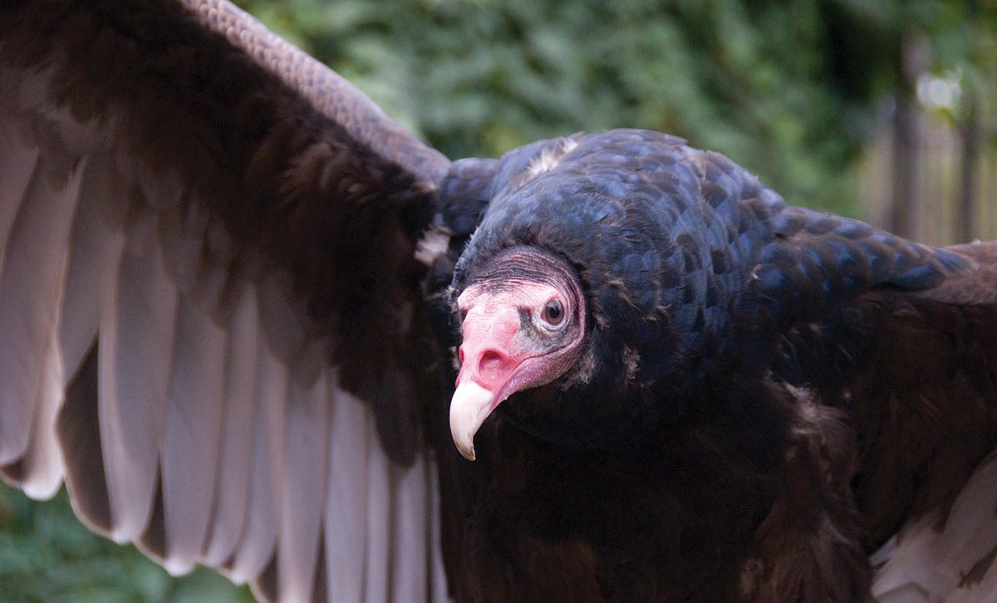

Turkey Vulture

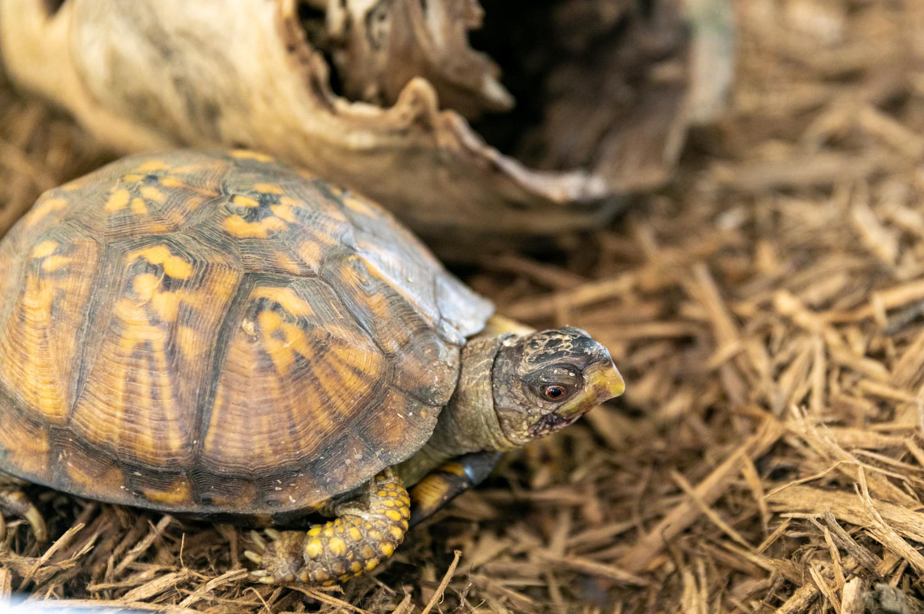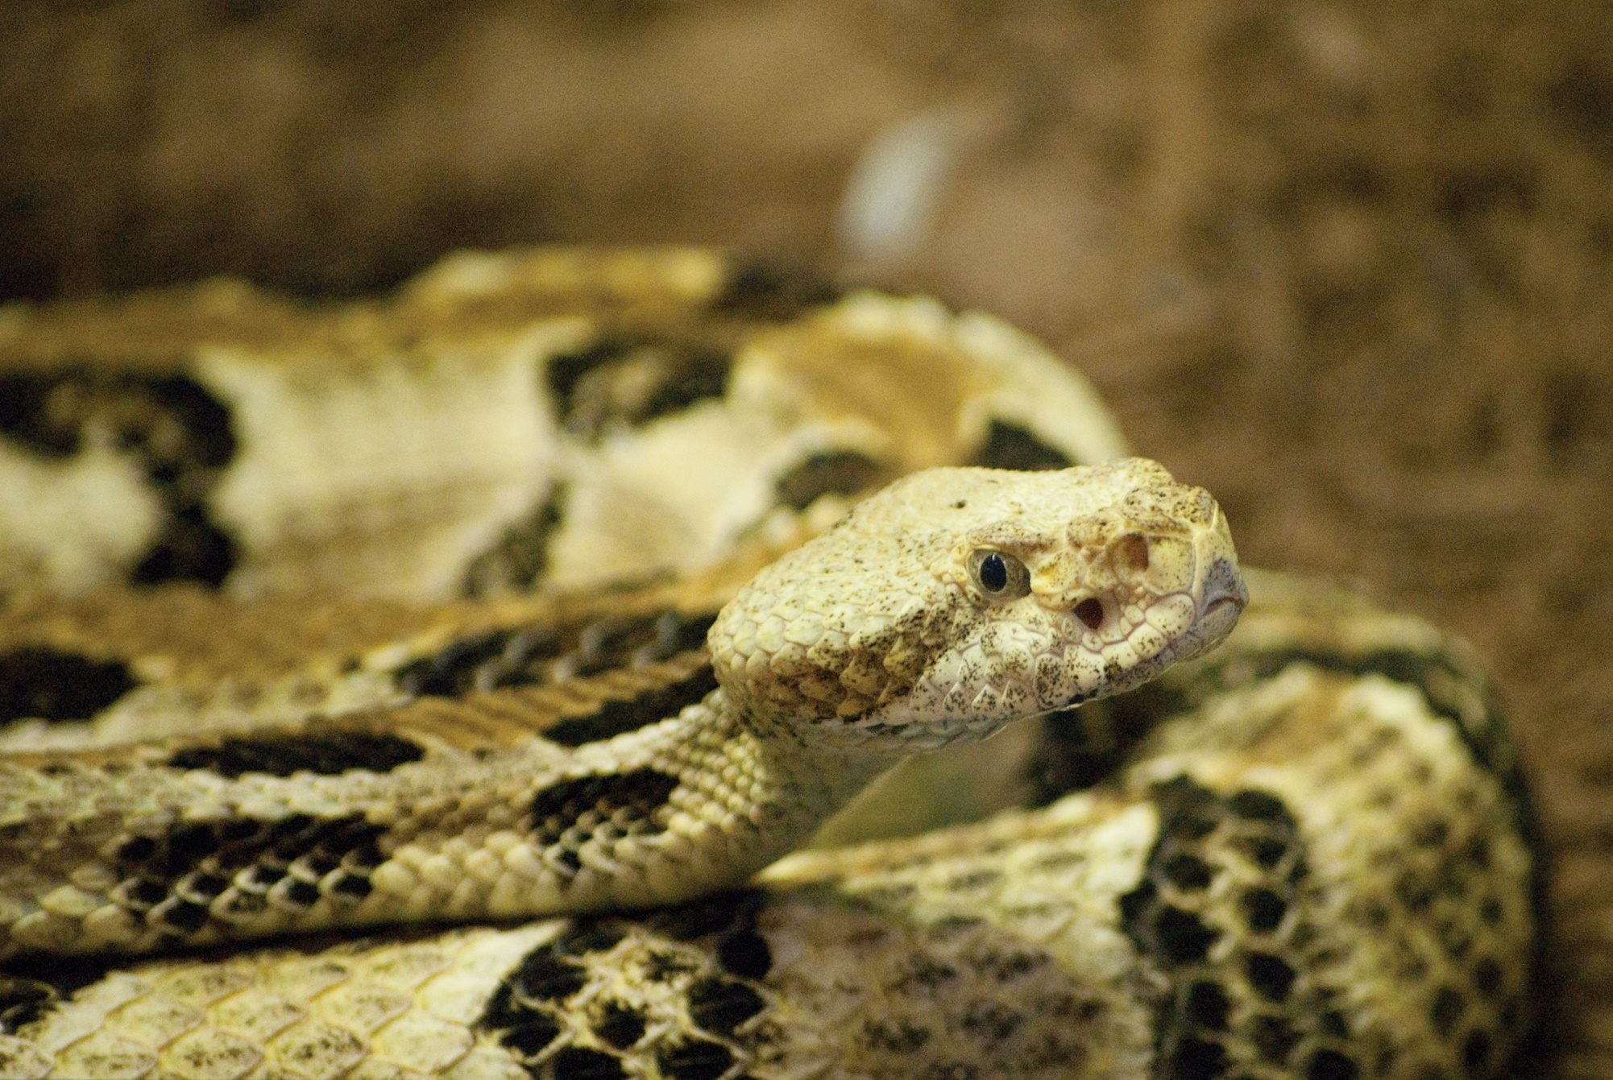

Eastern Box Turtle

Timber Rattlesnake

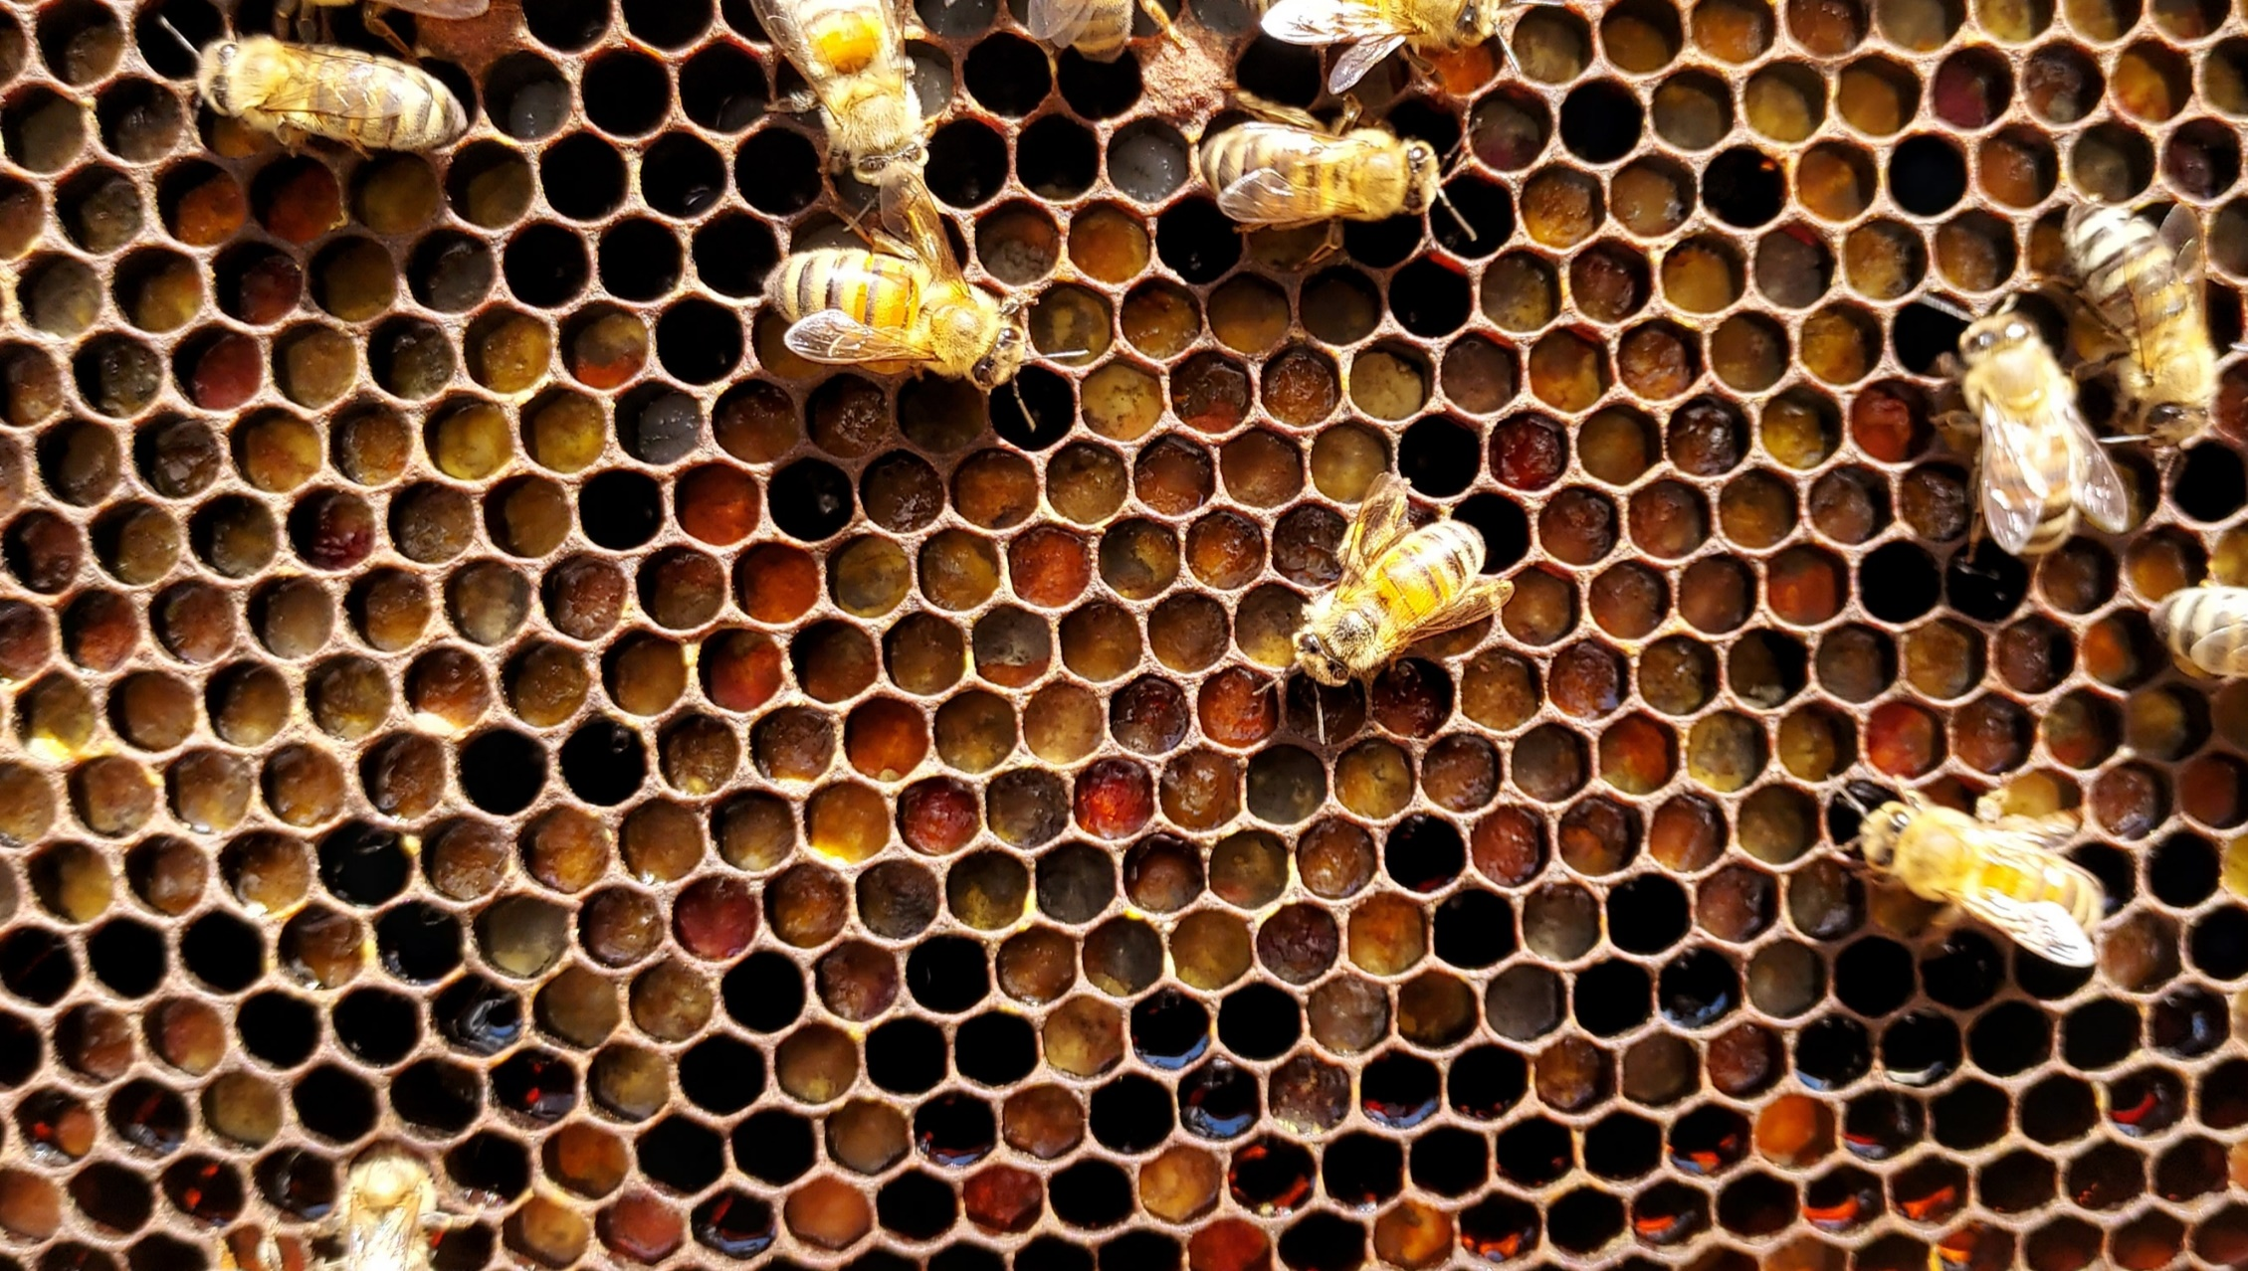

Italian Honeybee

Name: __________________________________________________________

Date: ___________________________________________________________

|  |  |  |  |
| --- | --- | --- | --- |
|  |  |  |  |
| **Turkey Vulture** | **Eastern Box Turtle** | **Timber Rattlesnake** | **Italian Honeybee** |

.

|  |  |  |  |
| --- | --- | --- | --- |
|  | **Answer Choice Letter** | **Answer Choice Details** | **Which animal do you think can help?** |
| Part 1: The Problem |  |  |  |
| Part 2: The Tools |  |  |  |
| Part 3: The Service |  |  |  |
| Part 4: The Solution |  |  |  |
| Part 5: The Outcome |  |  |  |

What other animals also support similar services?

__________________________________________________________________________________________

What other services can animals provide in a habitat?

__________________________________________________________________________________________

Why would it be important to have many different types of plants and animals within a habitat?

__________________________________________________________________________________________

What could happen if one of these animals were removed from their habitat?

_______________________________________________________________________________________