**Habitats and Adaptations**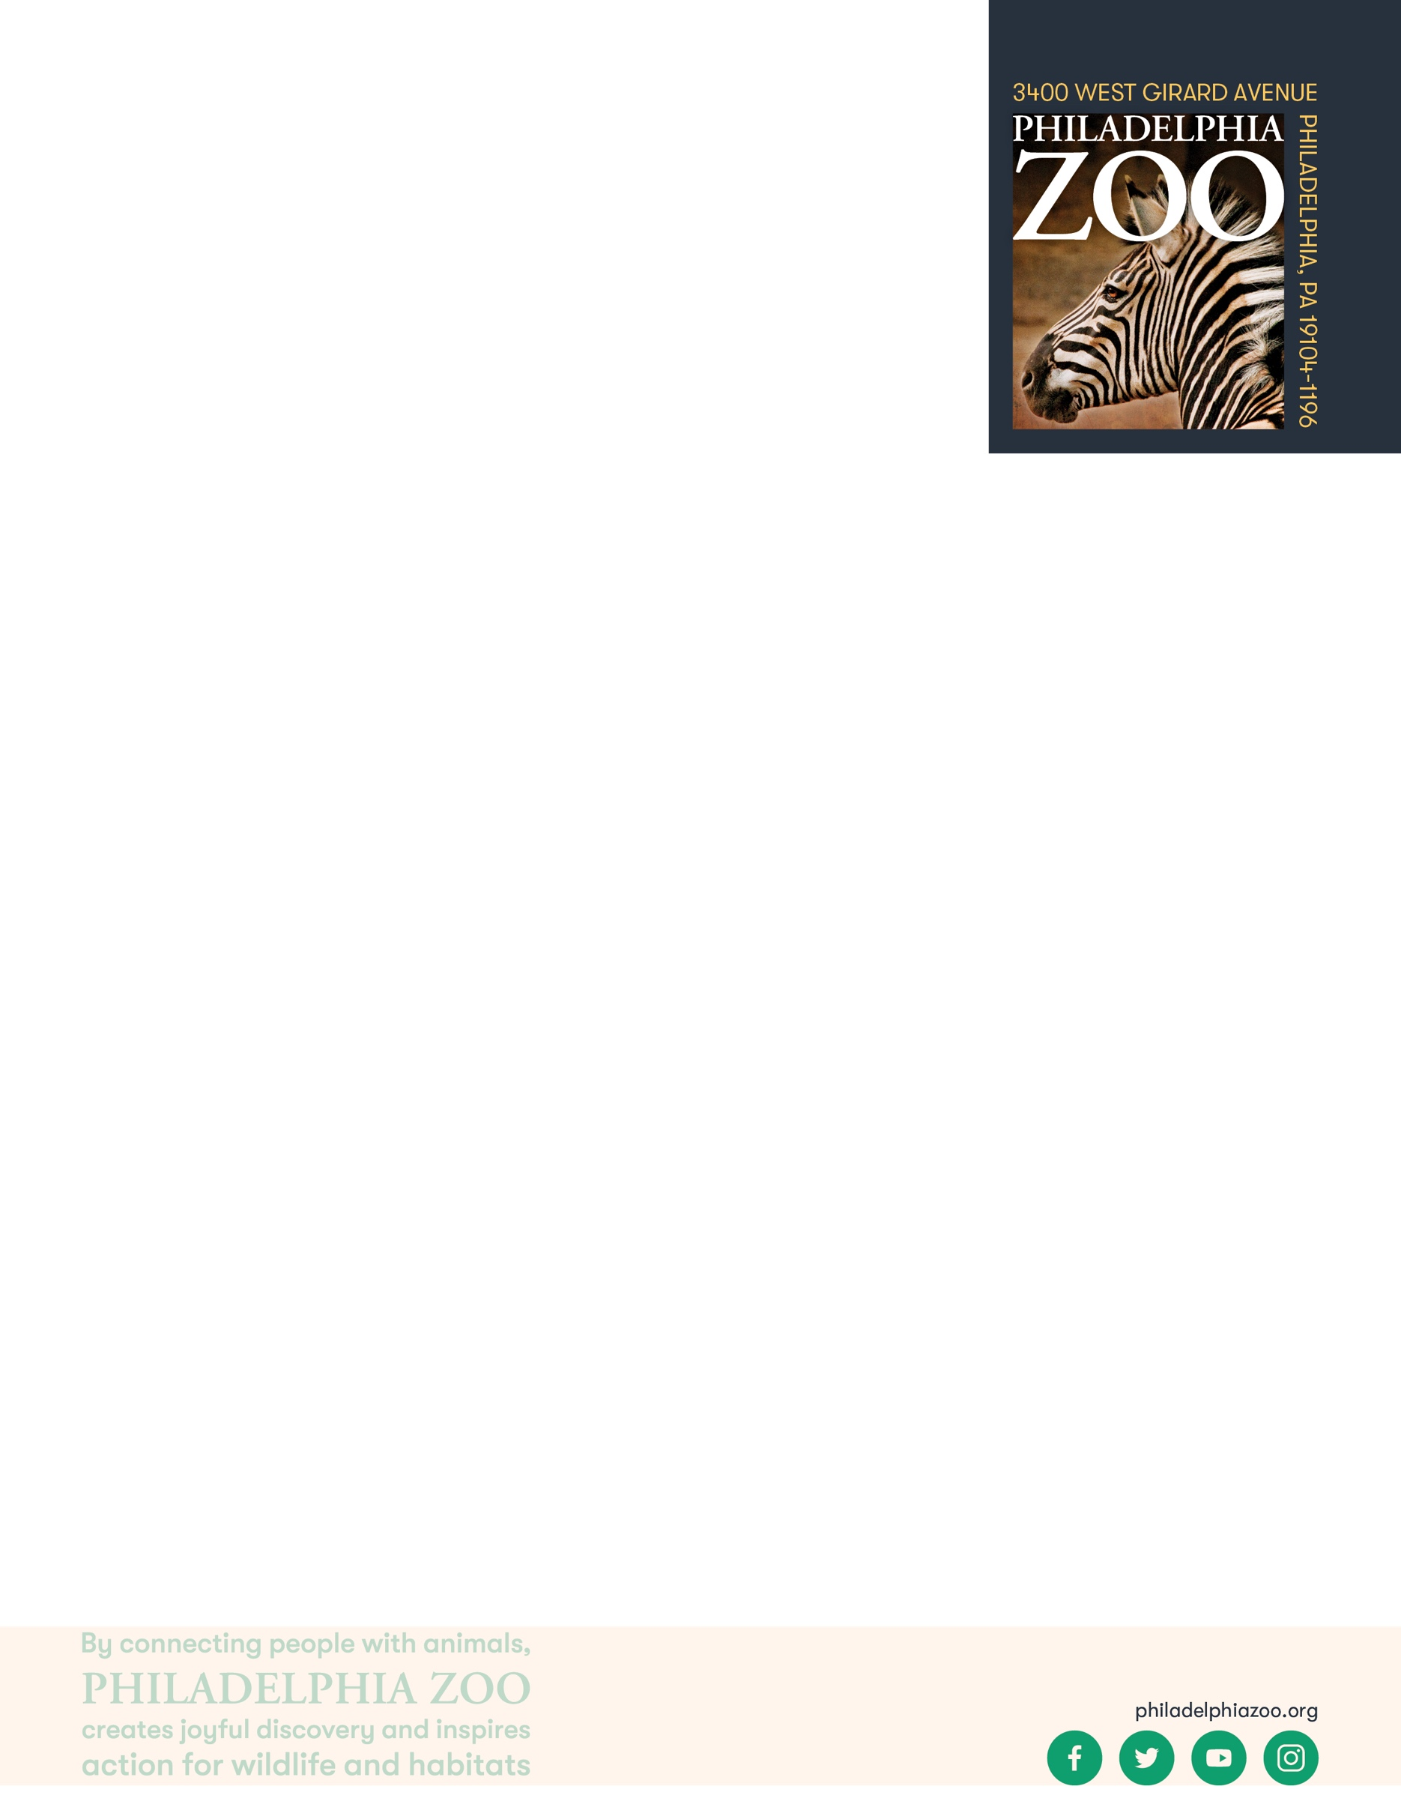

**9-12 Pre-Activity**

**Lesson Summary**

Students complete simulations to examine the factors impacting population sizes.

**Objectives**

Students will be able to identify trends and patterns in population sizes

Students will be able to graph and analyze data

Students will be able to apply understanding of resources to provide reasoning for changes in population size

**Essential Question**

Why are adaptations important?

**Materials**

* Hula hoop
* Resources cards (provided at the end of the lesson)
* Envelopes (for as many as there will be groups)
* Timer
* Paper (or worksheet such as provided at the end of the lesson)
* Writing utensils

**Prep**

1. 1 Week before: Acquire and/or purchase any materials that might be necessary.
2. 1 Day before: Print and cut out resource cards (print as many copies that are equal to 2.5 times the number of students in the class) and worksheets as needed (1 for each student). Place all of the resources together in a bowl or bucket.

**Key Terms**

* **Habitat:** the natural environment of an animal or plant, where that living thing can find their food, water, shelter, and space
* **Competition:** the process of trying to get something that others are also trying to get
* **Adaptation**: features that an organism has developed that helps them meet their basic needs, survive, and multiple in their habitat
* **Behavioral Adaptation:** inherited behaviors of an organism that helps the success of the animal, such as searching for food, mating, or vocalizing
* **Physical/Structural Adaptation:** physical features of an organism that helps the success of the animal, including shape, covering, or armament
* **Physiological/Functional Adaptation:** special functions within the animal that helps the success of the animal, such as regulating temperature or making venom
* **Basic needs**: the absolute minimum resources necessary for long-term physical well-being and survival
* **Survival**: the ability to stay alive, especially through hard conditions
* **Food Web:** The entire flow of energy in an ecological community
* **Food Chain:** Flow of energy through a series of living things that feed on each other shows how living things get energy from the food they eat
* **Predator:** an animal that hunts other animals for food
* **Prey:** an animal being hunted, caught, and eaten by another animal
* **Biodiversity:** the variety of living things in terms of individuals, species, and ecosystems.
* **Carrying Capacity:** The maximum number of a species that can sustainably live in a given area based on the available resources



**Background**

All animals require food, water, and shelter in order to survive. Where an animal finds these basic needs are within their habitat. There are many different habitats, and they are characterized by physical and biological features. For a population of animals living in the habitat, there is competition amongst the individuals for these needed resources available.

An adaptation is a trait that helps an organism survive and succeed in the habitat that they live in. They help the animal obtain its basic needs while. Adaptations can include physical traits and structures, like body color and wings, as well as behavioral traits, like migration. If an animal is relocated to a different kind of habitat, its adaptations would not necessarily be suited for survival, and could possibly cause harm to its success.

**Implementation**

1. Excite: Present a hula hoop in front of the students and invite volunteers to come up and try and fit as many students in the hula hoop as possible (without hurting the other students).
2. Once students have spent some time trying to fit as many of them as possible within the hula hoop, ask them to share how many they were able to fit. Ask the students to consider why they weren’t able to fit more students. Students will likely conclude that they ran out of resources – space.
3. Ask the students to consider that although this might be the maximum number of students that could fit in the hula hoop, how many would be able to fit comfortably long term?
4. Explore: Share with students that they will be acting as animals in a designated habitat, exploring looking for the things that they need. They will be exploring how resources in a given habitat may be distributed and rationed.
5. Provide each student an envelope and invite them to write their names on the envelope. As they are doing that, scatter the pieces of paper throughout the room.
6. When the students and the room are all ready, demonstrate to the students that they will leave their envelopes at their desks, traveling around the room collecting resources (represented by the pieces of paper) one at a time. After collecting a resource, they will return to their desk and place the resource in the envelope. They will want to get as many resources as possible within one minute’s time.
7. At your signal, the students will begin to walk collecting items needed in their habitat. When the minute passes, invite students to review how many and what resources they were able to obtain.
8. After collection time, ask the students to count how many food cards they were able to collect. Ask the students who were able to collect 3 or more raise their hands. Those students are the animals that got enough food to survive. Ask the students who got less than 3 cards to raise their hands. Those are the animals that did not get enough food to survive.
9. Ask student to consider how adaptations play a role in an animal’s ability to get the resources. Adaptations help support the animal the increasing the likelihood that they will be able to meet their basic needs and get all the resources necessary, but does not guarantee their ability to.
10. Explain: Invite the students to return to their seats for a discussion on why some animals survived whereas others didn’t. After receiving a number of responses, review that all living things need air, food, water, shelter and space to live but there are only so many of these resources available in a given habitat leading to competition amongst individuals.
11. Ask students to consider what could happen to the population overtime if there are not enough resources versus if they are enough resources. Collectively conclude that if there are not enough of these resources for the animals present, populations decrease, and when there are enough healthy individuals are able to reproduce and the population increase. There is a maximum population size that a species can sustainably and comfortably live in a given area based on the available resources, and this is called the carrying capacity.
12. Elaborate: Invite students to complete multiple rounds of collecting food in the habitat in the same ways as before. Those that were able to collect enough food would be healthy enough to reproduce – and for every 2 successful animals, an additional animal should be added to the population from the individuals that did not survive (representing a recycling of nutrients as well). Complete rounds and record the population size after each round.
13. After at least 5-10 rounds, stop the simulation and invite students to graph the generational data. Trends will begin to emerge which will quantify the carrying capacity for this population in this habitat with the resources available.
14. Upon graphing the population size changes over generations, invite groups to share what they notice. They will likely see fluctuations in population sizes, where populations can only increase so much before competition of resources then causes the population to decrease again. Invite them to draw a line at the number where it seems like the population hovers over.
15. Share with the students that in this simulation, the only resource examined was food. Ask students to consider what other resources could impact the carrying capacity of a specific animal within a designated habitat. Answers may include any resource that the species needs to survive – shelter, water, air, space (as was explored with the hula hoop), etc.
16. Ask student to consider what factors could impact the resources in a habitat and thus influence carrying capacity. Responses might include natural factors, such as disease or natural disasters, and human-caused factors, such as hunting or habitat destruction.
17. Evaluate: Asks students to review and define carrying capacity, what factors determine carrying capacity, and what factors allow for greatest success of a population of animals in a habitat.



**PA STEELS Standards**

3.1.9-12.I, 3.1.9-12.L



Name: __________________________________________________________



Date: ___________________________________________________________

All living things need air, food, water, shelter and space to live but there are only so many of these resources available in a given habitat leading to competition amongst individuals. This has implications on a population size of animals within a given habitat overtime. There is a maximum population size that a species can sustainably and comfortably live in a given area based on the available resources, and this is called the carrying capacity.

Complete the chart below based on numbers from the activity. Then graph the data.

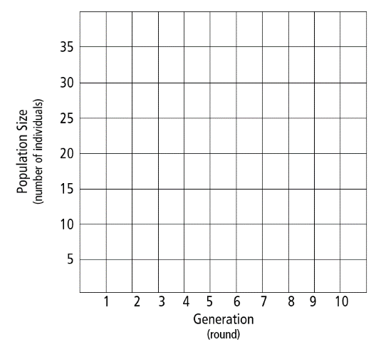

|  |  |  |  |
| --- | --- | --- | --- |
| Generation $$( round )$$ | Starting  population | Surviving  population | Ending population  ($\# survivors+ \frac{\# survivors}{2}$) |
| 1 |  |  |  |
| 2 |  |  |  |
| 3 |  |  |  |
| 4 |  |  |  |
| 5 |  |  |  |
| 6 |  |  |  |
| 7 |  |  |  |
| 8 |  |  |  |
| 9 |  |  |  |
| 10 |  |  |  |

What trends or patterns are you noticing in the chart? ________________________________________________

__________________________________________________________________________________________

Draw a line where the population sizes are fluctuating above and under. This is the carrying capacity in this habitat.

What other resources can impact the carrying capacity? _______________________________________________

__________________________________________________________________________________________

What factors could have an impact the resources available in a habitat and influence carrying capacity?

__________________________________________________________________________________________

__________________________________________________________________________________________