**Habitats and Adaptations**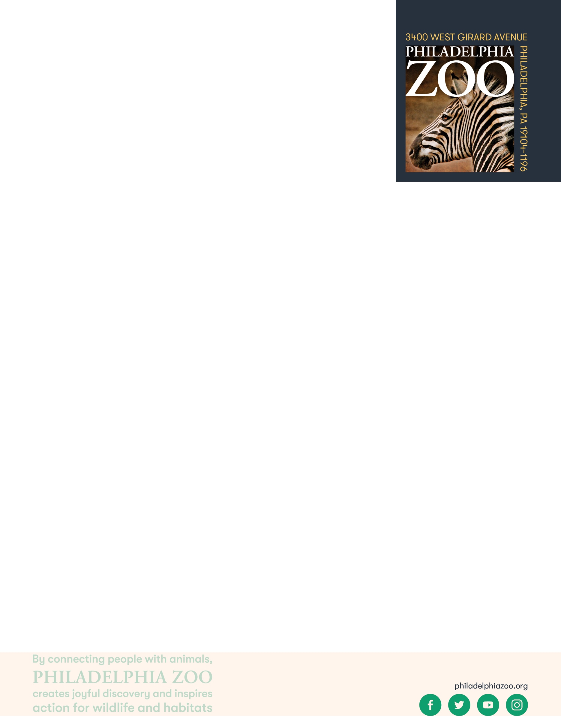

**9-12 Onsite Activity**

**Lesson Summary**

Students observe different animals at the Zoo and determine the advantages and disadvantages of these features and its impact on the species survival.

**Objectives**

Students will be able to provide details on features of an animal

Students will be able to determine potential benefits and detriments of these features

**Essential Question**

Why are adaptations important?

**Materials**

* Paper (or worksheet such as provided at the end of the lesson)
* Writing utensils

**Prep**

1. 1 Week before: Look at the [Zoo map](https://www.philadelphiazoo.org/zoo-map/) to determine locations for observations
2. 1 Day before: Print out worksheets as needed (1 for each student)
3. 15 minutes before: Prep students for expectations

**Key Terms**

* **Habitat:** the natural environment of an animal or plant, where that living thing can find their food, water, shelter, and space
* **Competition:** the process of trying to get something that others are also trying to get
* **Adaptation**: features that an organism has developed that helps them meet their basic needs, survive, and multiple in their habitat
* **Behavioral Adaptation:** inherited behaviors of an organism that helps the success of the animal, such as searching for food, mating, or vocalizing
* **Physical/Structural Adaptation:** physical features of an organism that helps the success of the animal, including shape, covering, or armament
* **Physiological/Functional Adaptation:** special functions within the animal that helps the success of the animal, such as regulating temperature or making venom
* **Basic needs**: the absolute minimum resources necessary for long-term physical well-being and survival
* **Survival**: the ability to stay alive, especially through hard conditions
* **Food Web:** The entire flow of energy in an ecological community
* **Food Chain:** Flow of energy through a series of living things that feed on each other shows how living things get energy from the food they eat
* **Predator:** an animal that hunts other animals for food
* **Prey:** an animal being hunted, caught, and eaten by another animal
* **Biodiversity:** the variety of living things in terms of individuals, species, and ecosystems.

**Background**

All animals require food, water, and shelter in order to survive. Where an animal finds these basic needs are within their habitat. There are many different habitats, and they are characterized by physical and biological features. For a population of animals living in the habitat, there is competition amongst the individuals for these needed resources available.

An adaptation is a trait that helps an organism survive and succeed in the habitat that they live in. They help the animal obtain its basic needs while.

Adaptations can include physical traits and structures, like body color and wings, as well as behavioral traits, like migration. If an animal is relocated to a different kind of habitat, its adaptations would not necessarily be suited for survival, and could possibly cause harm to its success.

**Implementation**

1. Excite: Welcome the students to the Zoo and ask them to share some of the most interesting animals that they might be familiar. What is it that makes these animals so unique?
2. Explore: As you walk around the Zoo, verbally discuss some of the features you and the students are noticing on the animals, and consider the purposes of these features.
3. Explain: Remind students that all living things have adaptations, that help them to meet their basic needs and survive in the habitat they live in. Although these adaptations benefit and support the animal’s ability to lives in its habitat, sometimes these features can have detriments too.
4. Elaborate: Visit a few exhibits at the Zoo to spend some extra time observing particular animal features (of the same animal or of different animals). Invite students to draw and label what they observe. Then, invite them to consider and hypothesize on what advantages or disadvantages that these features might have that can affect the success of the animal in its habitat.
5. Discuss why these advantages and disadvantages might exist, and how they might affect a population long term.
6. Evaluate: Ask students to share what additional things they may have learned about animal adaptations through their deeper observations.

**PA STEELS Standards**

3.1.9-12.U, 3.1.9-12.W

Name: __________________________________________________________

Date: ___________________________________________________________

School: _________________________________________________________

Date: ___________________________________________________________

Welcome to the Zoo! Animals have different adaptations that help them survive in the habitat they live in. Although these adaptations benefit and support the animal’s ability to lives in its habitat, sometimes these features can have detriments too.

Examine a few animal features and include drawings and labels of what you observe. Then, hypothesize some advantages and disadvantages that these features might have that can affect the success of the animal in its habitat.

|  |  |  |
| --- | --- | --- |
| Feature | Advantages | Disadvantages |
|  |  |  |
|  |  |  |
|  |  |  |

How could these advantages or disadvantages affect a population long term? ______________________________

__________________________________________________________________________________________

__________________________________________________________________________________________

